|  |
| --- |
|  |
| DPM User Guide |
| K2View DPM |
| 6/1/2020 |

Table of Contents

1 Overview 7

1.1 About This User Guide 7

1.2 Glossary 7

1.3 DPM Entities 8

2 Admin Module 9

2.1 Overview 9

2.2 Admin Menu Options 9

2.3 DPM Configuration 10

2.3.1 Overview 10

2.3.2 Flows, Stages, Tasks 11

2.3.3 Regulations and Activities 25

2.3.4 Activity Details 26

2.3.5 Add an Activity 27

2.4 Roles Management 27

2.4.1 Overview 27

2.4.2 DPM Roles 28

2.4.3 Corporate Roles 29

2.4.4 Managing Users in the Admin Module 34

2.4.5 DPM Main Menu 35

3 Representative User Interface 37

3.1.1 Search a Request 37

3.1.2 Submit a Request 39

4 Customer direct Requests 40

4.1 DPM Customer’s Built-in User Interface 41

4.1.1 Customer Dashboard 41

4.1.2 Customer Submits a Request 41

4.1.3 Customer View Requests 42

4.2 DPM APIs for Customer Requests 44

5 Steward User Interface 44

5.1 Steward Dashboard 44

5.1.1 Steward Dashboard Filters 45

5.1.2 Steward Dashboard Totals 45

5.1.3 Steward Graphs 46

5.2 Tasks List 46

5.3 Executing a Task 47

5.4 Task Details 48

5.4.1 Progress Bar 49

6 Case Owner User Interface 49

6.1 Case Owner Dashboard 49

6.1.1 Case Owner Dashboard Filters 50

6.1.2 Case Owner Dashboard Totals 50

6.1.3 Case Owner Graphs 51

6.2 Case Owner Requests List 51

6.3 Case Owner Request Details 52

6.4 Case Owner Task Details 54

7 Supervisor User Interface 55

7.1 Supervisor Requests Dashboard 56

7.2 Supervisor Requests List 56

7.3 Supervisor Case Owner Allocation Configuration 56

7.3.1 Assignment Method 57

7.3.2 Assignment Criteria 58

8 Consent Management 59

8.1 Consent Management Overview 59

8.2 Consent Topics and Categories Configuration 60

8.2.1 Consent Topics List 60

8.2.2 Create New Consent Topic 62

8.3 Obtain Customer’s consent and preferences 63

8.3.1 Customer Facing Interface 63

8.3.2 Customer Consent Management Screen 63

8.3.3 Customer Service Representative (CSR) User Interface 65

8.4 Consent Data Repository, Historical Data and Audit Information 66

8.5 Consent Data Ingestion to/from other systems 66

8.5.1 Acquire and Publish in Real-Time 68

8.5.2 Consent Preferences Reminders 68

List of Figures

Figure 1. Main DPM Entities 9

Figure 2. Admin Module 10

Figure 3. Admin Menu 10

Figure 4. Flows List screen 11

Figure 5. New Flow 13

Figure 6. Configuration of a New Flow - Initial screen 13

Figure 7. Import Flow Example 15

Figure 8. Adding a New Stage 16

Figure 9. Flow with a new Stage screen 17

Figure 10. Flow Stages 17

Figure 11. Add/Edit a Task screen 18

Figure 12. Task tab 19

Figure 13. Task Configuration - Task tab 21

Figure 14. Task Configuration - Reminders tab 22

Figure 15. Task Configuration - Operations tab 23

Figure 16. Operation Parameters Types 23

Figure 17. Task Operation - the data to be configured for each input option 24

Figure 18. Regulations List 25

Figure 19. Activity List for a Regulation 26

Figure 20. Edit Activity 27

Figure 21. Corporate and DPM Roles 28

Figure 22. Role Management Menu 30

Figure 23. Corporate Role Management 30

Figure 24. Detailed Authorization Configuration 31

Figure 25. New Corporate Role 32

Figure 26. Corporate Role Permissions Configuration 33

Figure 27. User Management 34

Figure 28. New User screen 35

Figure 29. K2View Main Menu 36

Figure 30. Main Menu with Two Menu Items 37

Figure 31. Representative Menu 37

Figure 32. Representative Search Request 38

Figure 33. Request Details 39

Figure 34. Representative Submits a New Request 40

Figure 35. Customer Landing Page 41

Figure 36. Customer Submits a Request 41

Figure 37. Customer View Requests 42

Figure 38. Customer Request Details 43

Figure 39. Steward Dashboard 45

Figure 40. Example of Applied Steward Dashboard Filter 45

Figure 41. Steward Dashboard Totals Example 46

Figure 42. Steward Graphs 46

Figure 43. Tasks List 47

Figure 44. Task Details 48

Figure 45. Progress Bar Example 49

Figure 46. Case Owner Dashboard 50

Figure 47. Case Owner Dashboard Filter Example 50

Figure 48. Case Owner Dashboard Totals Example 51

Figure 49. Case Owner Graphs Example 51

Figure 50. Case Owner Requests List 52

Figure 51. Case Owner Request Details 53

Figure 52. Case Owner General Information for Request Example 53

Figure 53. Case Owner View of Stages of Request 53

Figure 54. Task List as Viewed by Case Owner 54

Figure 55. Case Owner Task Details 55

Figure 56. Supervisor User Interface 56

Figure 57. Supervisor Resource Management screen 57

Figure 58. New Requests Assignment Method 57

Figure 59. Assignment Criteria 58

Figure 60. Resource Selection for CCPA 59

Figure 61. New Filter: Regulation/Activity 59

Figure 62. Consent Management Menu Item 61

Figure 63. Consent Management Configuration Screen 61

Figure 64. New Consent Topic Configuration 62

Figure 65. Consent Management at customer level 64

Figure 66. Customer Consent Management Screen 64

Figure 67. Consent History 65

Figure 68. Consent Management at representative menu 65

Figure 69. Representative Consent Management Screen 66

Confidentiality

This document contains copyrighted work and proprietary information belonging to K2View.

This document and information contained herein are delivered to you as is, and K2View makes no warranty whatsoever as to its accuracy, completeness, fitness for a particular purpose, or use. Any use of the documentation and/or the information contained herein, is at the user's risk, and K2View is not responsible for any direct, indirect, special, incidental, or consequential damages arising out of such use of the documentation. Technical or other inaccuracies, as well as typographical errors, may occur in this Document.

This document and the information contained herein and any part thereof are confidential and proprietary to K2View. All intellectual property rights (including, without limitation, copyrights, trade secrets, trademarks, etc.) evidenced by or embodied in and/or attached, connected, or related to this Document, as well as any information contained herein, are and shall be owned solely by K2View. K2View does not convey to you an interest in or to this Document, to information contained herein, or to its intellectual property rights, but only a personal, limited, fully revocable right to use the Document solely for reviewing purposes. Unless explicitly set forth otherwise, you may not reproduce by any means any document and/or copyright contained herein.

Information in this Document is subject to change without notice. Corporate and individual names and data used in examples herein are fictitious unless otherwise noted.

Copyright © 2020 K2View Ltd./K2VIEW LLC. All rights reserved.

The following are trademark of K2View:

K2View logo, K2View's platform.

K2View reserves the right to update this list from time to time.

Other company and brand products and service names in this Document are trademarks or registered trademarks of their respective holders.

Revision History

|  |  |  |  |
| --- | --- | --- | --- |
| Revision | Date | Author | Changes |
| Initial version | Jun 01 2020 | Adi Di Nur |  |
| Updated Draft | Dec 28 2020 | Matthew Fogel | Throughout document |
|  |  |  |  |
|  |  |  |  |
|  |  |  |  |
|  |  |  |  |

# Overview

## About This User Guide

This document describes the use of K2View’s Data Privacy Management (DPM) tool. This user guide is written for the different users of this tool, such as DPM Administrators, Case Owners, Data Stewards, Call Center Representatives and Supervisors. For information about the roles this document applies, see the section, *DPM Roles*.

## Glossary

|  |  |
| --- | --- |
| Term | Description |
| DPM | Data Privacy Management Tool |
| DSR | Data Subject Request |
| GDPR | General Data Protection Regulation – The European Union regulation. |
| CCPA | California Consumer Privacy Act |
| LGPD | Brazil’s General Data Protection law |

The Data Privacy Management Tool provides an efficient and effective means to administer data privacy regulations such as the European General Data Protection Regulation (GDPR), California Consumer Privacy Act (CCPA), Brazil’s General Data Protection law (LGPD), and others.

K2View’s DPM tool embodies a flexible system to allow a company to define the types of data requests for the regulations affecting the company’s use of customer data, the processes and flows for how data is tasked to completion to fulfill regulations compliant to one or more data privacy regulators.

K2View’s DPM tool is comprised of two main modules:

**Admin module**: The Admin module is used by the DPM Administrator for the configuration of the tool. The Administrator defines all DPM aspects, such as the supported regulations, the types of requests allowed for each regulation, the task flow required to fulfill each request, customer consent configuration, and more.

**Data Subject Requests and Consent Management**: Role-based components that serve different users, such as:

* *Call Center Representatives* - responsible for submission of data requests
* *Data Stewards* - responsible for fulfillment of data requests
* *Case Owners* - responsible for successful completion of the requests administered.
* *Supervisors* - administer allocation of Data Requests to Case Owners

The preceding user-based components cover the end-to-end life cycle of data privacy-related requests, including

* Submission of a new request
* Request fulfilment process
* SLA management
* Management dashboards, and
* Generation of audit data.

In the following topics this user guide describes the details of the functionality of the modules and user-based roles.

## DPM Entities

DPM configuration is based on the following entities:

* *Regulation* – DPM configuration is flexible by allowing compliance with any current or future regulation, such as GDPR, CCPA, LGPD, or any other. This flexibility also extends to no limit on the number of regulations supported.
* *Activities* – Each regulation is defined by a set of Activities. Each Activity represents an action, related to Data Privacy legislation that can be requested by a customer. For example, an Activity may be a request to provide the customer with data or a request to delete the customer data. There is no limit on the nature of, or number of configurable Activities
* *Flow* – a Flow is a series of stages that are executed in their particular order to fulfill an Activity. Each Activity is linked to a Flow that is responsible to execute the process to perform the specific customer request. A Flow can be used in multiple Activities. For example, if the Activity “Request My Data” is supported both under CCPA and GDPR Regulation but can be executed similarly regardless of which privacy legislation applies, then the same flow will be linked to this Activity under both regulations.
* *Stage* – A Stage is the building block for a Flow. Each Flow has at least one Stage. Stages are executed in sequence to fulfill customer data requests.
* *Task* – Each Stage is composed of one or more Tasks. Task is the lowest level component that is defined in the Admin by the Administrator. It typically performs one specific Activity, such as: check request validity, send an e-mail to the customer, or gather customer data. Tasks can be defined to be executed in parallel or in sequence. Once all the Tasks of a specific Stage are completed, then the next Stage begins.

An example of the relationship between the previously described entities is depicted in the following diagram.

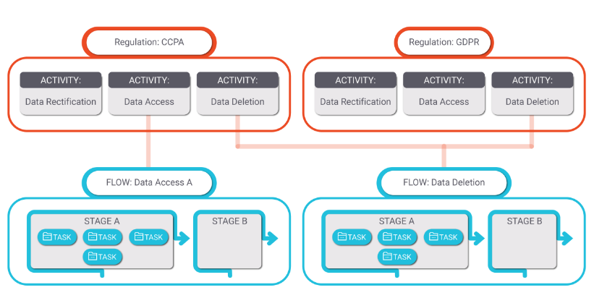

Figure 1. Main DPM Entities

# Admin Module

## Overview

The Admin module provides the means to:

* Define regulations covered by the DPM
* Create the Activities that are supported for each regulation
* Create the Flows, Stages and Tasks needed for the execution of a customer request
* Manage user roles
* Define customer consent topics
* and more.

## Admin Menu Options

Once a user logs into the DPM system as Administrator, the Admin menu options, the screen is updated with two frames (windows) of information. The left frame displays a list of menu options for this module. The right frame displays the Regulations list.

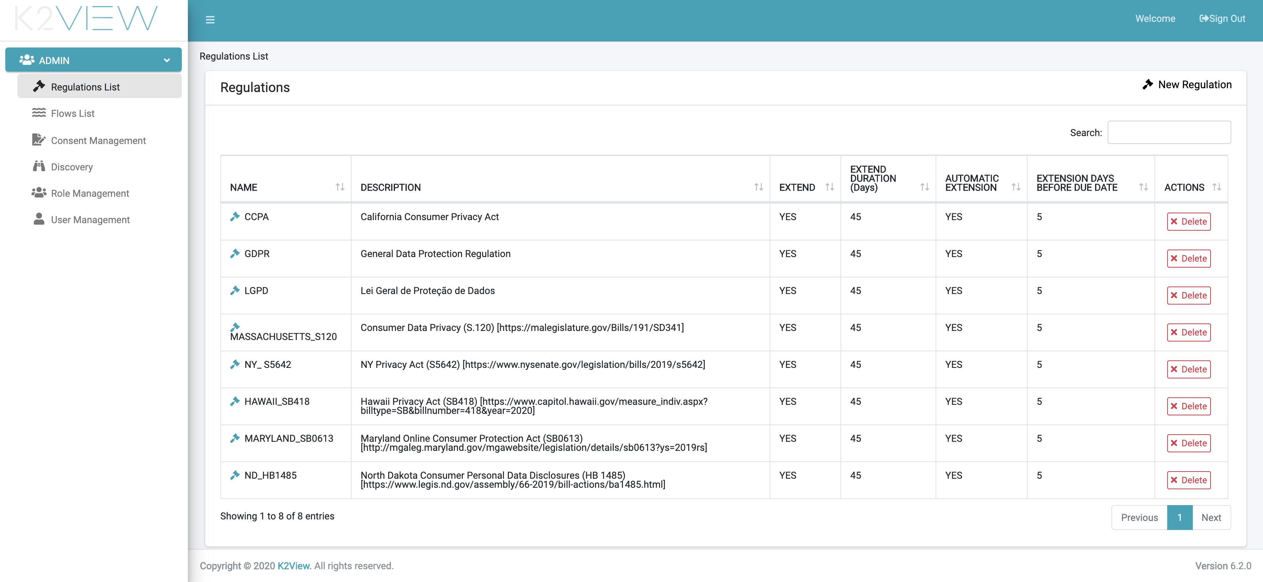

Figure 2. Admin Module

From the left window (frame), the Administrator can access the available DPM configuration options. The details for each option are described in the following *DPM Configuration* section.

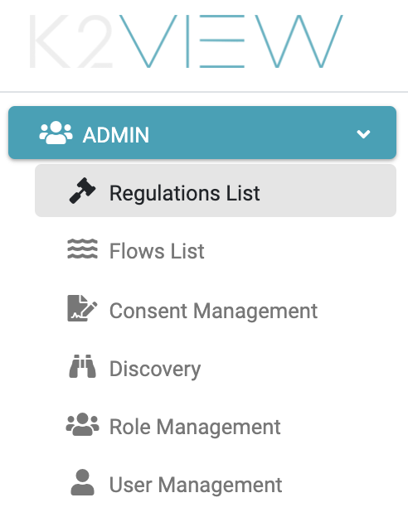

Figure 3. Admin Menu

## DPM Configuration

### Overview

As described in the first section, the Admin module is where the DPM Administrator can define the support for the different Privacy Regulations and their respective Activities.

The configuration is comprised of:

* Define Flows: The Flows specify the set of tasks that are required for the fulfillment of a customer request.
* Define Regulation and Activities: Configure the Regulation and Activities that the DPM supports. Once an Activity is defined, it is mapped to the corresponding Flow.

### Flows, Stages, Tasks

A Flow is an entity that defines the sequence of actions to be executed in order to fulfill a specific DPM request type. For example, the actions to fulfill the request to “get my data” or “forget me”.

The Flow is the main component in the DPM request definition and can be viewed as the “brain” of a DPM request.

A Flow is composed of *Stages*, and Stages include one or multiple *Tasks* in them.

Once a Flow’s configuration is complete, it can be linked to a DPM Activity. From that moment on, any time a customer request for this Activity is processed, the stages and tasks defined in the Flow are followed.

The Admin can view the list of existing flows by selecting the “Flows List” menu option at the left frame of the application screen.

The right frame displays the details for each listed flow and allows the Admin to search for a specific Flow, review any particular flow, and create a new Flow.

#### Flows List

The list of existing Flows provides high-level information about each of the configured Flows.

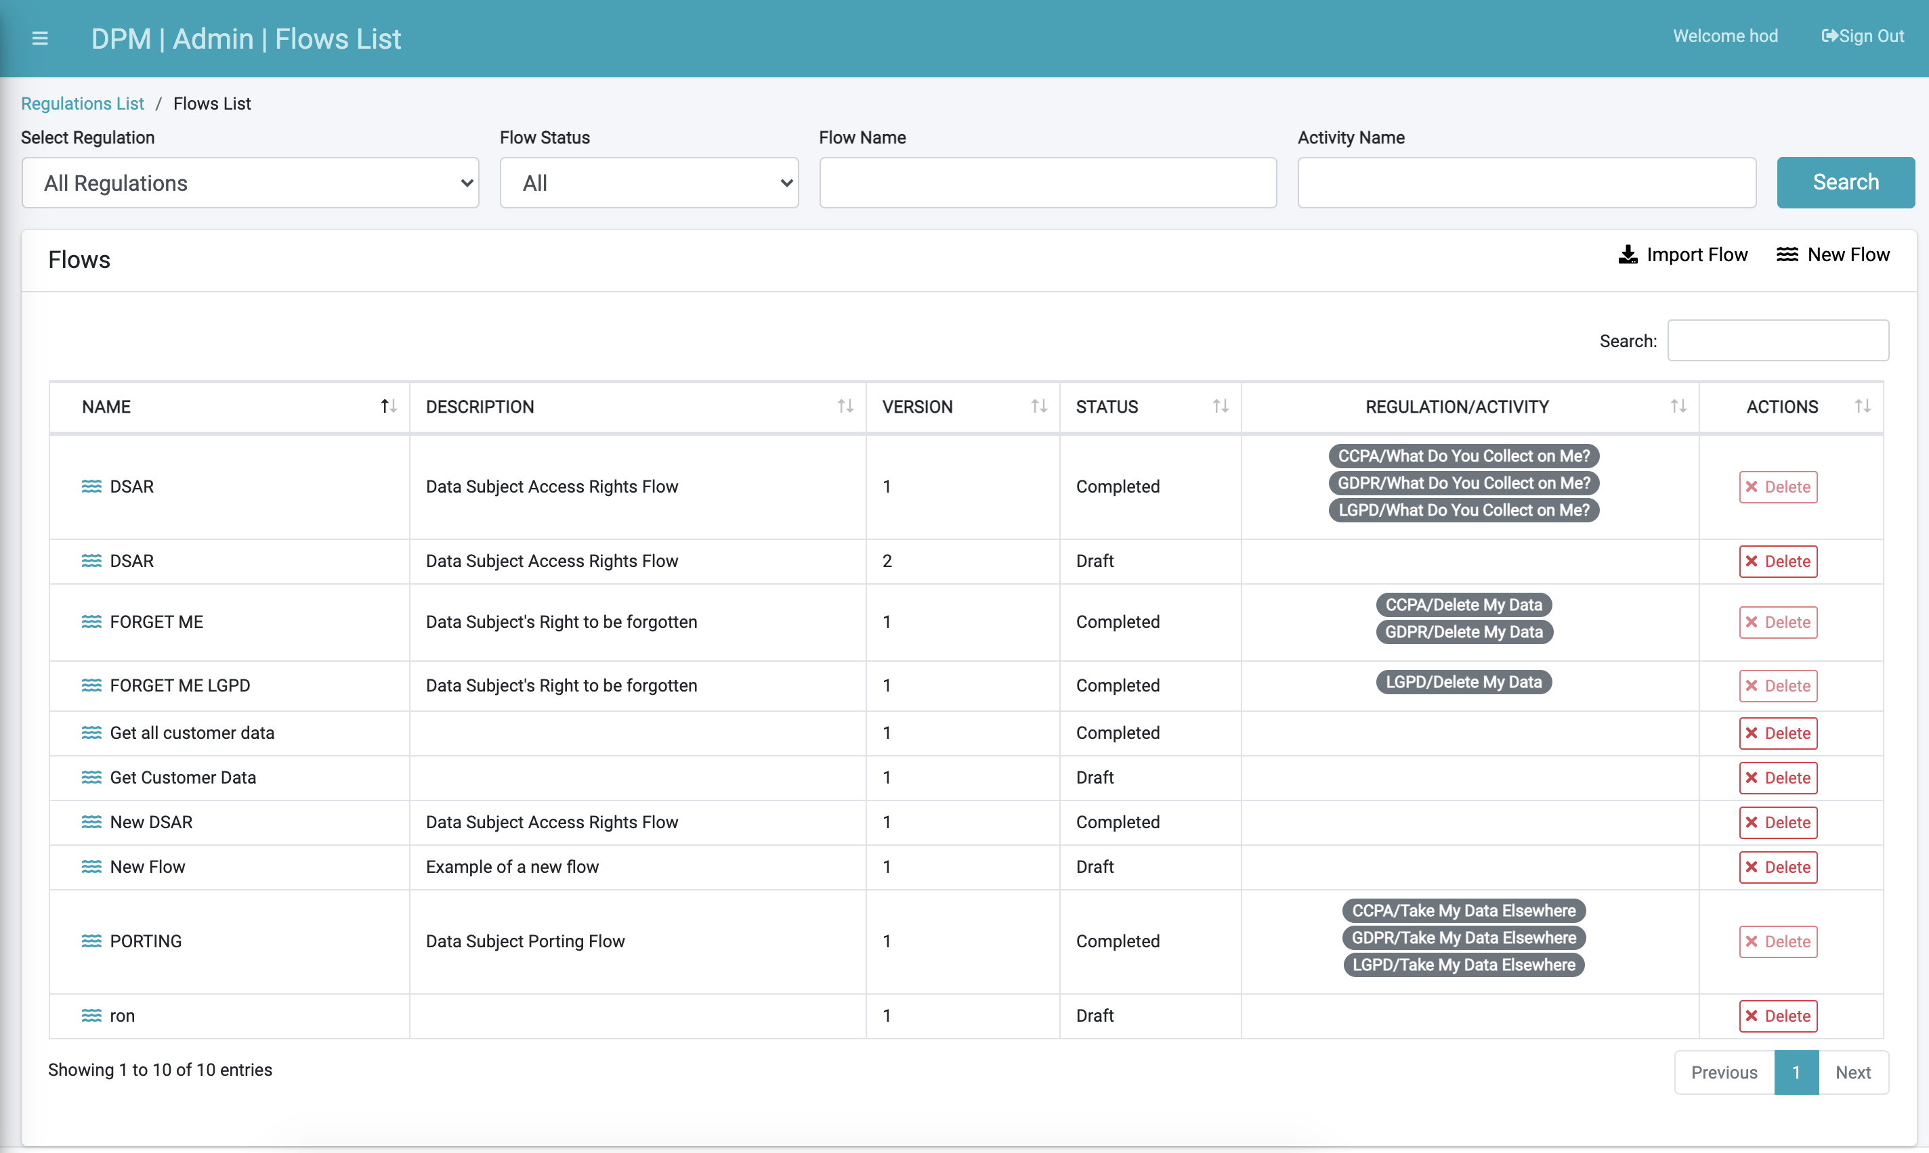

Figure 4. Flows List screen

The preceding figure is an example of listed flows. Information about each Flow includes:

* **Name**: The Flow name.
* **Description**: Describes the purpose of this Flow.
* **Version**: A Flow may have more than one version. All versions are presented.
* **Status**: A Flow is created as a *Draft*, and then changed to *Completed*. Only *Draft* Flows can be altered. *Completed* Flows cannot be changed and can be assigned to Activities.
* **Regulation/Activity**: List of all the Activities that use this Flow.
* **Actions**: provide the option to delete a Flow.

The following sections provide additional information about the options and information in the “Flows List” screen.

##### View Flow Details

View the details of a specific Flow by clicking the line of information displayed.

##### Delete a Flow

Delete a Flow by selecting the “Delete” button under the *Actions* column. Only Flows not linked to an Activity can be deleted.

##### Flow Status

Flow Status - When a new Flow is created, its status is defined as *Draft*. In this status, the DPM Administrator can perform any configuration on this Flow, such as creating new stages, adding new tasks, and more.

Once the Administrator completes the configuration, the Flow can be marked as *Completed*. Marking the Flow as *Completed* blocks further changes to the Flow. At this point, the Flow can be linked to a DPM Activity for execution as part of the DPM fulfillment process. The same Flow can be linked to more than one DPM Activity.

##### Flow Version

Any Flow can have multiple versions. A new version should be created when a change to an existing *Completed* Flow is required. The version number is determined by the Administrator when the new Flow version is created. The Administrator can accept the system’s version or modify the version as desired. Creating a new version of a Flow is described in the section “Flow Details”.

##### Create New Flow

The Administrator creates a new Flow using the “Add a Flow” button at the top-right corner of the screen.

The Administrator is then prompted to provide the Flow name, version, and description, as shown by the next image and detailed by the subsequent table.

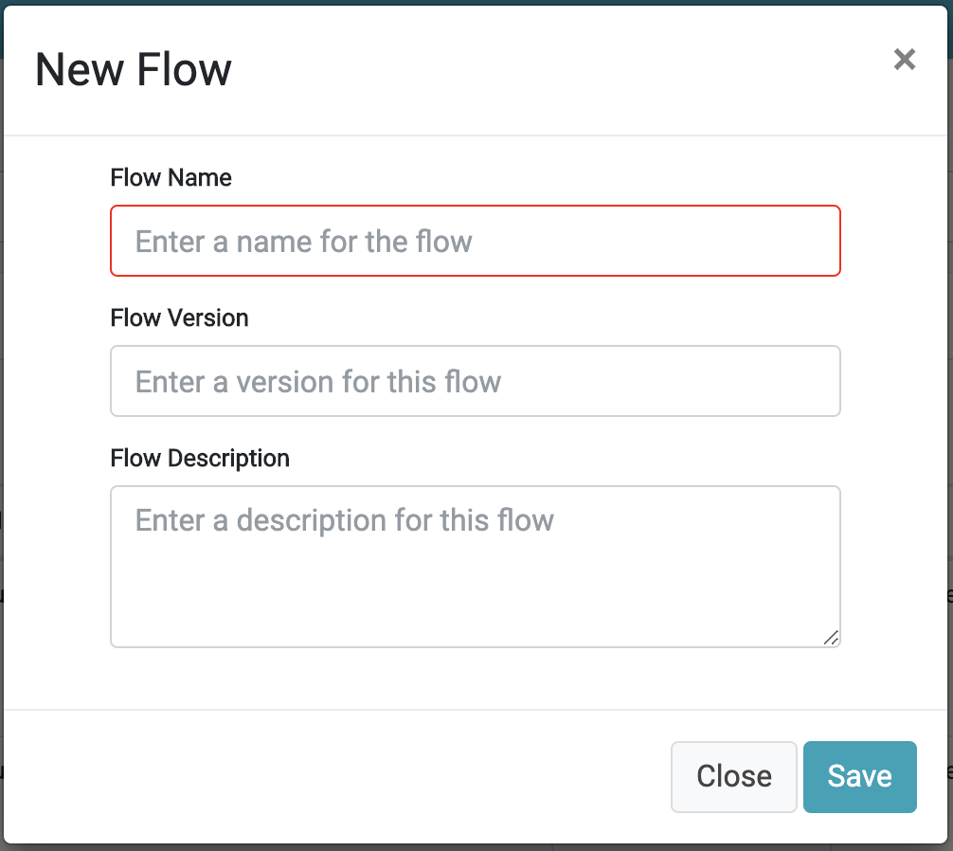

Figure 5. New Flow

|  |  |
| --- | --- |
| Property | Description |
| Flow Name | The name of this Flow. |
| Flow Version | [Optional] The Flow version can be specified by the user or is automatically assigned by the system. The logic for the automatic version number allocation is as follows:   * If there is no other Flow with the same name, the system will automatically set it to 1. * If there is a Flow with the same name, the system will set the Flow version of the new Flow to one higher than the version number of the Flow with the same name.   The system will not allow the creation of two Flows with the same name and the same version. |
| Flow Description | [Optional] Description of the Flow’s purpose. |

Once the Flow information is defined and the new Flow is saved, the system displays the Flow Editing screen, where the Administrator can add Stages and Tasks under those Stages.

The Flow name and the Flow description can be updated at any time, by using the edit icon next to the Flow name

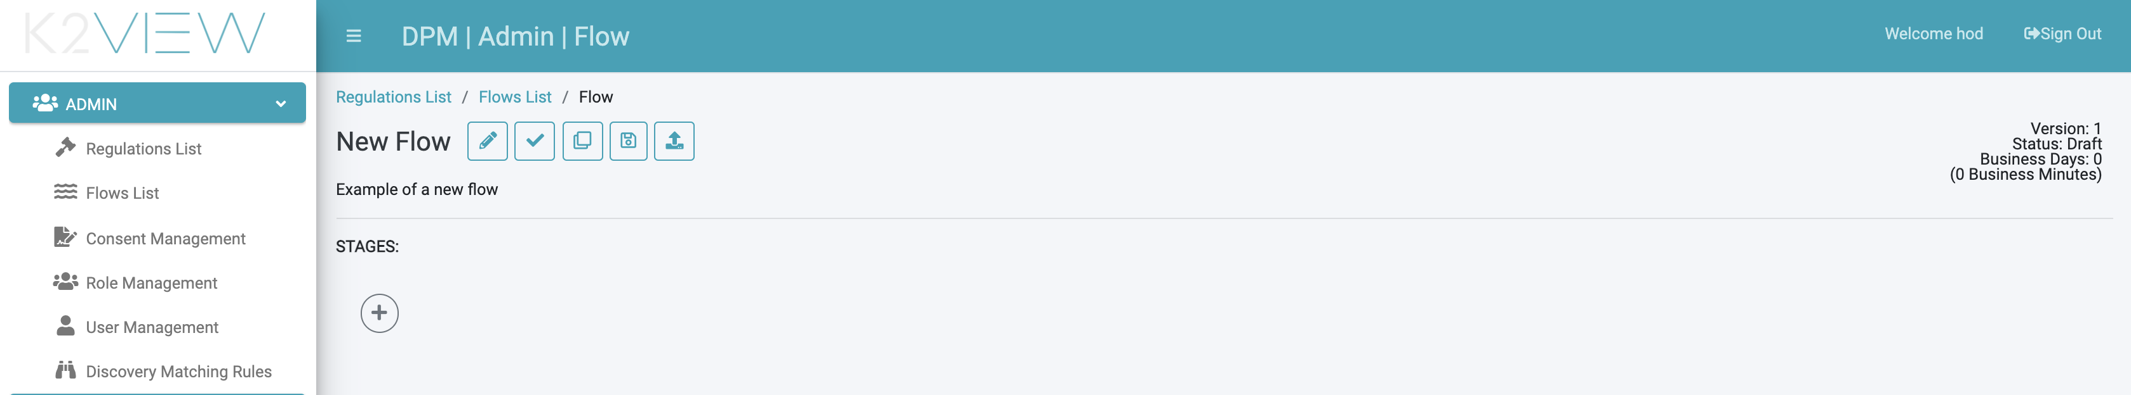

Figure 6. Configuration of a New Flow - Initial screen

#### Flow Level Actions

The set of icons next to the Flow name are actions at Flow level:



|  |  |
| --- | --- |
| Icon | Description |
|  | Edit Flow: Change the Flow Name and/or Description. The Flow name and/or the Flow description can be updated prior to the Flow marked as *Completed*. |
|  | Mark as *Complete*: Once the Flow configuration is completed, use this icon to mark the Flow as *Completed*. No further changes can be made to a flow that is marked as Completed. The Flow is now available to be associated with an Activity in the Activity configuration screens. |
|  | Duplicate this Flow: this icon is used in order to create a new version of the Flow, starting as a clone from a Draft or Completed Flow. The new version is created in *Draft* status and allows the user to change the details of the Flow in the new version. |
|  | Save Flow As: Use the “save as” icon to create a new Flow in *Draft* status, that initially has the same details of the original Flow. The new Flow created is independent from the source Flow. |
|  | Export Flow: This icon serves in order to export the flow to a file. Use this option when you want to recreate this Flow in another environment, for example, when a Flow that was created in testing environment should be imported at the production environment. Read more about the Export/Import option at the dedicated section below. |

##### Export and Import Flow

Flows that are generated in one environment can be exported and then imported at another environment.

This functionality allows you to create a Flow and test it in one environment and then transfer the Flow without any effort to a higher environment such as Acceptance Test and later Production environment.

**To export a Flow** – click the  icon, located at the upper-left corner of the Flow screen. This creates a json file containing the Flow configuration, which can be imported at the target environment.

**To import a Flow** – at the target environment, at the Flow List screen, use the option , located at the upper-right corner of the screen.

As a result, a pop-up window is presented, where the information for the import activity is defined.

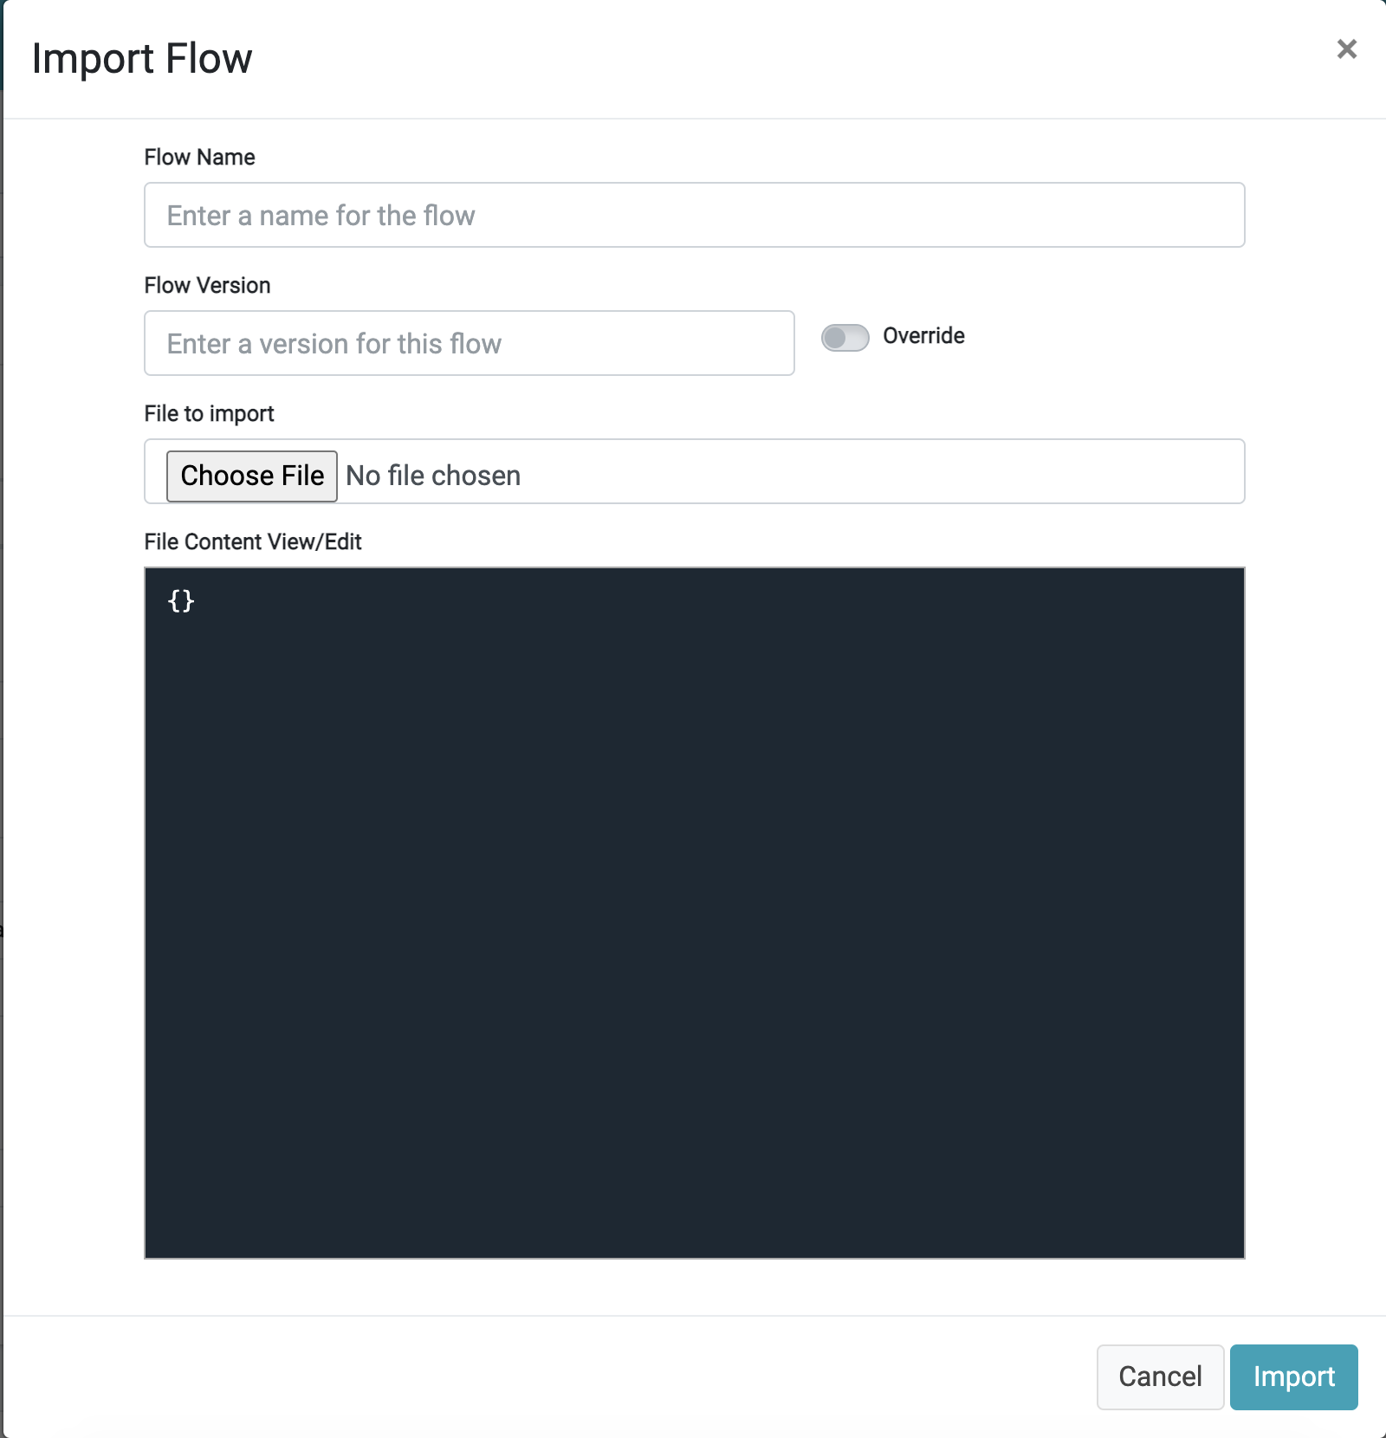

First, Choose the file that contains the Flow configuration (that was generated as a result of the export at the previous step).

Once the file was selected, the DPM loads the configuration, identifies the Flow name and version of the imported Flow, and present the information to the user:

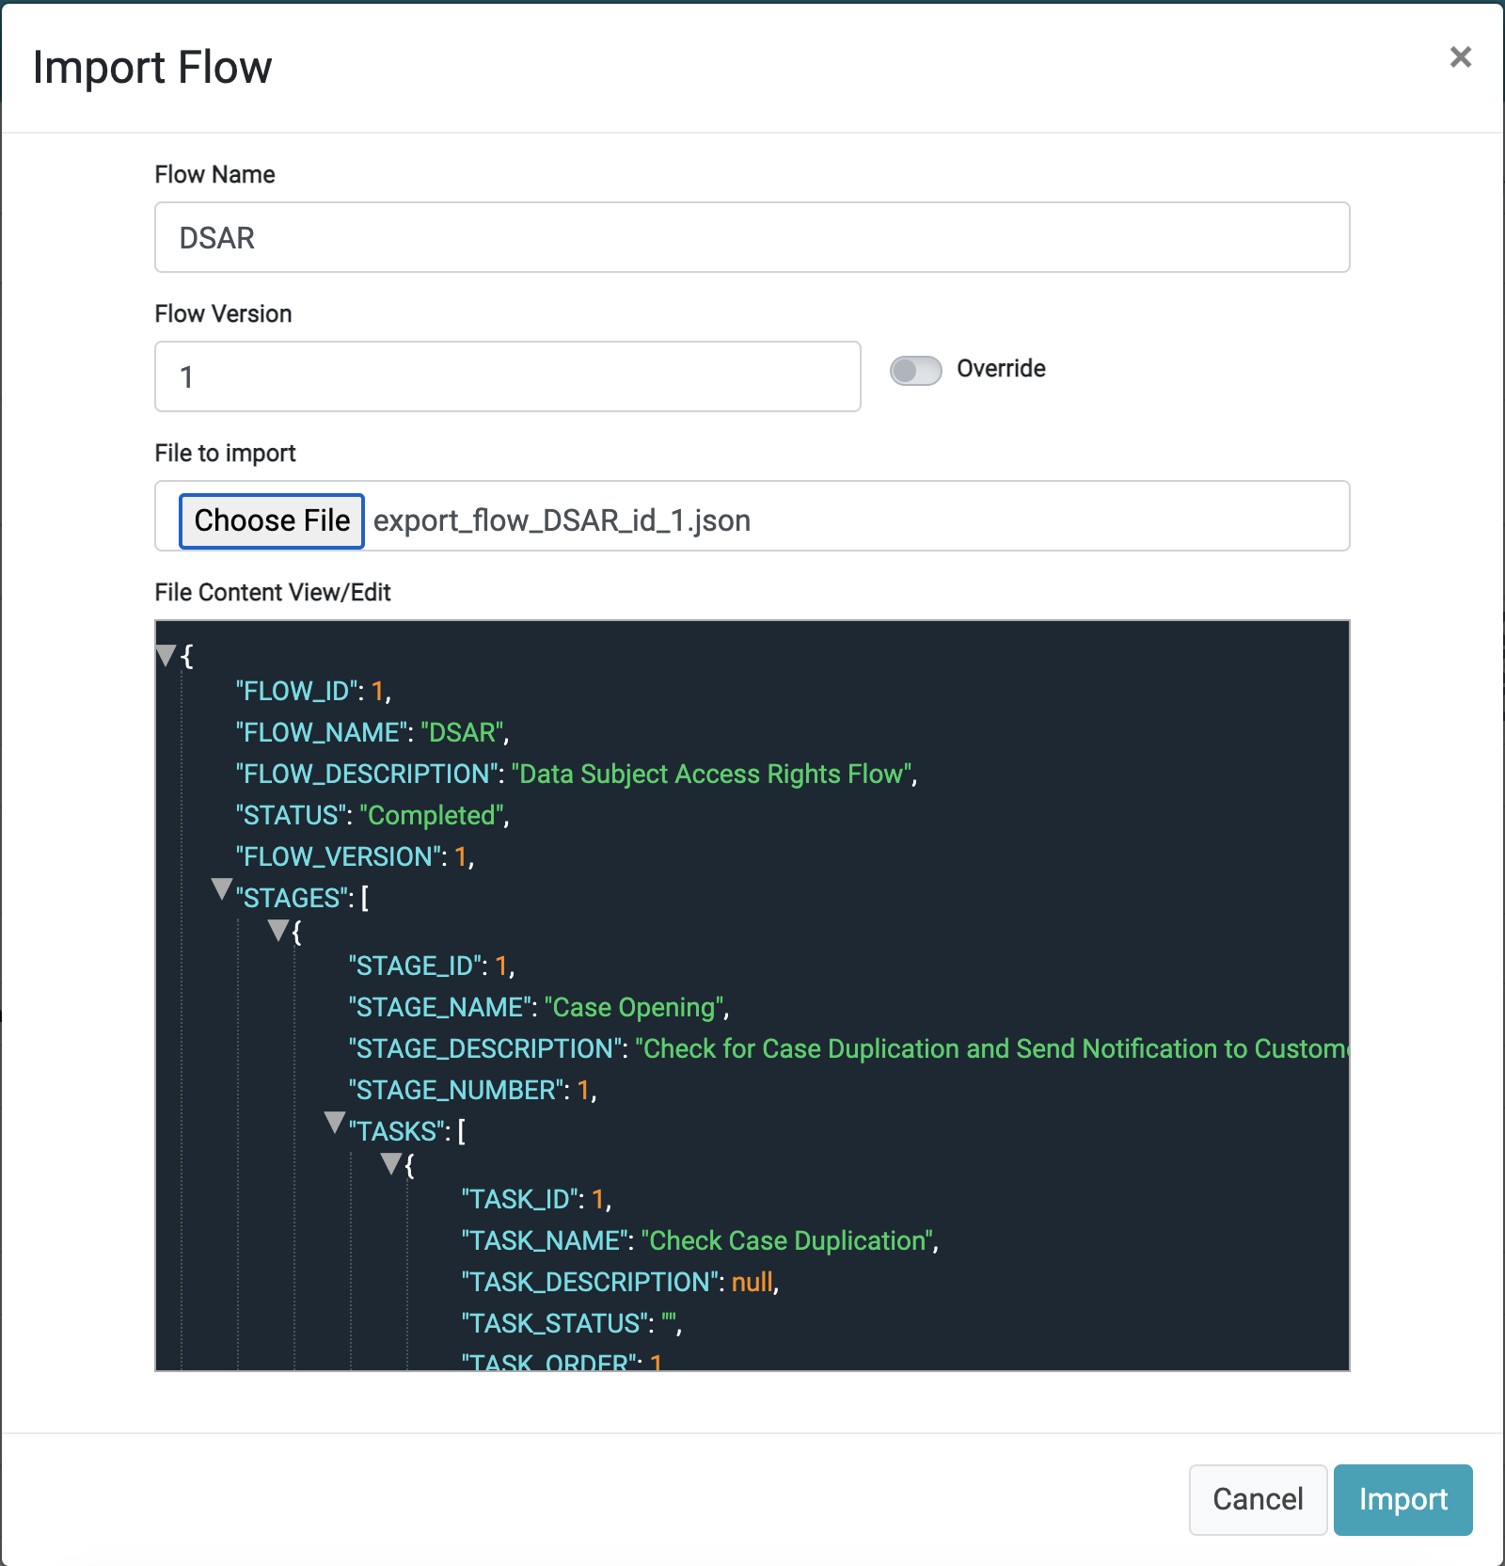

Figure 7. Import Flow Example

Before confirming the import, you can change the Flow name and version. If the purpose is to update the definitions of a Flow and version that already exists in the target environment - Define the same name and version as the Flow you would like to update and turn on the override indicator: .

When needed, the Flow configuration can be edited manually before the import, by changing the content of the json file or editing the json when it is presented on the screen. This editing should be done with care in order not to create invalid scenario or invalid json structure.

##### Flow general information

At the upper-right corner of the Flow screen, the system shows Flow information:

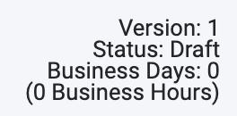

Each information item is described by the next table.

|  |  |
| --- | --- |
| Information | Description |
| Version | The Flow Version. |
| Status | Indicated as “Draft” or “Completed”. |
| Business Days | The duration, in business days, needed to complete all the tasks in the flow. The number of business days is based on the deadlines of the Tasks included in the Flow. The number is rounded up to a whole number of days. |
| (x business Hours) | Indicates the total number of hours to process the Flow, according to the deadline information of all its Tasks. The unit of time measure can be configured as hours or minutes. Note that changing the configuration from Hours to Minutes alters the expected duration of the Flow, and not only the units. For example: A Task with the deadline configured in hours and noted as “1”, the task is understood to take one hour to complete. When the configuration is set to “Minutes”, the task is set with deadline of one minute duration. The option of “Minutes” is usually utilized for testing purposes, when the tester would like to have the Flows executed faster. |

#### Add a Stage

Use the  button from the left side of the Flow screen to add a new Stage. As a result, the user is prompted to define a Stage name and description, as shown by the following figure and description table.

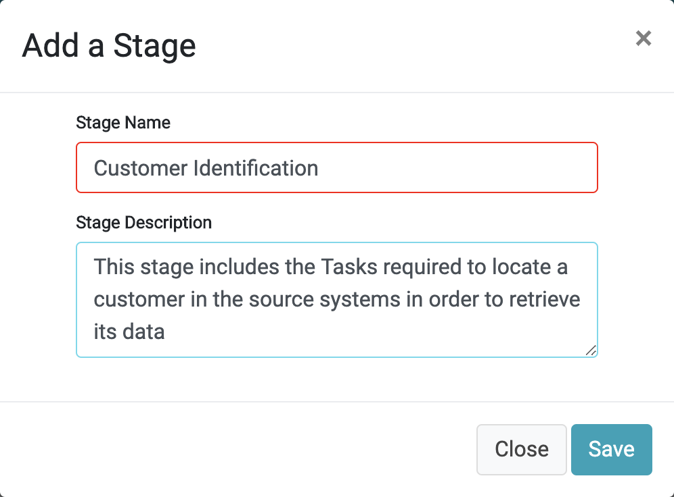

Figure 8. Adding a New Stage

|  |  |  |
| --- | --- | --- |
| Property | M/O | Description |
| Stage Name | M | The name of the Stage. |
| Stage Description | O | The Stage description. |

Saving the new Stage opens the screen to define tasks in this stage.

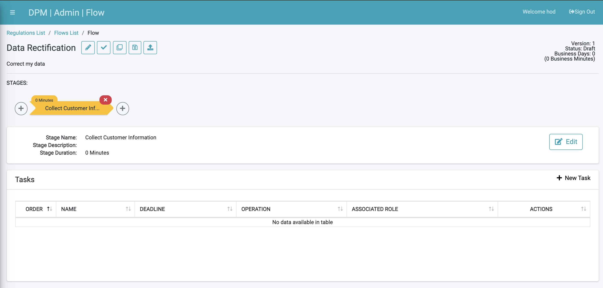

Figure 9. Flow with a new Stage screen

While the Flow is not marked *Completed*, additional Stages can be added, or updated by adding or modifying Tasks.

#### Stages Management

The Stages comprising a Flow are shown in the bar below the Flow header. An example follows.

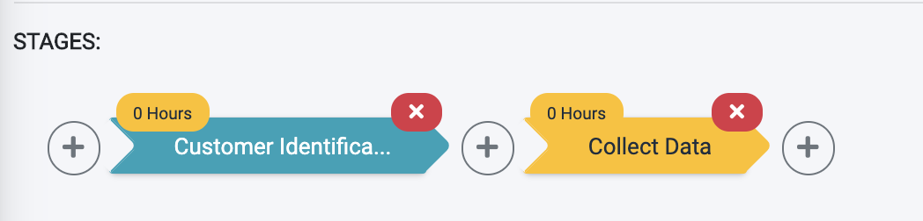

Figure 10. Flow Stages

* Use the + buttons to add a Stage
* Use the x buttons to delete a Stage

The duration of each Stage is marked by the yellow tag at the top of the Stage arrow. This duration is based on the SLAs of the tasks within the Stage. The duration takes into consideration the order and dependencies of the tasks included in each Stage.

The Stage name and description can be changed as long as the Flow is not marked as *Completed*. Edit this information by using the 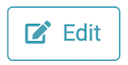 button, located at the right side of the Stage header section.

#### Add/Edit a Task

A Stage is composed of one or more Tasks. Each Task performs a specific action in the Customer Request Fulfilment process. Examples of Tasks are provided next.

* Validates the customer’s request
* Send an e-mail to the customer acknowledging registration of the request.
* Gather the requested customer data.
* Review the gathered data.

To add a new Task under a specific Stage, click the Stage name on the Stage bar and access the 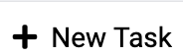 option from the right.

The Task Configuration screen is displayed. This screen includes several tabs, each providing an aspect of Task configuration.

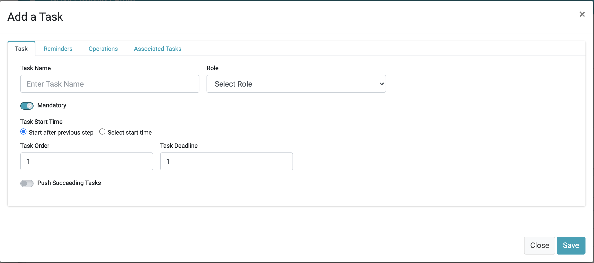

Figure 11. Add/Edit a Task screen

The following tabs constitute the Task Configuration screen:

* Tasks
* Reminders
* Operations, and
* Associated Tasks.

Tasks can be divided into two primary categories: Manually executed Tasks, and Tasks configured to run automatically. An automatic Task is performed by the DPM system, while a manual Task will be allocated to Steward role and teams.

The following sections describe the task properties to be configured when defining a Task, and the different configurations of automatic and manual tasks.

##### Tasks Tab

The **Tasks** tab includes the configuration of parameters, such as:

* Task Name
* Task owner
* Define the Task as mandatory, when applicable
* Provide execution order of Tasks
* Define Dependencies with other Tasks
* Task expected duration
* Task execution timing

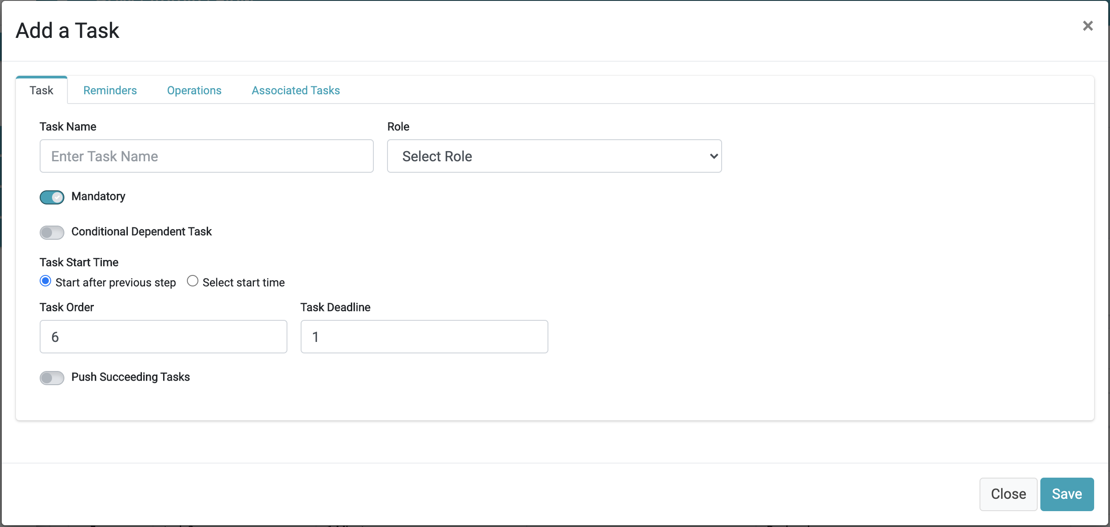

Figure 12. Task tab

The following table details the options for the Task tab:

|  |  |  |
| --- | --- | --- |
| Property | M/O | Description |
| Task Name | M | The Task name identifies the Task throughout the system. |
| Role | M | The defined role of a team representing a group assigned to the Task. For manual Tasks, the Role is assigned to one of the Data Stewards’ group. For automatic Tasks, the DPM system informs the assigned role when the process fails or the deadline of the Task expired without completing the task. |
| Mandatory | M | A Task indicated as mandatory signifies the associated flow will not proceed until this Task is completed.  If the “Mandatory” property is not marked and the Task deadline is reached, the flow continues even if the Task has not been completed. In this case, the system marks the Task as “waived”. If there are no further Tasks in the Request, the Request is marked as “completed”. |
| Task Start Time | M | This property defines when the next task in the flow should be started. There are two options: Start the task immediately after the preceding task has completed or start the task as defined by the configurable time lag, described next.  The time lag configuration:  A screenshot of a cell phone  Description automatically generated  The configuration depends on the selected time unit:  If “hour” is selected, the user defines the minute the task starts. Once the preceding task has completed, this task will start in the defined minute of the following hour.  If “day” was selected then the hour of the day is defined.  The configuration of other time unit choices of “week”, “month” and “year” follow the same logic. |
| Task Order | O | Task Order defines the execution of the task within its Stage. Tasks to be executed in parallel are assigned to the same order number. The default value is 1. |
| Task Deadline | M | The task deadline defines the maximum time the task is expected to complete. If the task execution exceeds this deadline, the task is defined as “past due”.  If a Task reaches its Deadline, an email is sent to the e-mail address registered for the Role of the task. The configuration of the e-mail used for this purpose is set in the Role Management screen of the Admin module. |
| Push Succeeding Tasks | O | This property relates to the overall order definitions of the tasks in the Stage. It is useful when creating a new Task in an already existing Stage and configuring this new Task to be executed before Tasks that were previously defined (given “push succeeding Tasks” is switched on), or without changing the other tasks (whereby “push succeeding Tasks” is switched off).  When a task is defined to an order number already assigned to another Task, then the “push succeeding Tasks” property defines whether to push the task with the same order to be set to *after* the new task (pushing succeeding tasks as well), or, to only add the new Task to the same order as existing Tasks. |
| Conditional Dependent Task | O | When a task is marked as “Conditional Dependent Task”, the task is dependent on a previous task and should be executed only if the task it depends on was not completed within the predefined time period. When this property is switched to “on”, the DPM will prompt the user to define the Task it depends upon and after how many hours from the parent Task start execution, the dependent Task begins.  The parent Task can be any other task from the same Stage.  This property is presented only if there is more than one Task in the current Stage. When this property is switched “on”, the property of “order” and “Deadline” are not relevant. Instead, the user should populate two additional properties: “Conditional Parent Task” and: Start Task After X Hours” (See details in next section). |

Conditional Dependent Task:

When “Conditional Dependent Task” is switched on, the Tasks tab changes to display the properties to be configured in this case:

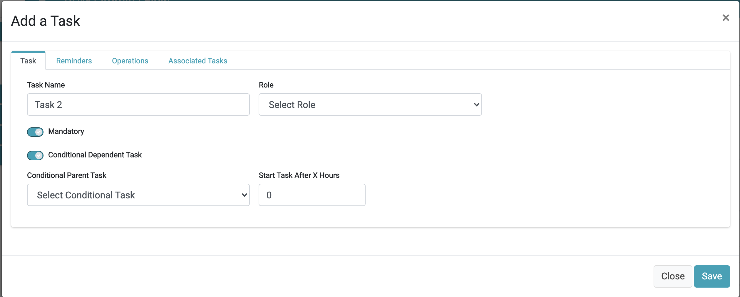

Figure 13. Task Configuration - Task tab

The additional properties that can be configured when the “Conditional Dependent Task is switched on are described as follows.

|  |  |  |
| --- | --- | --- |
| Property | M/O | Description |
| Conditional Parent Task | M | This property is presented only when the Conditional Dependent Task is switched on. It defines the parent Task that this current Task depends upon. It can be any other task from the same Stage that precedes the dependent task. |
| Start Task After X Hours | M | This property is shown only when the Conditional Dependent Task is switched on. It indicates after how many hours should the dependent Task begin following the parent task start time. |

When a Flow including a conditional Task is executed, the conditional Task will only be executed if the Task it depends on has been “in progress” for a longer duration than is defined for the conditional Task to start. If the parent Task was completed before the determined duration, then the conditional Task is marked as “skipped” and is not executed.

##### “Reminders” Tab

Reminders are used in order to preemptively call attention to Tasks that might not be progressing at the expected pace.

In the Reminders tab, the user can define one or more reminders that should be sent after a predetermined time.

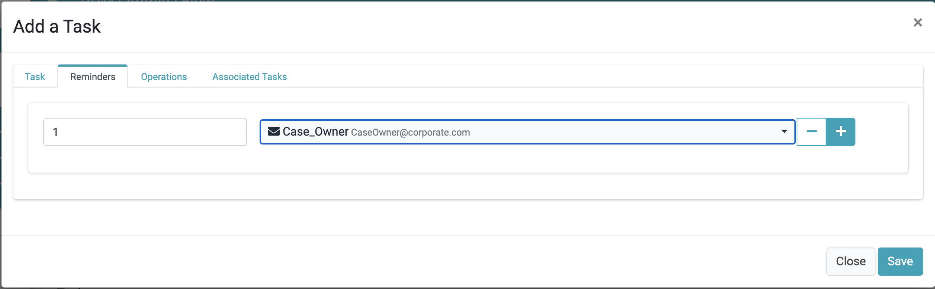

Figure 14. Task Configuration - Reminders tab

Use the  control in order to add more than one reminder or remove a reminder.

|  |  |  |
| --- | --- | --- |
| Property | M/O | Description |
| Reminder timing | M | Defines how many hours after the Task had started a reminder be sent. The reminder mail is sent only if by the reminder set time the task was not completed. |
| Reminder Audience | M | Defines to whom the reminder should be sent. The reminder can be sent to the email address of either one of the Roles, or to one of the users that are defined in the system.  In the dropdown, only roles and users that have configured an email are included |

Reminders are always sent to the current email of the user or Role. This means that if the email of a user or Role is changed, reminders generated by the DPM system from that point on will be sent to the new email address.

The email addresses used by the Reminders can be configured by the Administrator in the Role Management and User Management screens.

In addition to the reminders that are configured in this tab, the system also has an automatic reminder that is sent if the Task reaches its deadline and has not completed. This automatic Reminder email is sent to the email address of the “Task Owner” (configured in the “Task” tab). As this is an automatic email, there is no need to configure a Reminder explicitly for this purpose.

##### “Operations” Tab

The Operations tab allows the Admin to add an automated Activity to be executed to perform the Task.

The user selects an Operation from the operation dropdown list. As a result, the list of parameters to be defined for the selected Operation is dynamically presented in the “inputs” section of the tab. Some operations may not need any parameters.

As an example, for a Task that should execute the Operation “SendMail” the system expects the parameters “Message”, “Subject” and “to” as configured items.

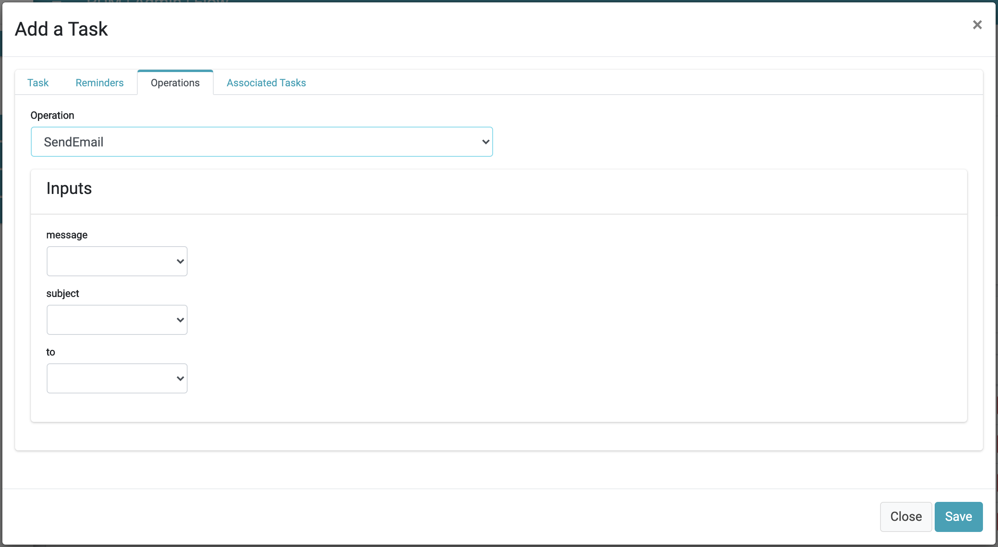

Figure 15. Task Configuration - Operations tab

**Configuring operation’s parameters:**

When an operation requires the configuration of one or more parameters, the value of those parameters can be defined in several different ways. Each parameter can be one of the following types:

* Value
* Link
* Input

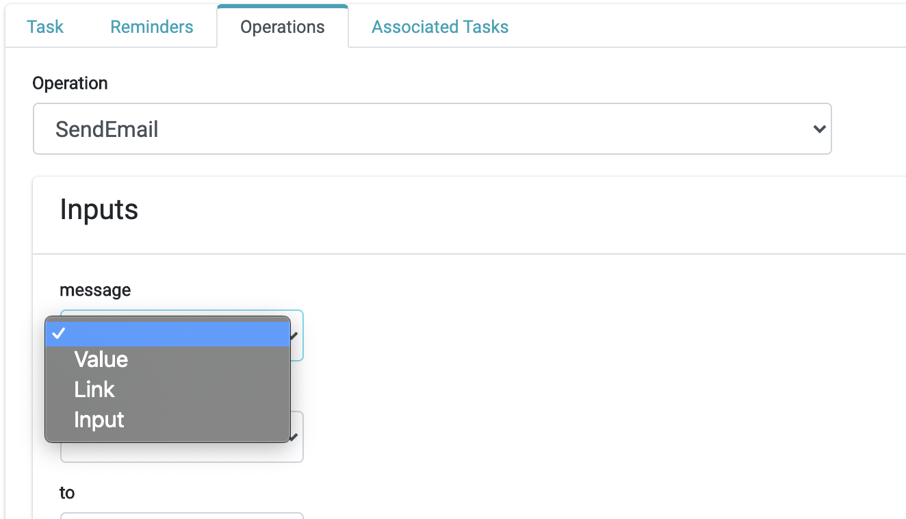

Figure 16. Operation Parameters Types

Each of those types allows the user to define a different way to obtain information needed for the execution of the operation. The following table describes the available options:

|  |  |
| --- | --- |
| Input Type | Description |
| Value | This input option is used when the value to be used is a fixed value for the given operation. It refers to a known value at the time of the Task configuration and does not depend on the customer that makes the request.  The value should be specified in the “value” field that the system presents to the user when this option is selected. |
| Link | This option enables the use of a value determined as a result of the execution of a previous Task. The previous Task can be derived from the same Stage of the current Task or from any of the previous Stages of the Flow. When selecting this option, the system enables the user to define the Stage, Task and Task-output to be used. |
| Input | Use the “input” option when the Task requires a specific input from the user at the moment of opening a new DPM Request.  The system requires the user to define the label of the field that the user will be requested to fill.  When a new DPM Request is submitted by a representative or customer, the system will present to the user the list of parameters that were defined as “input” and the label defined here appears as the label of the field that should be populated.  For example, when the input parameter is the email address of the customer, the label can be defined to be “email address” or “Please provide your email address”. |

The following image demonstrates the information the DPM requests the Administrator to fill for each input option.

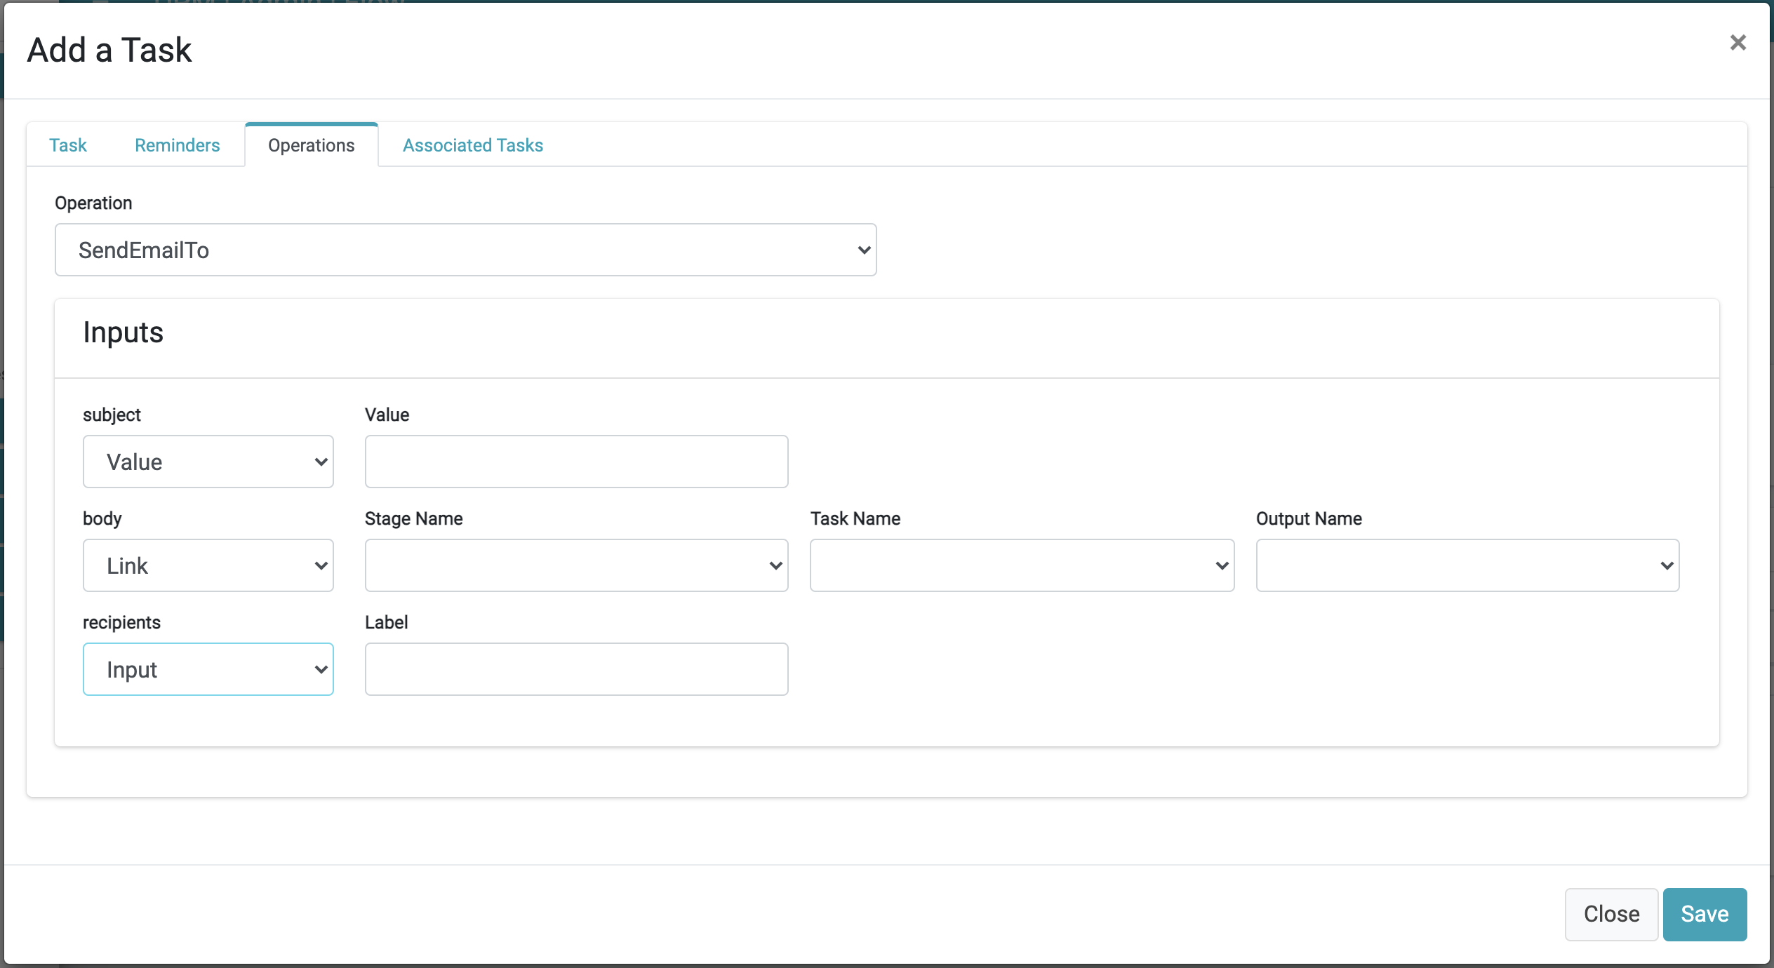

Figure 17. Task Operation - the data to be configured for each input option

In this example of an operation that sends emails, three input parameters are required: Subject, Body and Recipients. To demonstrate the different types of input types, each of those three fields was defined as one of the three types:

* The field “Subject” was defined as “**Value**”, meaning the administrator can define a fixed text that will be presented as the subject of the mail. The system presents to the administrator the field where the text should be written
* The field “Body” was defined as “Link”, and as a result the system presents to the administrator the fields Stage Name, Task Name and Output Name. The administrator can define from which previous Task the information for this field is to be received.
* The field “Recipients” was defined as “input”, meaning the customer will be requested to provide this value at the moment of submitting a request. The system presents to the administrator the field “Label”, which defines the text that will be presented to the customer so he will know to provide the recipient email address.

### Regulations and Activities

The Regulation menu option is used to define and maintain the list of Privacy-related Regulations handled by the DPM system and the Activities for each included Regulation.

Click the Regulations List option from the menu to access the list of Regulations.

#### Regulations List

The Regulations screen displays the list of Data Privacy Regulations the company is committed for compliance.

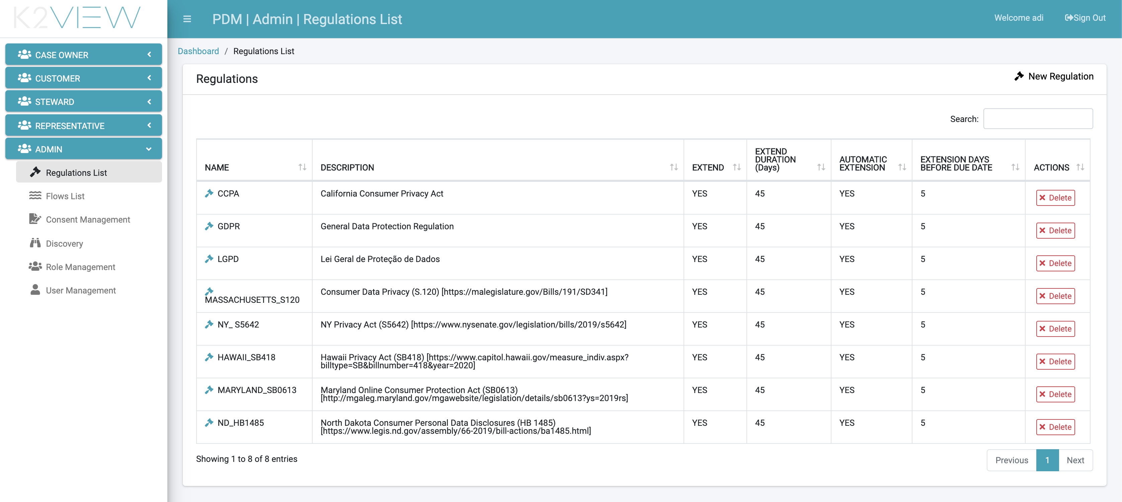

Figure 18. Regulations List

From this screen, the user can:

* View the details of a specific regulation by clicking the line of this regulation.
* Add a Regulation by clicking the “New Regulation” button, or by using the left bar menu option.
* Remove a regulation by clicking the remove button under the “Action” column.

#### View Regulation Details

When selecting a regulation, a screen is displayed showing the list of Activities defined by this regulation.

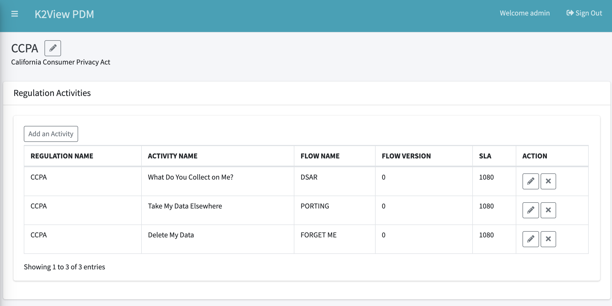

Figure 19. Activity List for a Regulation

In this screen the user can:

* View the list of Activities for the selected Regulation. For each Activity, the high-level information about the Activity is presented, including the name of the Flow used to fulfill the Activity, the version of this flow in use, and the SLA of this Activity, indicated by the number of hours.
* Access the “Edit Activity” screen for the selected Activity, or remove the selected Activity, by using the corresponding “Edit” and “Delete” icons under the “Action” column.
* Add an Activity, using the button on the upper left side of the table.
* Edit the Regulation name and description by using the Edit icon next to the regulation name.

### Activity Details

When one of the lines in the Activities table is selected, or, by using the “Edit” icon, the system displays the “Edit Activity” pop-up screen.

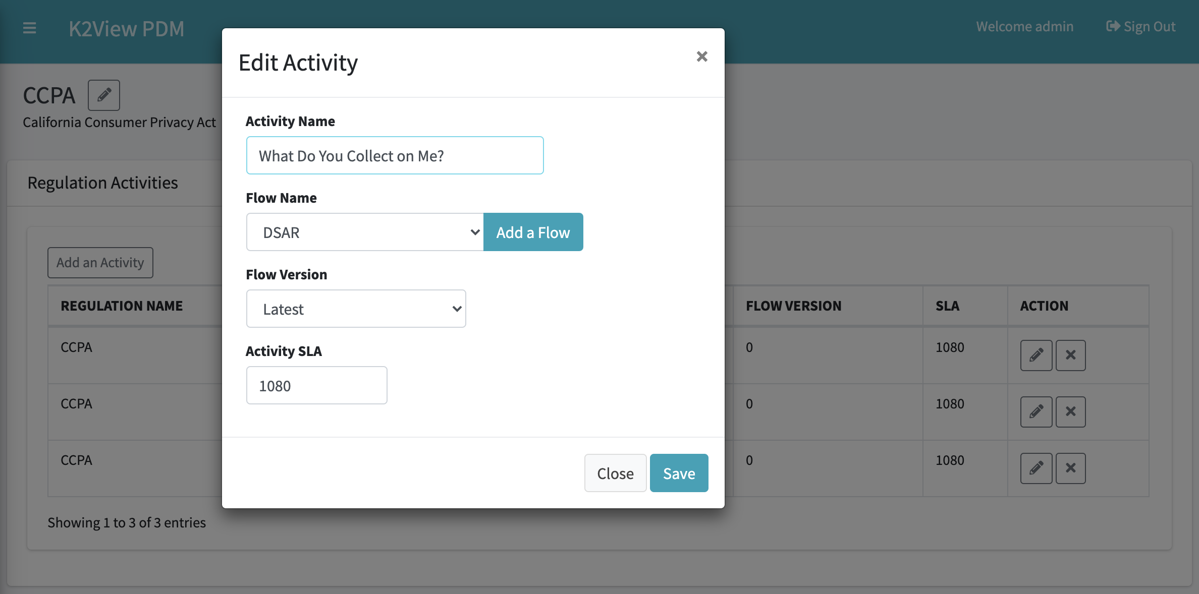

Figure 20. Edit Activity

From this screen, the user can:

* Change the name of the Activity.
* Change the flow used to fulfill the request. This is accomplished by selecting one of the finalized flows from the drop-down list of available flows.
* Add a new flow by selecting the “Add a Flow” button. The “Create a new flow” screen is displayed.
* Update the flow version. If the option “latest” is selected, then each time a new version of the selected flow is marked as “finalized,” the Activity is automatically updated to use this latest flow.
* Update the Activity SLA, in hours.

Any update performed on the Activity impacts only requests from the update moment forward. Requests that were already submitted will maintain the previous parameters.

### Add an Activity

In order to add a new Activity to a Regulation, select the Regulation from the Regulation screen, and then click the “Add an Activity” button on the “Regulation Activities” screen.

The pop-up screen presented is the same as the one used for “Edit an Activity”.

## Roles Management

### Overview

The DPM is a role-based application. Each user is associated with one or more roles. The role determines the Activities the user can perform in the system.

The roles are structured in two layers:

* DPM Application Roles – each application role includes a set of DPM functionality a user can perform.
* Corporate Roles – Configurable roles defined by the corporation to represent the corporate organizational structure for DPM users. Each user to take part in one of the DPM Activities is first assigned to a Corporate role.

For a user to be able to perform a specific action in the DPM, the user is assigned to a Corporate Role that has enabled the Application Role where the Activity is included.

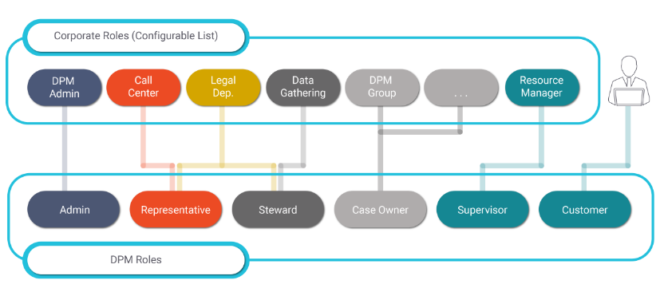

Figure 21. Corporate and DPM Roles

Upon login, the system identifies the user’s corporate role and the associated DPM Application Role. The user is granted access only to the functionality defined for their role.

The Admin module allows the DPM Administrator to define the relationship between users, corporate defined roles and the functions assumed in the DPM system.

### DPM Roles

#### Overview

The DPM roles define the functions within the DPM which are enabled for each user:

* **Admin users**: Admin users are responsible to configure the flows to be executed for each Data Subject Request. An Admin user can perform all the Activities that are a part of the Admin module, such as:
  + Define Regulation and the included Activities.
  + Create or update flows, including their stages and tasks.
  + Manage corporate roles and assign users to corporate roles.
  + Map between corporate roles and the DPM functions.
* **Customer Service Representative (CSR)**: a CSR is a call center representative attending customer requests by submitting a Data Privacy related request on their behalf. A CSR can:
  + Submit a new request.
  + Review the details of an existing request, without changing its details.
* **Data Steward**: data stewards are users made a part of the Request fulfilment process and are responsible to execute a specific task in the request flow. The Data Steward can:
  + View the list of open tasks to be handled by the group this Steward is a part of.
  + Mark a task as assigned to themselves to avoid other stewards from working on the same task.
  + Review, Update, or Approve a task to move it to the next step
  + Release a task that is assigned to the data steward.
* **Case Owner**:
  + Each customer request submitted in the DPM is assigned to a specific case owner. The case owner follows up on the request progress and assures the request is completed within the expected SLA. A case owner can:
    - View the list of, and filter requests, to identify risks of not completing the request within the timeline stated by the SLA.
    - Open a specific request and view or complete its tasks within its stages.
* **Supervisor**: The supervisor is responsible to manage the allocation of requests to the case owners. The supervisor can:
  + Access the dashboard to see the summary view for all requests.
  + Define the criteria for the allocation of requests to Case owners.
* **Customer**: Data Subject Requests can be submitted directly by a customer. A customer can:
  + Create a new request
  + Search for their requests
  + Check the status of their requests
  + Review the data provided as an output of a completed request

The DPM roles are predefined in the system. Each role includes a designated set of screens and actions relevant for this role. DPM roles are used by the Administrator to grant a specific corporate group the ability to view or execute actions in the DPM system. The way those roles are used is explained in the next section about the Corporate roles.

### Corporate Roles

#### Overview

Corporate Roles represent the roles defined by the company. Such roles represent the different groups that take part in the DPM processes. Corporate roles are fully configurable, and each corporation defines roles according to its own organizational structure.

Corporate roles are configured by the DPM Administrator by accessing the Role Management menu option.

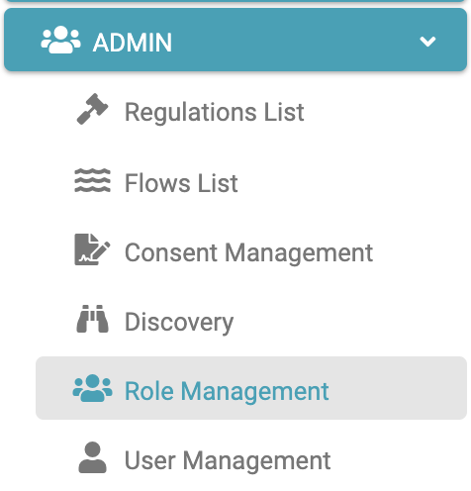

Figure 22. Role Management Menu

The “Corporate Roles” screen displays the list of the corporate roles.

When selecting one of the corporate roles, the right side of the screen displays the DPM Application Roles that are enabled for this Corporate Role.

For example – A user belongs to the “Legal Fulfilment” group and is responsible to work on Tasks as part of the fulfilment process. Performing a Task is defined as part of the Steward Application Roles. So, for the user to perform a Task, the DPM Administrator acts to:

1. Create a Corporate Role to represent the Legal team, called “Legal”, as shown by the following example
2. Mark this Role to perform the actions grouped under the “Steward” DPM Application Role (on the right side of the screen).
3. Assign the user to the corporate Role “Legal” (user management is detailed in the next section).

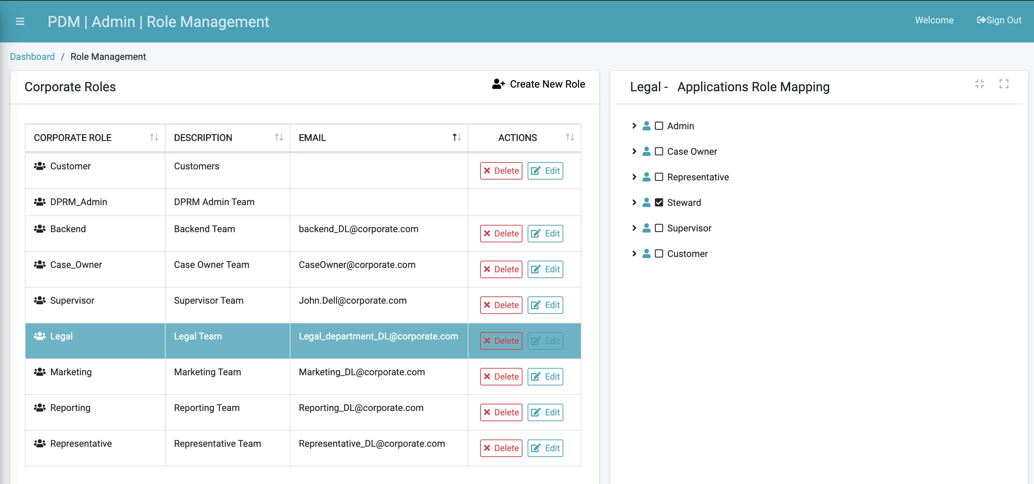

Figure 23. Corporate Role Management

If a more detailed authorization definition is required, the Administrator can expand the options displayed under the selected Application Role, and specify with more details those actions the users from this corporate role can perform:

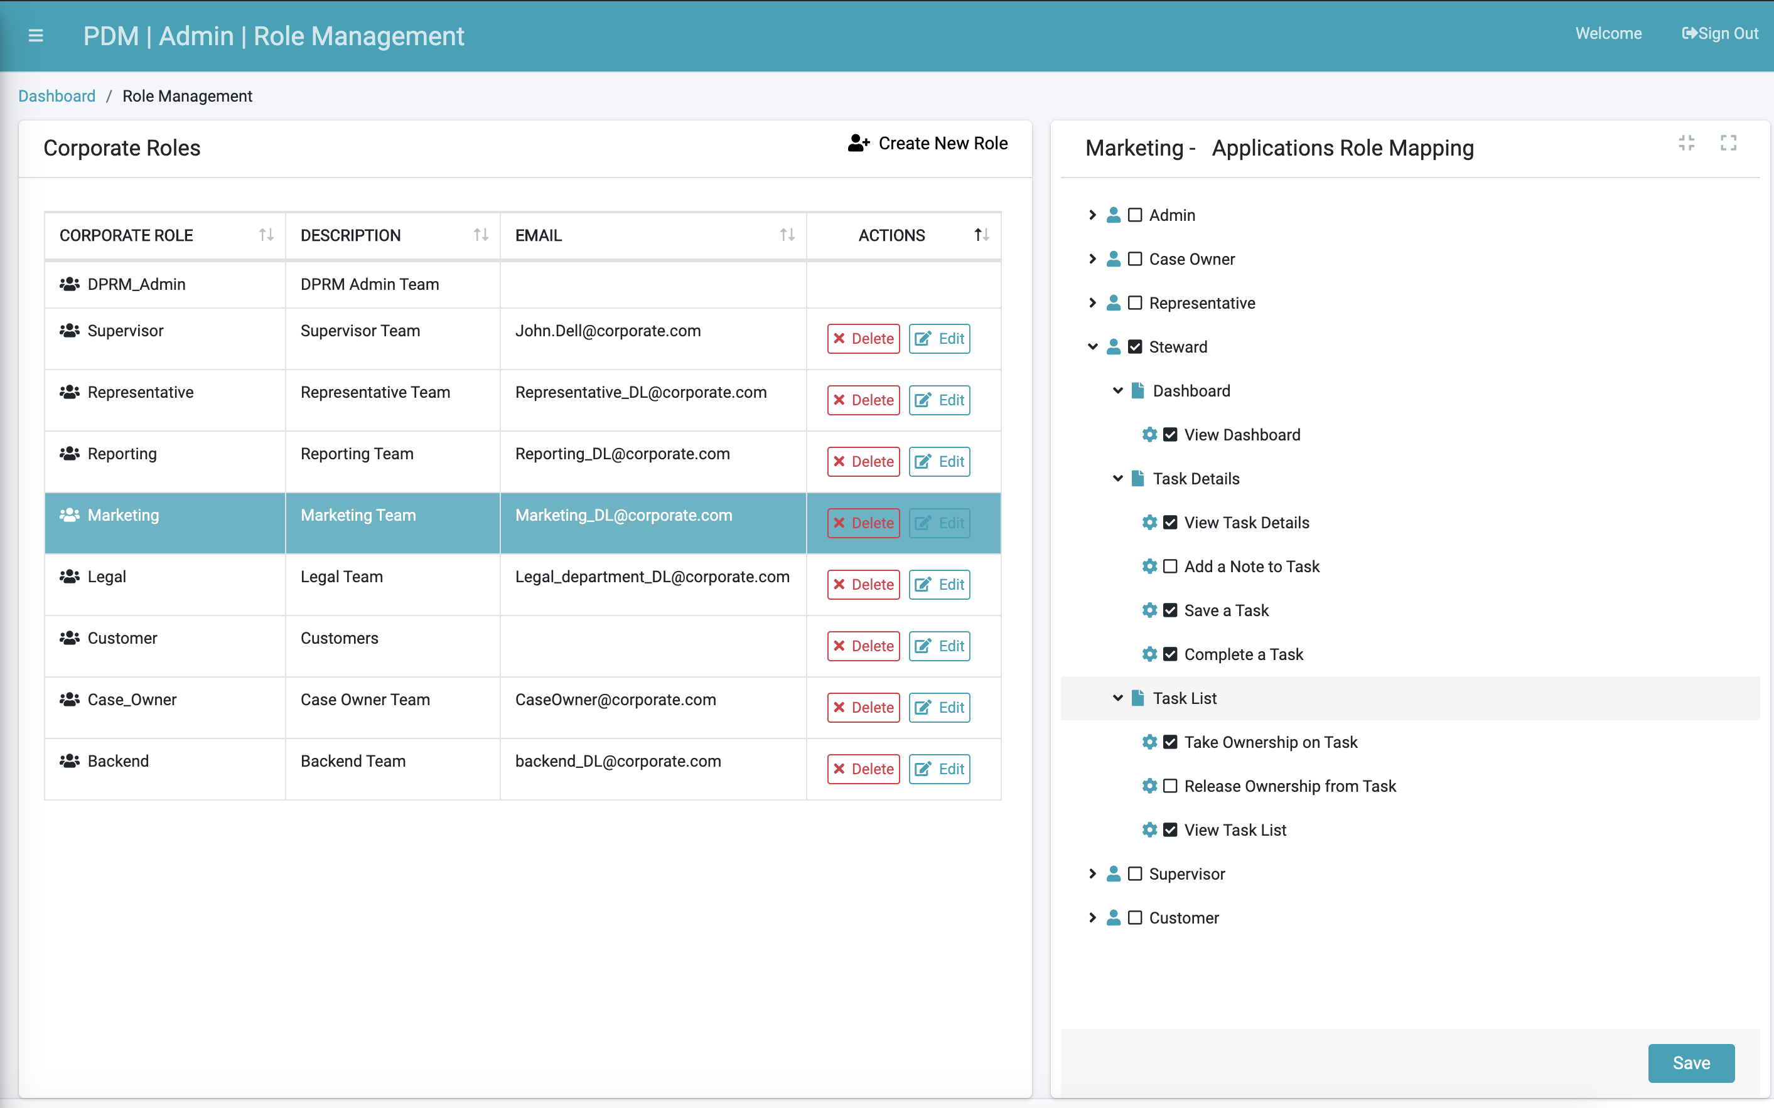

Figure 24. Detailed Authorization Configuration

In the preceding screen example, the Corporate Role called “Marketing” was assigned the “Steward” Application Role but will not be allowed to add a note to a Task or Release Ownership of a Task.

Each Corporate Role can have multiple Application Roles enabled. This means that the users assigned to such a Corporate Role will be able to perform actions or view information defined as part of all of the enabled Application Roles.

The main menu on the left side of the screen is constructed based on the list of Application Roles that are enabled for the Corporate Roles to which the user belongs. See more details about the menu options presented to each user in the DPM Main Menu section following.

#### Add a New Corporate Role

To create a new Corporate Role, use the  option at the top of the Role Management screen.

The “New Corporate Role” screen is displayed:

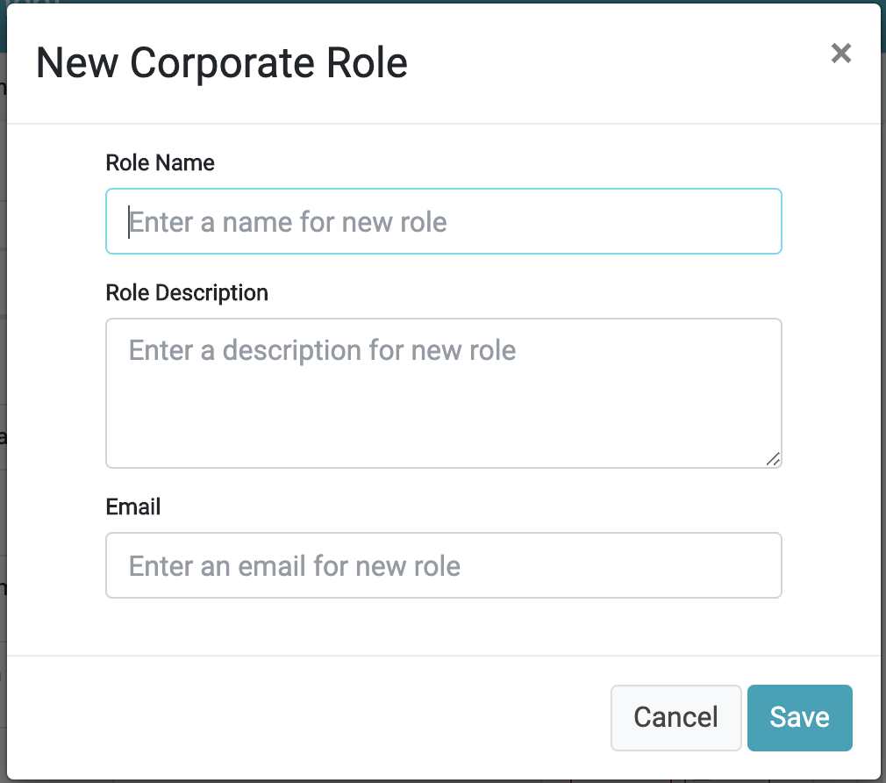

Figure 25. New Corporate Role

|  |  |  |
| --- | --- | --- |
| Property | M/O | Description |
| Role Name | M | The Corporate Role name. |
| Role Description | O | The Corporate Role description. |
| Email | O | The email or distribution list name for the corporate role. This email address is used when a Task reminder is configured and the user selects the corporate role as the reminder target email. |

Once the user completed and saved the new Corporate Role, the new Role appears in the list of roles at the center of the screen.

#### Mapping a Configuration Role to an Application Role

The next step after creating a Corporate Role is to define the mapping to GDPR Application Roles assigned to it, and under each Application Role, what screens and actions this Corporate Role can view or perform.

In order to perform this configuration:

1. Select the Corporate Role line on the central part of the screen. As a result, the right side of the screen presents a tree of options allow the mapping to the application roles available to the group.
2. Define the configuration by checking or unchecking the box options from this tree.
3. Save the configuration using the “Save” button at the bottom of the screen.

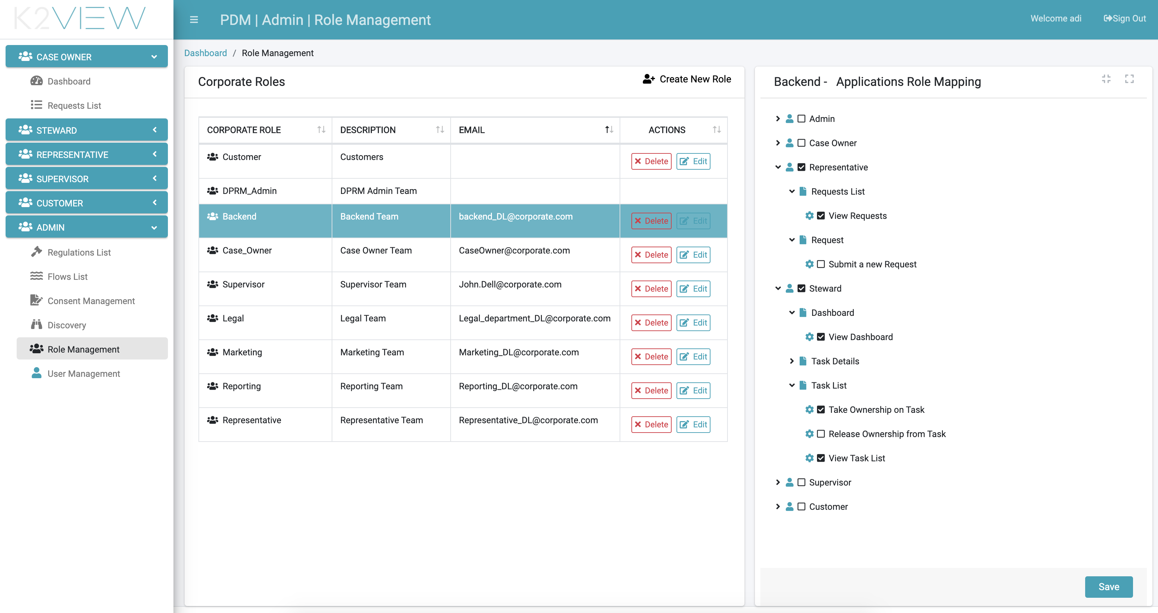

Figure 26. Corporate Role Permissions Configuration

In the example above, the “Backend” Corporate Role is selected from the list of Corporate Roles. The right side of the screen presents the mapping of this “Backend” Corporate Role to the list of related Application Roles.

At the highest level (first level of the tree), the checkboxes of “Representative” and “Steward” are checked. This means that the “Backend” Corporate Role is configured to have the functionality of the roles of Representative and Steward. A user that belongs to the “Backend” Corporate Role will have only those two options on the main menu on the left side of the screen (more about that in the Main Menu section).

As observed, the permissions tree has multiple levels, which allow control of the Activities the user can or cannot perform. For example, from the preceding screen, the option “Submit a new Request” under the “Representative” branch was unchecked. This means that though the users will have the option to use Representative functionality, such as View the request list, or view a specific request, they will not be able to submit a new request.

#### Edit or Delete a Corporate Role

Use the 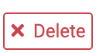 button to delete a Corporate Role. The deletion of the Role removes it from all users to which it was assigned.

Use the  button to edit the Email address of a Corporate Role.

### Managing Users in the Admin Module

For a person to access and perform Activities in the DPM, the user must be defined for this person in the DPM system, and this user should have a Corporate Role assigned to it.

The authorized user selects User Management menu option under the Admin menu to manage users and privileges for the DPM system.

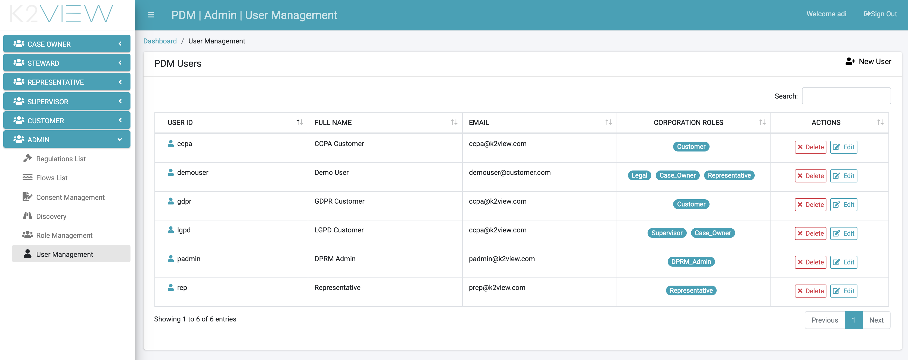

Figure 27. User Management

The list of existing users is displayed. For each user, the user ID, username and email are shown. In the Corporate Role column, the list of Corporate Roles assigned to this user is displayed. Each user can have multiple Corporate Roles, and the functionality assigned to the user reflects the sum of all options enabled under each assigned role.

#### Create a New User

Use the  button to add a user to the system. “Create New User” screen is displayed.

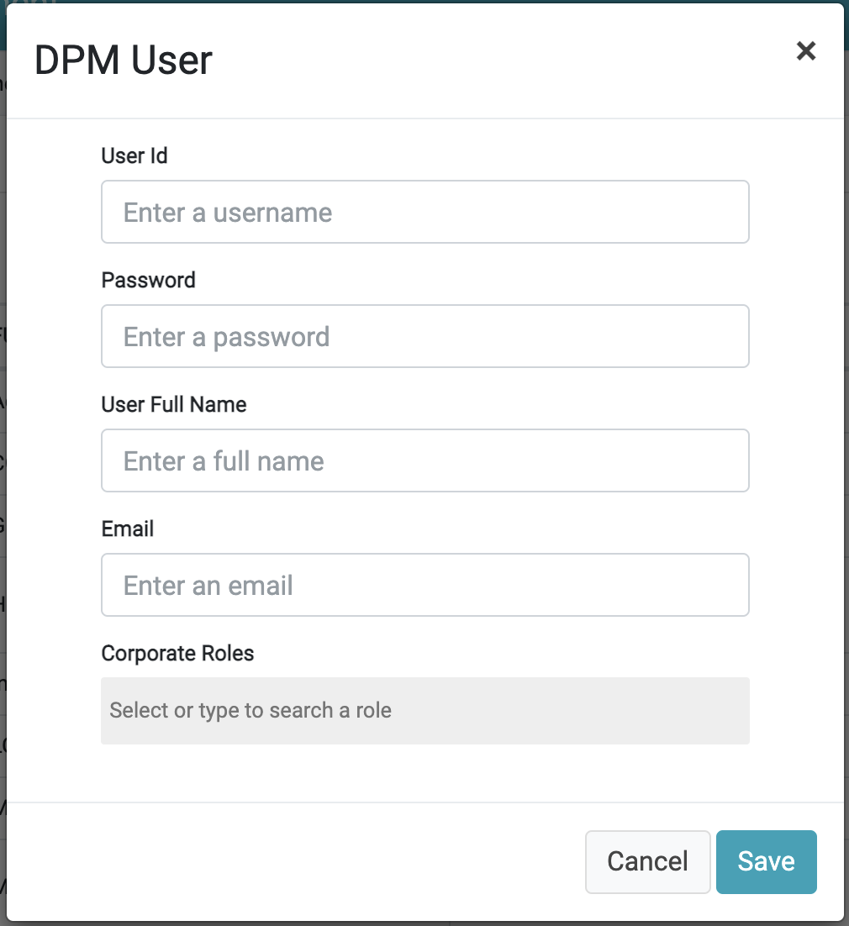

Figure 28. New User screen

|  |  |  |
| --- | --- | --- |
| Property | M/O | Description |
| Username | M | The distinct name for the user. |
| Password | M | Defines the user-directed secure characters to log in to the system. This field is displayed only on the new user screen. |
| User Full Name | M | The name this user is to be represented in the system. |
| Email | O | The email of the user. The email address is used when a Task reminder is configured and the user selects the target user to receive the task reminder email. |
| Corporate Roles | O | This field allows the user to select from available roles to assign to the user. |

#### Edit or Delete a User

Use the  button to delete a User.

Use the  button to edit the name, email address and Corporate Roles assigned to a User.

### DPM Main Menu

The DPM Main Menu is the starting point for every user action. The Main Menu is located on the left side of the K2View screen. The main menu options represent the different DPM Application Roles, including: Representative, Case Owner, Supervisor, Steward, Customer and Admin.

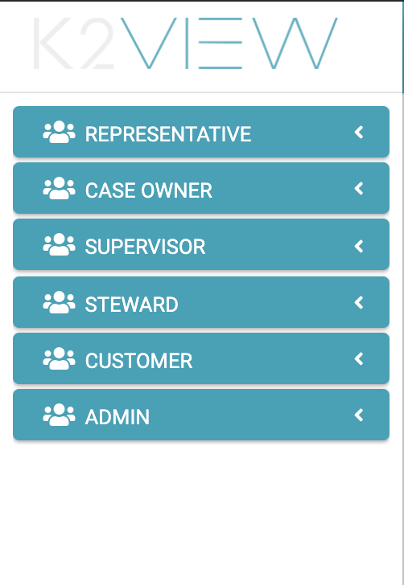

Figure 29. K2View Main Menu

Each user sees only the Application Roles enabled to their defined Corporate Role. The options presented to each user depend on the DPM Application roles granted to that user:

* Each Corporate Role can have multiple Application Roles assigned to it (see the Role Management section).
* Each user is assigned one or more Corporate Roles (see the User Management section).
* The DPM system identifies the list of DPM application Roles enabled for each Corporate Role assigned to the user and builds the list of Main Menu options accordingly.

For example, a user is assigned two corporate Roles:

* Corporate Role that has the “Steward” Application Role assigned to it
* Corporate Role that has the “Case Owner” Application Role assigned to it

The Main Menu items displayed to this user are both the Steward and the Case Owner menus.

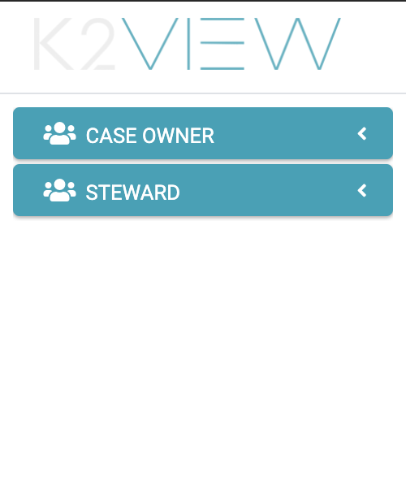

Figure 30. Main Menu with Two Menu Items

The order by which the roles are listed in the menu reflects the same order of the roles as they appear to this user in the role assignment field.

# Representative User Interface

A Customer Service Representative (CSR) that supports the DPM processes should be user assigned to a corporate role mapped to the Representative DPM Application role.

A Representative can:

* Search for previously submitted Requests
* Submit a new Request

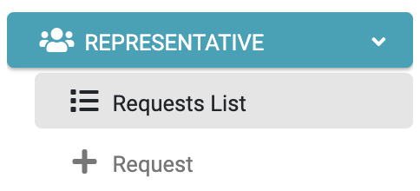

Figure 31. Representative Menu

### Search a Request

Search a request from the Representative menu by selecting the “Requests List” menu option. The displayed screen includes the list of existing requests and allows searching for a specific request based on multiple parameters.

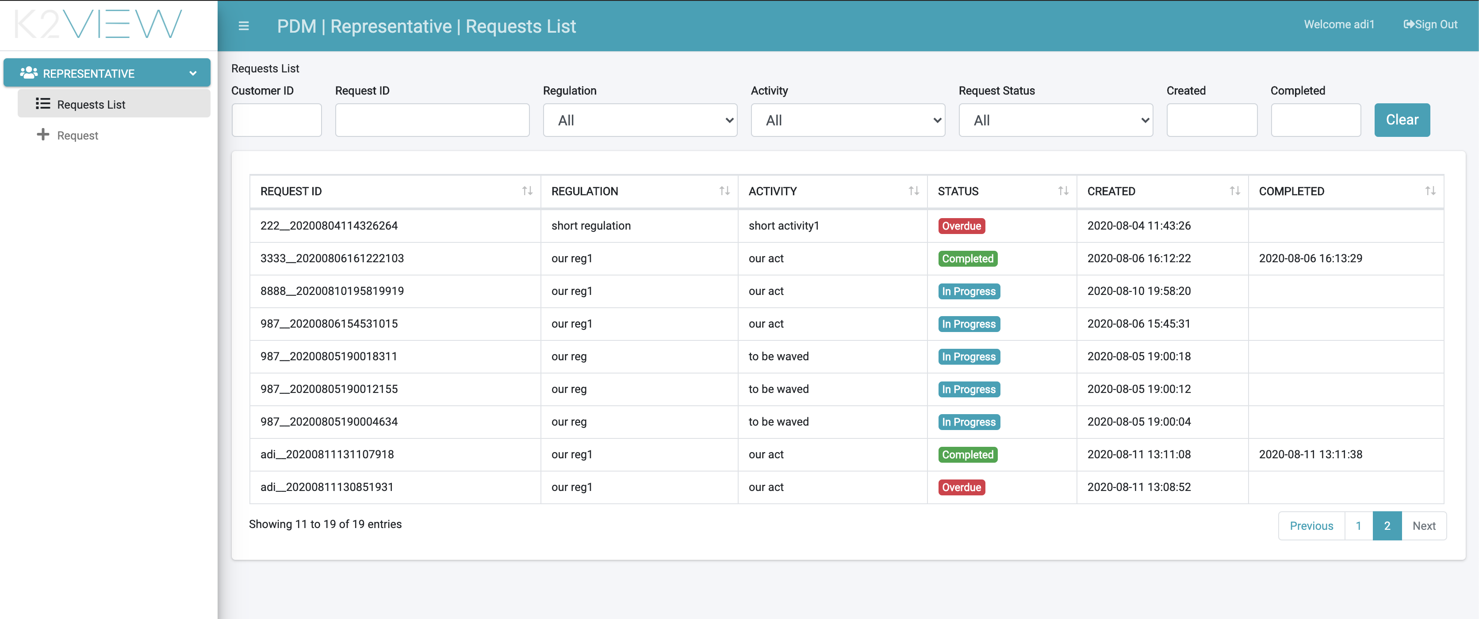

Figure 32. Representative Search Request

|  |  |
| --- | --- |
| Column | Description |
| Request ID | The unique identification of the request. |
| Regulation | The Regulation for which this request was created. |
| Activity | The Activity this Request executes. |
| Status | The Request status. Values may be: In Progress, Completed, Stopped. A Stopped Request is a Request, during its execution the system identified it should stop the request execution. For example, if there is a validation, the same customer cannot open two equal Requests, and there is already an in-progress Request for this same customer and Activity. |
| Created | The date and time that the Request was submitted. |
| Completed | The date and time that the Request was completed (completed requests only). |

For the search criteria selected by a drop-down list or by selecting a date: Regulation, Activity, Request Status, Created and Completed – the search is executed upon a value selected.

For the search criteria entry fields Customer ID and Request ID: typing in either the customer ID and Request ID, the search is invoked upon the first three stated characters or more.

Once the search results are presented, the representative can view further details of a specific request by clicking the row of this request:

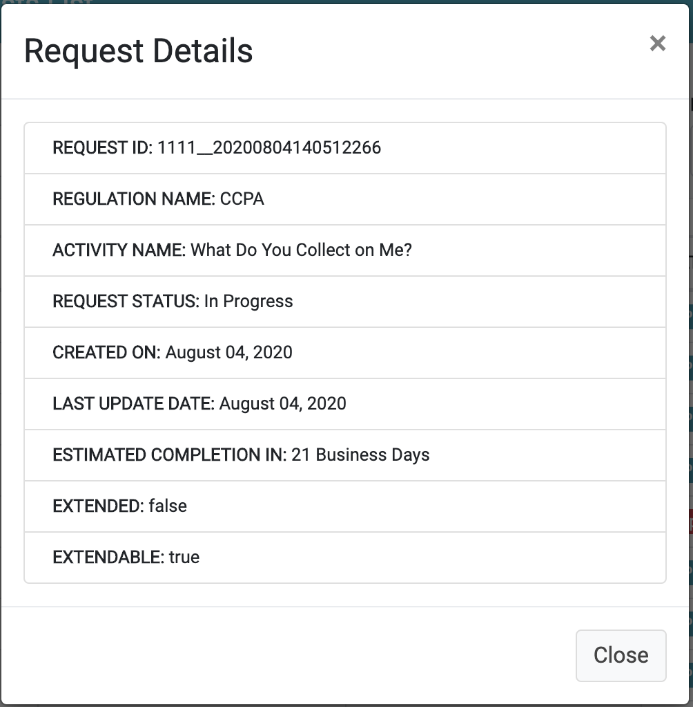

Figure 33. Request Details

|  |  |
| --- | --- |
| Field | Description |
| Request ID | The unique identification of the request. |
| Regulation name | The Regulation for which the request was created. |
| Activity name | The Activity this Request executes. |
| Request Status | The Request status. |
| Created on | The date and time the Request was submitted. |
| Last Update Date | The last time this request was updated. The Request is updated as its execution is progressing – so this date indicates the last date that a Task was executed in the Flow fulfilling this Request. |
| Estimated completion in | The number of days the request is expected to complete. The number of days calculation is based on the Request creation date and the Activity SLA. |
| Extended | Indicates if the Request SLA was extended. The values are true/false |
| Extendable | Indicates if the Request SLA can be extended. This depends on the configuration of the Activity of this task. |

### Submit a Request

A representative can submit a request on behalf of a customer, using the “Submit a Request” button located on the search screen, or by using the menu on the left. The list of requests by type and the information to be provided for each of request, is defined by implementation using the Admin module.

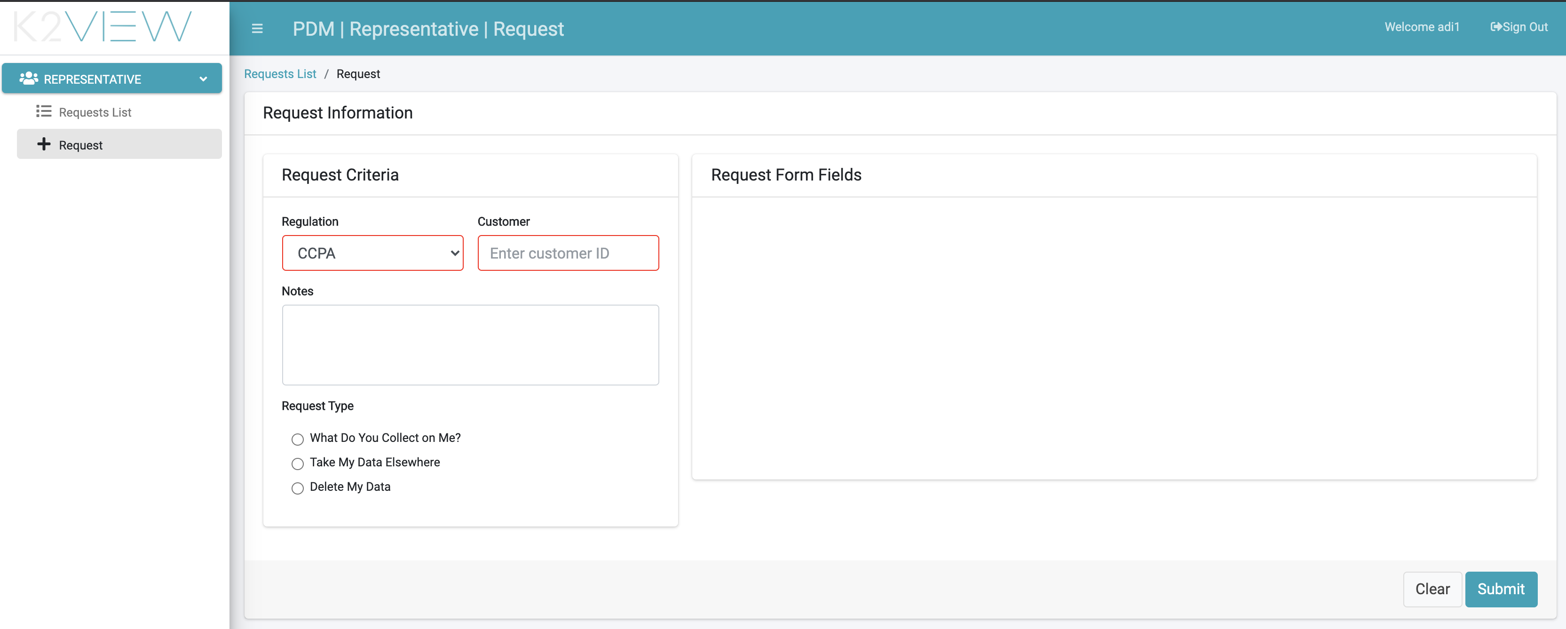

Figure 34. Representative Submits a New Request

When submitting a new request, the representative first selects the applicable regulation to the customer from the Regulation dropdown list and enters the customer number in the Customer field.

The representative can add notes to the Request before submission.

The list of Request Types displayed at the bottom of the submission form changes according to the selected Regulation.

Once the Request type is selected, the right side of the form displays the list of fields to be completed before submitting the request. This list is automatically correlated with the Request type.

|  |  |
| --- | --- |
| Field | Description |
| Regulation | The Regulation applicable to the customer. |
| Customer | The customer identification requesting submission of the request. |
| Notes | Free text. Comments that the representative wish to be registered as part of the request. |
| Request Type | The specific Request to be submitted. The options in this section depend on the selected Regulation. |
| Request Form Fields | Depending on the selected Request Type, different fields are displayed in this section, and the representative should populate them on behalf of the customer. |

# Customer direct Requests

The DPM system provides different ways to allow a customer to submit a DPM request, search for a previously submitted request and view of its details. The DPM:

* includes a built-in user interface for the use of a customer
* provides a set of APIs that can be integrated with the customer portal of each corporation that uses the system.

## DPM Customer’s Built-in User Interface

The DPM includes a set of screens that allow a customer to submit DPM Requests, as well as view request details.

### Customer Dashboard

When a customer logs into the DPM user interface, the first screen displayed is the Customer Dashboard. The Dashboard includes the following items:

* Submit a Request: button used to submit a request.
* My Open Requests: displays the number of requests processing for this customer.
* View Requests: expands to view the list of the customer’s requests.

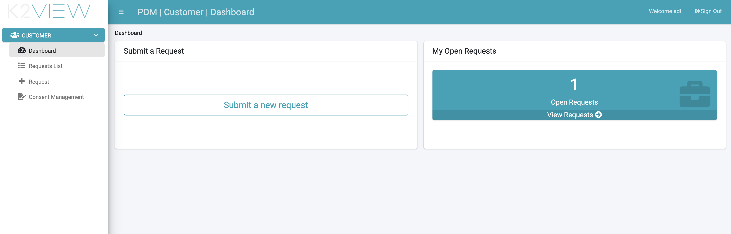

Figure 35. Customer Landing Page

The same options can be reached also from the menu items on the left side of the screen.

### Customer Submits a Request

When a customer selects “New Request”, the system displays the Request Details screen. The list of requests type and the information that should be provided for each of them is defined by implementation using the Admin module.

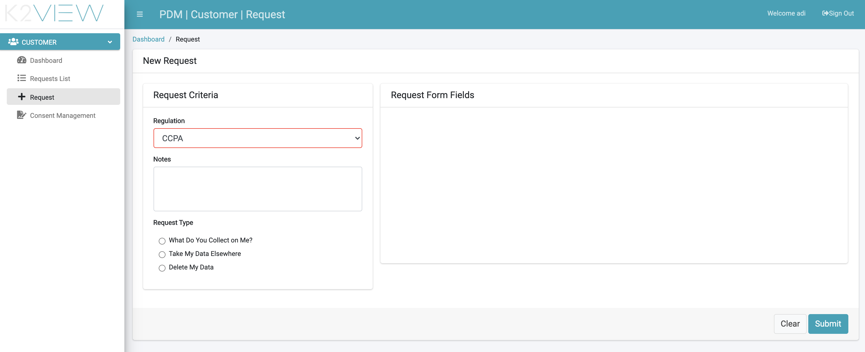

Figure 36. Customer Submits a Request

When submitting a new request, the customer first selects the relevant regulation from the Regulation dropdown list.

The customer can add notes to the Request before submission.

The list of Request Types presented at the bottom of the submission form changes according to the selected Regulation.

Once the Request type is selected, the right side of the form displays the list of fields to be completed before submitting the request. This list is automatically built, in accordance with the Request type.

|  |  |
| --- | --- |
| Field | Description |
| Regulation | The Regulation that applies to the customer asking to submit a request. |
| Notes | Free text. Comments that the customer wishes to be registered with the request. |
| Request Type | The specific Request to be submitted. The options in this section depend on the selected Regulation. |
| Request Form Fields | For the selected Request Type, different fields will be presented in this section, and the customer populates the fields before submitting the request. |

The customer number is not requested when submitting the request, as the customer number or identification is already in place at the customer level.

### Customer View Requests

The customer can view requests by either selecting the “Requests List” menu option, or by selecting the “View Requests” options from the Dashboard.

The requests presented include both completed requests and in-progress requests.

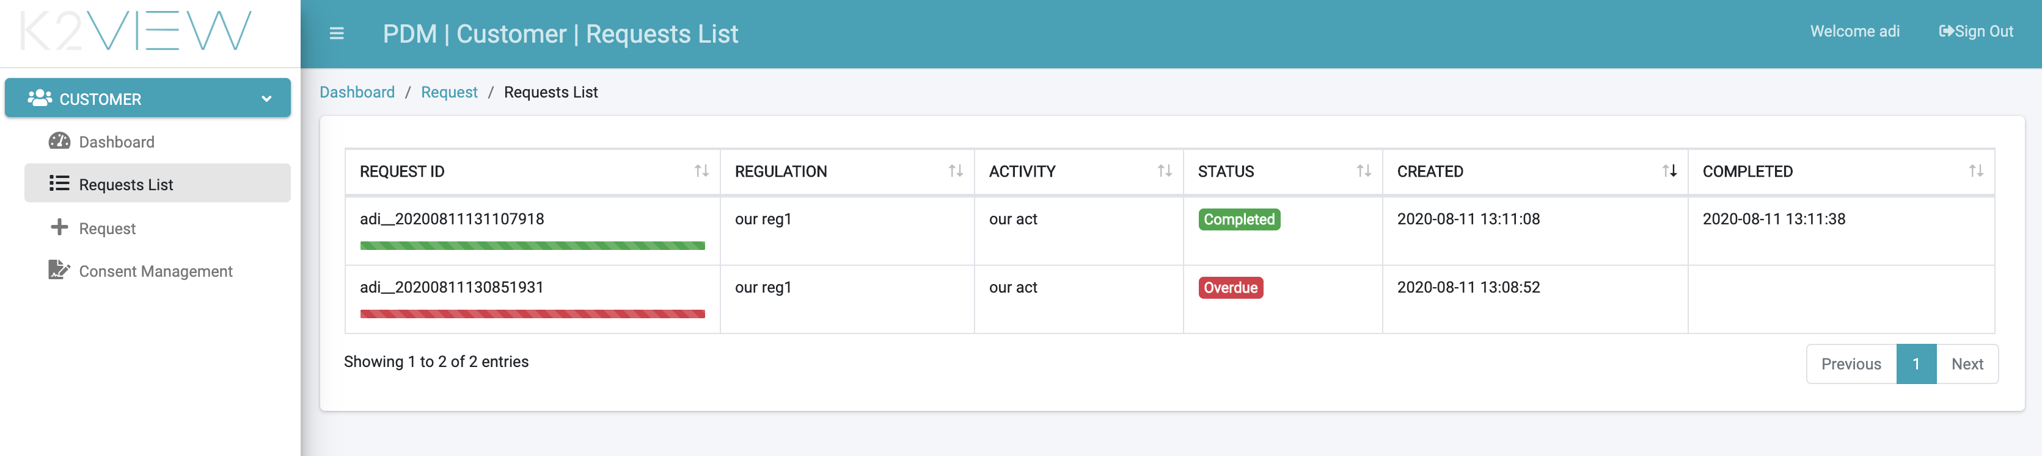

Figure 37. Customer View Requests

|  |  |
| --- | --- |
| Column | Description |
| Request ID | The unique identification of the request.  A progress bar is displayed beneath the Request ID. The progress is calculated based on the Request open date and the SLA for this request. The related bar is displayed in green while the Request is within the SLA period (or extension period). The bar is displayed in red when the Request is overdue. |
| Regulation | The Regulation for which the request was created. |
| Activity | The Activity that this Request executes. |
| Status | The Request status. Status values may be: In Progress, Overdue, Completed, Stopped. A Stopped Request is a Request whereby, during its execution, the system identified it should stop the Request execution. For example, a customer attempts to open a second request that is equal to the first request while the first request is in progress. The validation of such a second request attempt will reject the second request for this reason. The rules and validations that can result in stopping a request are defined by configuration. |
| Created | The date and time the Request was submitted. |
| Completed | The date and time the Request was completed (completed requests only). |

Additional details about a specific request can be viewed by clicking the request row:

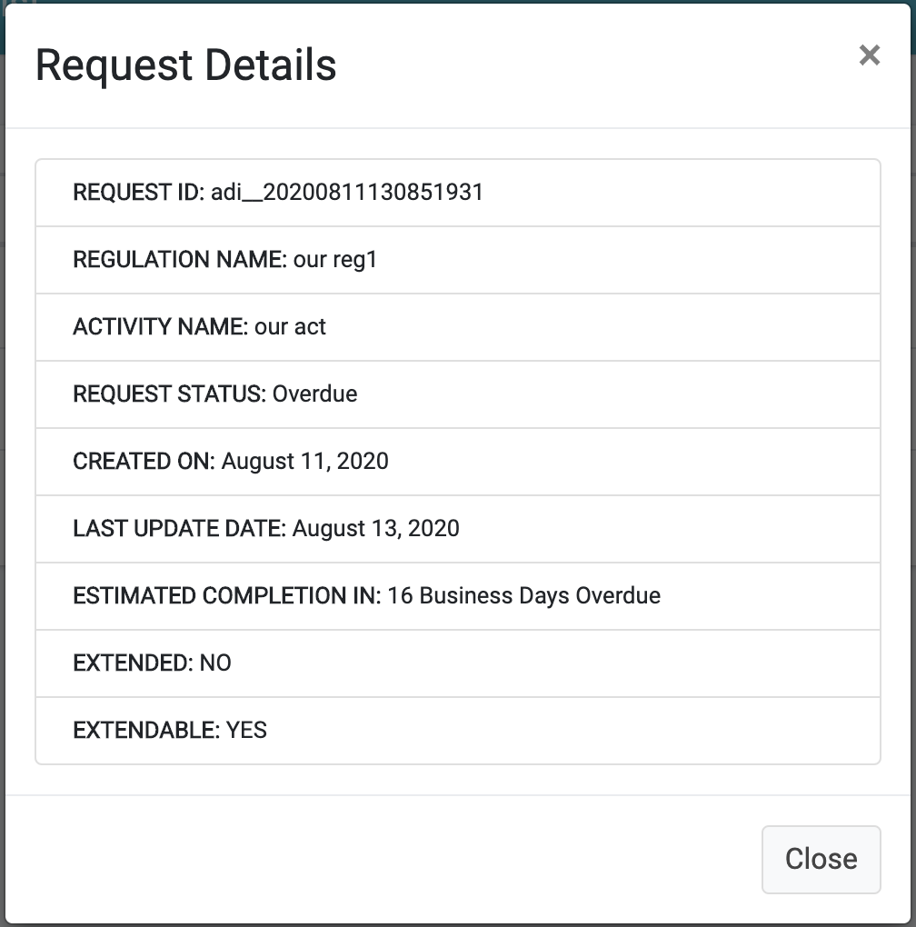

Figure 38. Customer Request Details

|  |  |
| --- | --- |
| Field | Description |
| Request ID | The unique identification of the request. |
| Regulation name | The Regulation for which the request was created. |
| Activity name | The Activity that this Request executes. |
| Request Status | The Request status (i.e., in-progress, completed, etc.). |
| Created on | The date and time that the Request was submitted. |
| Last Update Date | The last time this request was updated. The Request is updated during the progression of its execution – in effect, this date indicates the last date a Task was executed in the Flow fulfilling the Request. |
| Estimated completion in | The number of days the request is expected to be completed. The number of days is based upon the calculation from the Request creation date and the Activity SLA. |
| Extended | Indicates if the Request SLA was extended. The values are true/false. |
| Extendable | Indicates if the Request SLA can be extended. Extendable is dependent upon the configuration of the Activity of this Request. |

## DPM APIs for Customer Requests

For companies that prefer to integrate the DPM requests in their own customer portal using their standard user interface design, DPM provides a set of APIs to be used by any client application.

For detailed documentation of those APIs, access the swagger documentation of the DPM system.

# Steward User Interface

A Steward in the DPM system is a user responsible to handle the execution of specific Tasks as part of the fulfillment process. Stewards are assigned a specific Corporate Role, which determines the type of Tasks that each Steward can perform.

At a high level, the system determines which Task to execute by which Steward, based on the Corporate Role selected when a Task is configured and the Corporate Role of the Steward: each Steward is assigned to a Corporate Role. Additionally, each Task, in the definition of a Flow, has a Corporate Role defined. When a new DPM Request is created, and the Request fulfillment process includes a Task that should be handled by a Steward, this Task appears to the Stewards assigned to the matching role.

A user that has Steward privileges will see the following menu options upon login:

* Dashboard
* Task List

## Steward Dashboard

The Steward Dashboard screen consolidates all important information for a Steward in order to obtain an overview of the current status of the Tasks allocated to their Role and allow them to take actions accordingly.

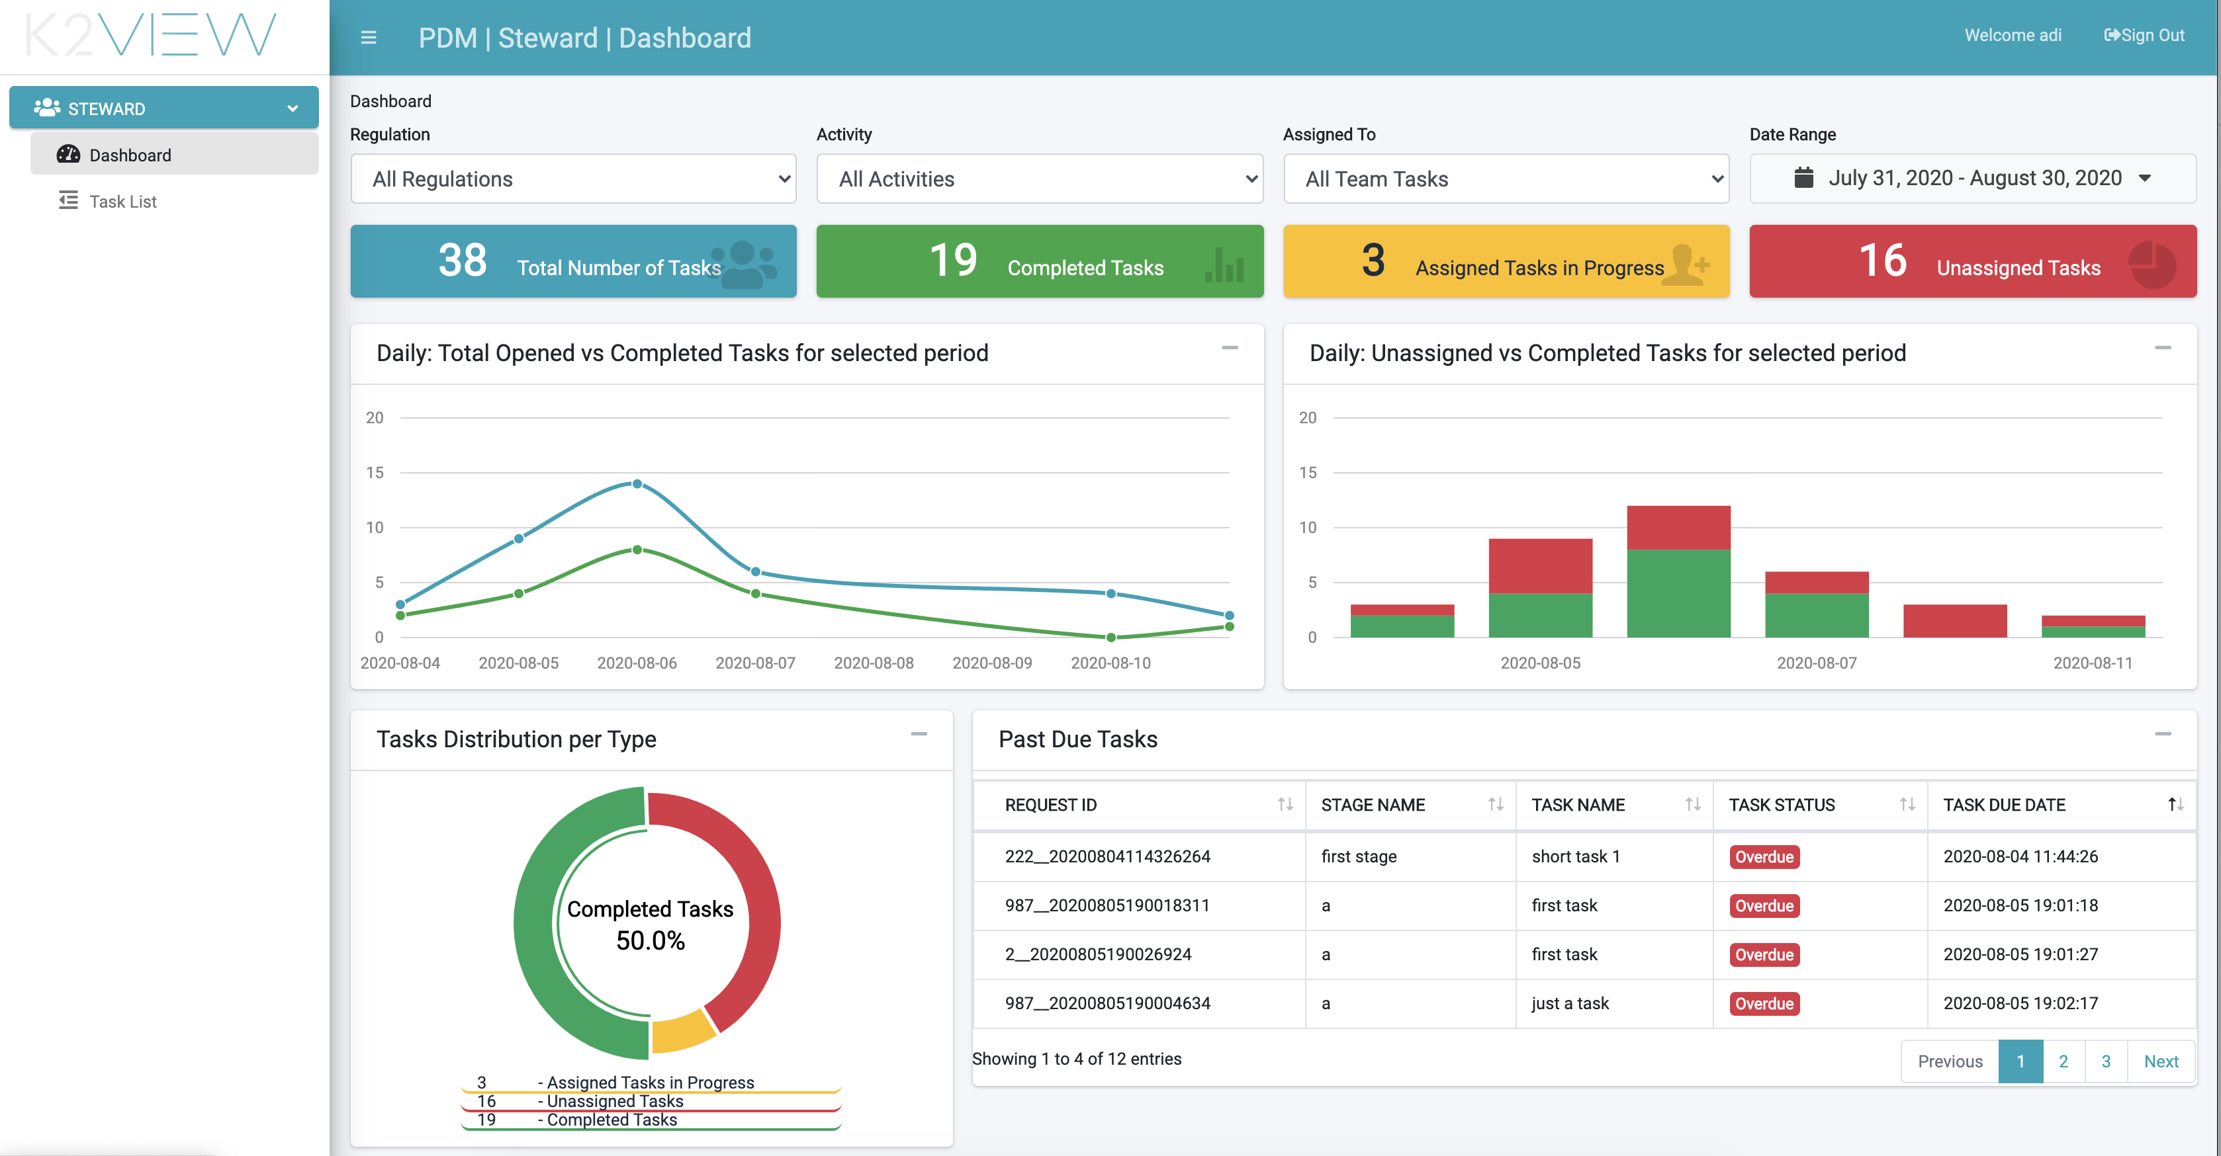

Figure 39. Steward Dashboard

### Steward Dashboard Filters

The graphs in the dashboard can be filtered based on a set of parameters displayed at the upper portion of the screen. The filters include:

* Regulation – Filter the information presented in the dashboard to Requests for a specific Regulation.
* Activity - Filter the information presented in the dashboard to Requests of a specific Activity.
* Assigned To – Permits the Steward to apply a selected filter to see only the Tasks assigned to this Steward, or to see all Tasks allocated to the Role held by the Steward.
* Data Range – This filter defines the date range used to filter the Tasks.



Figure 40. Example of Applied Steward Dashboard Filter

The filter selected varies the displayed information for graphs and totals shown for the dashboard.

### Steward Dashboard Totals

The totals in the dashboard reflect the list of Tasks that match the selection criteria specified by the dashboard filters:

* Total Number of Tasks – Total number of Tasks in the selected period.
* Completed Tasks – Total number of Tasks completed in the selected period.
* Assigned Tasks in Progress – Tasks in progress that are already assigned. If the filter “Assigned to” was set to “All Team Tasks”, then this total includes all assigned Tasks to the corporate role team of the Steward. If this filter is set to “Tasks Assigned to Me”, then only the Tasks directly assigned to the Steward are included.
* Unassigned Tasks – Total of Tasks in the selected period not assigned to any steward.



Figure 41. Steward Dashboard Totals Example

Clicking on any indicated Total takes the user to the list of Tasks represented by this total.

The total number of Tasks (leftmost total) is the sum of the three totals to its right.

### Steward Graphs

* Daily: Total Opened Vs. Completed Tasks for selected period – This graph compares, for the filter conditions, the number of the Tasks opened in any given day of the selected date range, with the number of Tasks closed in the same period.
* Daily: Total Unassigned Vs. Completed Tasks for selected period – This graph compares, for the filter conditions, the number of unassigned Tasks opened in any given day of the selected date range, with the number of Tasks closed in the same period.
* Open Requests per Selected Date Range – this graph shows the distribution of the open requests according to the request submission date. The graph indicates the number of open Requests, as well as how many of those requests have at least one overdue Task.

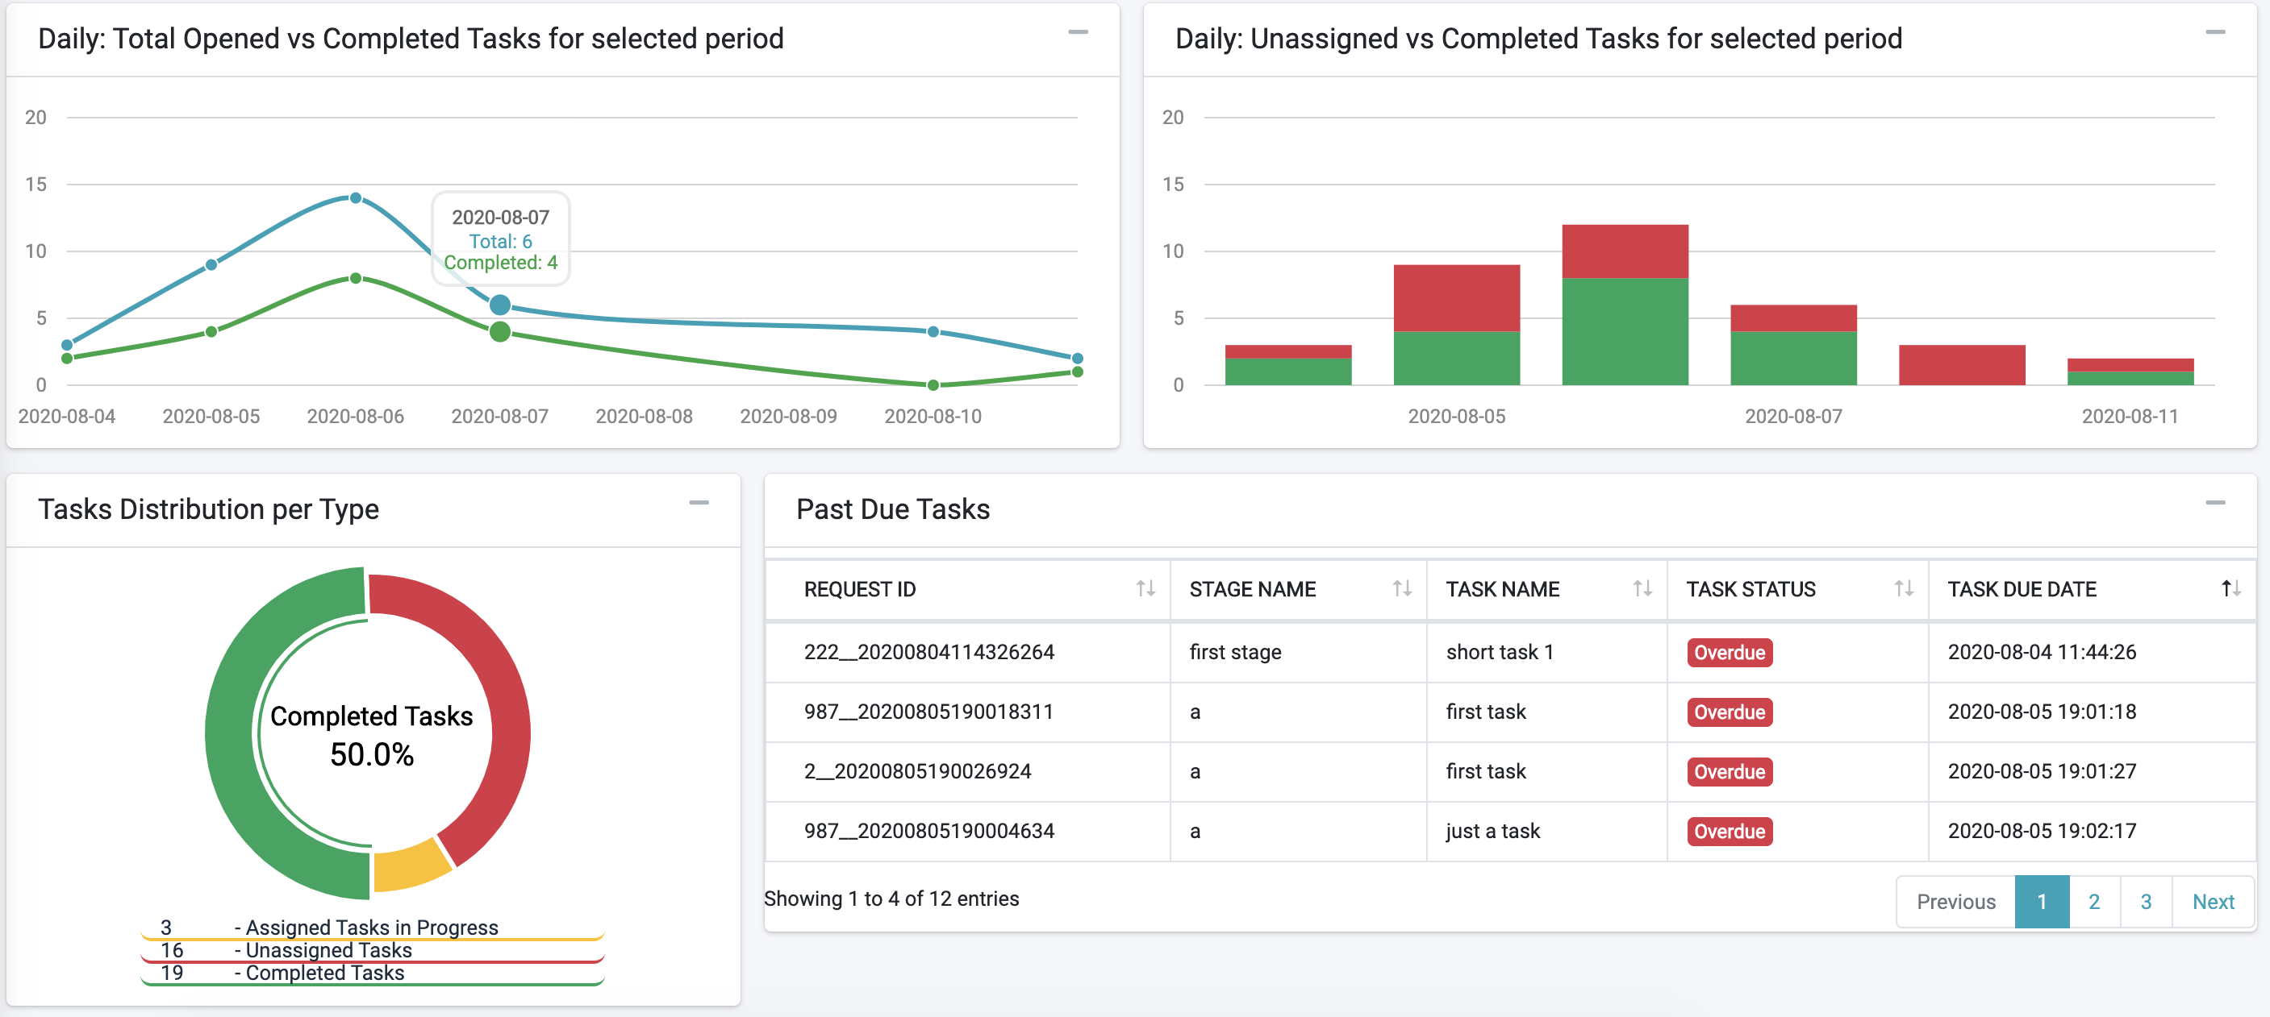

Figure 42. Steward Graphs

## Tasks List

The Tasks List screen shows Tasks allocated to the Corporate Role of the specific Steward.

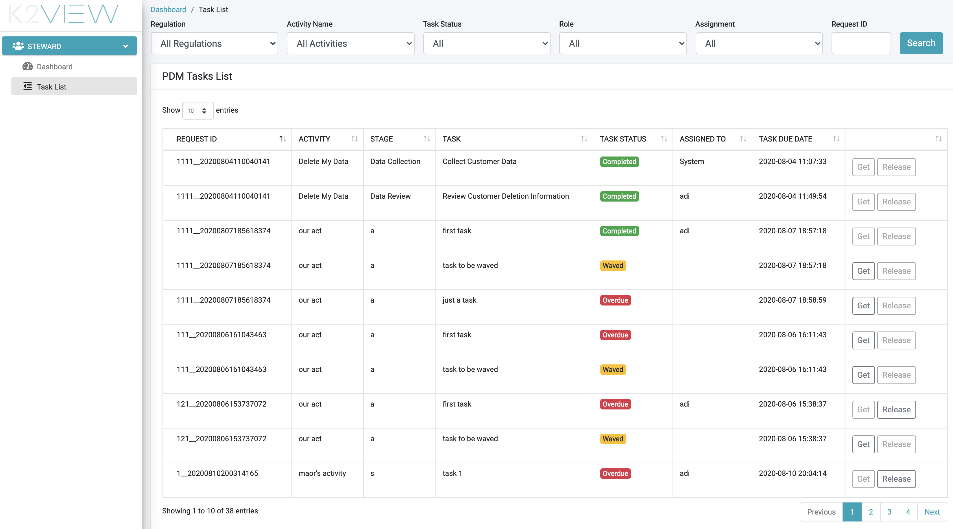

Figure 43. Tasks List

At the top of the screen, filters allow the user to search tasks that answer specific criteria.

The filters are:

* Regulation – Filter according to a specific Regulation.
* Activity Name – Filter according to a specific Activity. This filter can be used only if a Regulation was selected in the Regulation filter; the dropdown list presents the Activity list according to the Activities of the selected regulation.
* Task Status – Filter by the Task status, for example – Completed or In progress.
* Role – the name of the Corporate Role that should perform the Tasks.
* Assignment – This filter allows the Stewards to view the list of Tasks only assigned to them, or view Tasks assigned to other stewards of the same role, or unassigned.
* Request ID – Used to search for a specific request ID.

Once the Tasks List is presented, the Steward can perform the following actions on the task:

* Get – This action assigns the task to the steward. The “Get” action is enabled only if the Task is not yet assigned to any user.
* Release – If a Task is assigned to a Steward, they can release it using this button. The Task then returns to the Unassigned status.
* Open the Task Details screen - The Steward selects the desired Task line.

## Executing a Task

A Task can be executed by any Steward sharing the same Corporate Role.

To perform a Task, the Steward selects the Task from the pending task list and takes assignment by selecting the  button, located at the right side of the row for the selected Task.

Next, the Task Details screen is displayed. The Steward performs the necessary actions to complete the Task, as explained in a following section.

Another option the Steward has to retrieve a task is to click the row of the Task to open the Task Details screen (described next). This screen also includes the “Get” button used to assign this task to the user.

## Task Details

The Task Details screen provides the Steward a view of the task details, from which notes can be added or the task can be marked “Complete”.

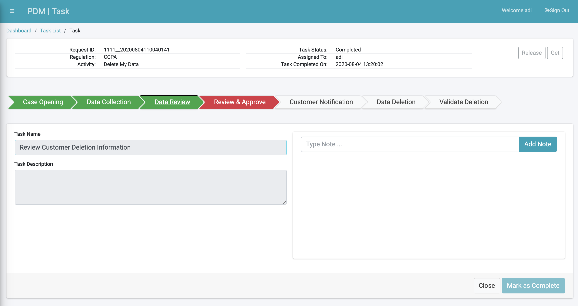

Figure 44. Task Details

If the Task is unassigned, the Data Steward can also use the “Get” button on the top of the screen to take ownership on the Task.

|  |  |
| --- | --- |
| Field | Description |
| Request ID | The unique identification of the request. |
| Regulation | The Regulation for which this request was created. |
| Activity | The Activity that this Request executes. |
| Task Status | The Task status. |
| Assigned To | Indicates the user assigned to this Task. Filled only for assigned Tasks. |
| Task Completed On | The date and time the Task was completed. Filled only for a Task that was already completed. |
| Task Name | The name of this Task. |
| Task Description | The Description of the Task. |

The actions available from this screen include:

* Add a Note - The Steward and Case Owner can each add notes to a Task. To add a note, type text in the text box next to the button, then click “Add Note” to submit it. The notes appear chronologically at the text box, just below the “Add Note” line.
* Get or Release a Task – use the  buttons to either “Get” a Task or “Release a Task. Getting a Task is enabled only when this Task is not yet assigned to another user. Releasing a Task is only enabled when the Task is assigned to the user currently viewing the screen. Both buttons are disabled when the Task is not to be executed (for example, the Task was already completed, waived or not yet ready for execution, since the Flow had not reached the point of execution).
* Mark a Task as Complete – if the Task is assigned to this user, the Task can be marked as Complete using the  button. Naturally, a Task should be marked as complete after the user had performed the expected action for this Task.
* Close the screen – the 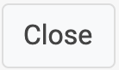 button removes the Task screen and returns to the Task List screen.

Information about the Flow of the Request is provided to the user through the progress bar. An example of the progress bar follows.



Figure 45. Progress Bar Example

### Progress Bar

The progress bar displays the Flow Stage; several stages are represented by the same fill color; Completed Stage appears in green; a Processing Stage appears in blue, and an Overdue Stage appears in red.

For the preceding example, the Stage of “Case Opening” appears in green, denoting completed. The stage “Data Collection” appears in blue, denoting it is the stage currently in progress. The Stages in gray are those not yet started.

# Case Owner User Interface

A Case Owner is the role responsible to assure the fulfilment of the DPM requests within the established SLA. The case owner is expected to monitor the DPM Requests allocated to them and to act if one of the Requests seems not to progress as expected.

Every open request is automatically allocated to a specific member of the Case Owners group. This automatic allocation is configurable by the Case Owner Supervisor. For further details on the allocation configuration options, please check the Supervisor user interface.

## Case Owner Dashboard

When a member of the Case Owners group logs into the DPM system, the initial screen presented is the Case Owner Dashboard:

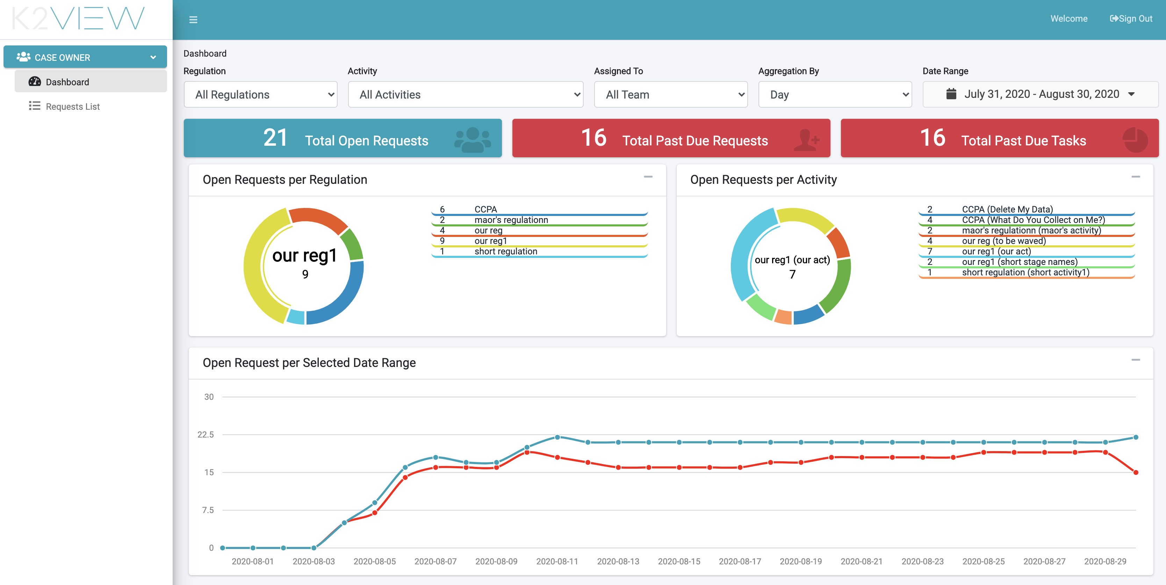

Figure 46. Case Owner Dashboard

The dashboard provides an overall status of the requests currently in process in the DPM system. Based on the information presented in this screen, the case owner can identify bottlenecks in the process and evaluate risk of missed SLAs.

### Case Owner Dashboard Filters

The graphs in the dashboard can be filtered based on a set of parameters that appear at the upper part of the screen. The filters include:

* Regulation – Filter the information to Requests for a specific Regulation.
* Activity - Filter the information to Requests of a specific Activity.
* Assigned to - Filter the information to Requests of a specific case owner or present the information about Requests regardless of Case Owner.
* Aggregation by – This filter impacts the graph of “Open Requests per Selected Date Range” in the area below the filters line. It defines the time units of the horizontal Axis. If “Month” is selected, then the open requests are aggregated per month. If “Day” is selected, then the graph presents the information per day.
* Data Range – This filter defines the date range used to display the open Requests.



Figure 47. Case Owner Dashboard Filter Example

The filter selection impacts the information displayed in the totals and graphs presented at the bottom sections of the dashboard.

### Case Owner Dashboard Totals

The totals in the dashboard reflect the list of DPM Requests that match the selection criteria specified by the dashboard filters.

* Total Open Requests – the total number of in-progress requests.
* Total Past Due Requests – The total number of requests that exceeded the expected SLA period for their Activity.
* Total Past Due Tasks – The total of tasks in progress that exceeded the expected SLA period of the task.



Figure 48. Case Owner Dashboard Totals Example

Selecting each of those totals takes the user to the “Requests List” screen, that presents Requests that answer the conditions of this total.

### Case Owner Graphs

* Open Requests per regulation – Provides a view of the distribution of the open requests per Regulation.
* Open Requests Per Activity – Provides a view of the distribution of the open requests per Regulation and Activity type.
* Open Requests per Selected Date Range – Displays a graph with the distribution of the open requests according to the request submission date. The blue line on the graph indicates the number of open Requests. The red line indicates how many of those requests have at least one Task that is overdue.

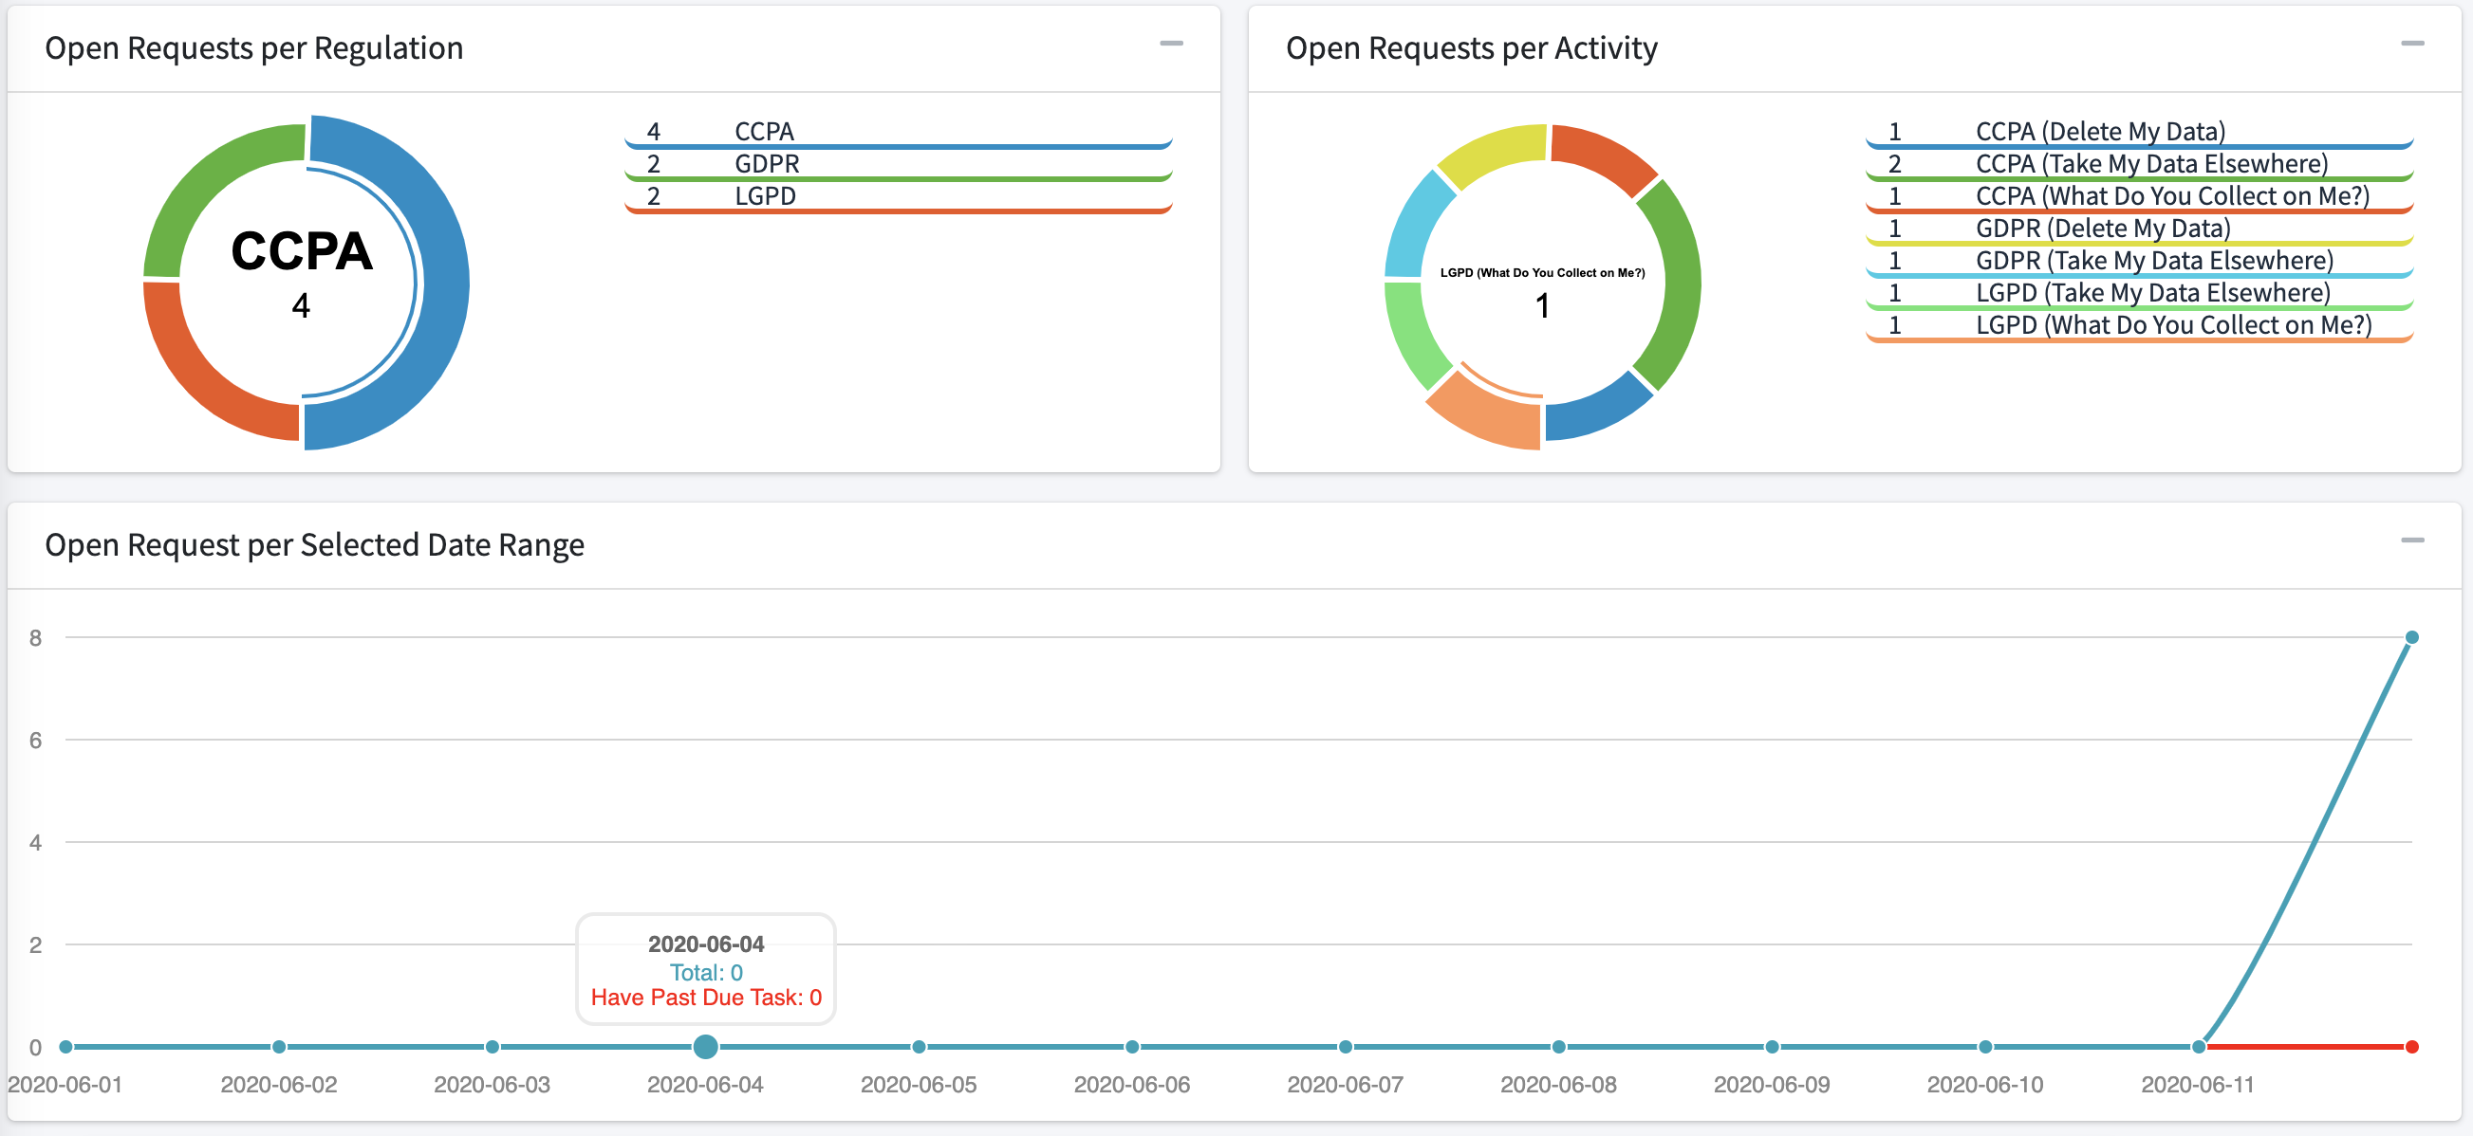

Figure 49. Case Owner Graphs Example

## Case Owner Requests List

The Case Owner Requests List presents to the Case Owner the list of Requests that are under their responsibility.

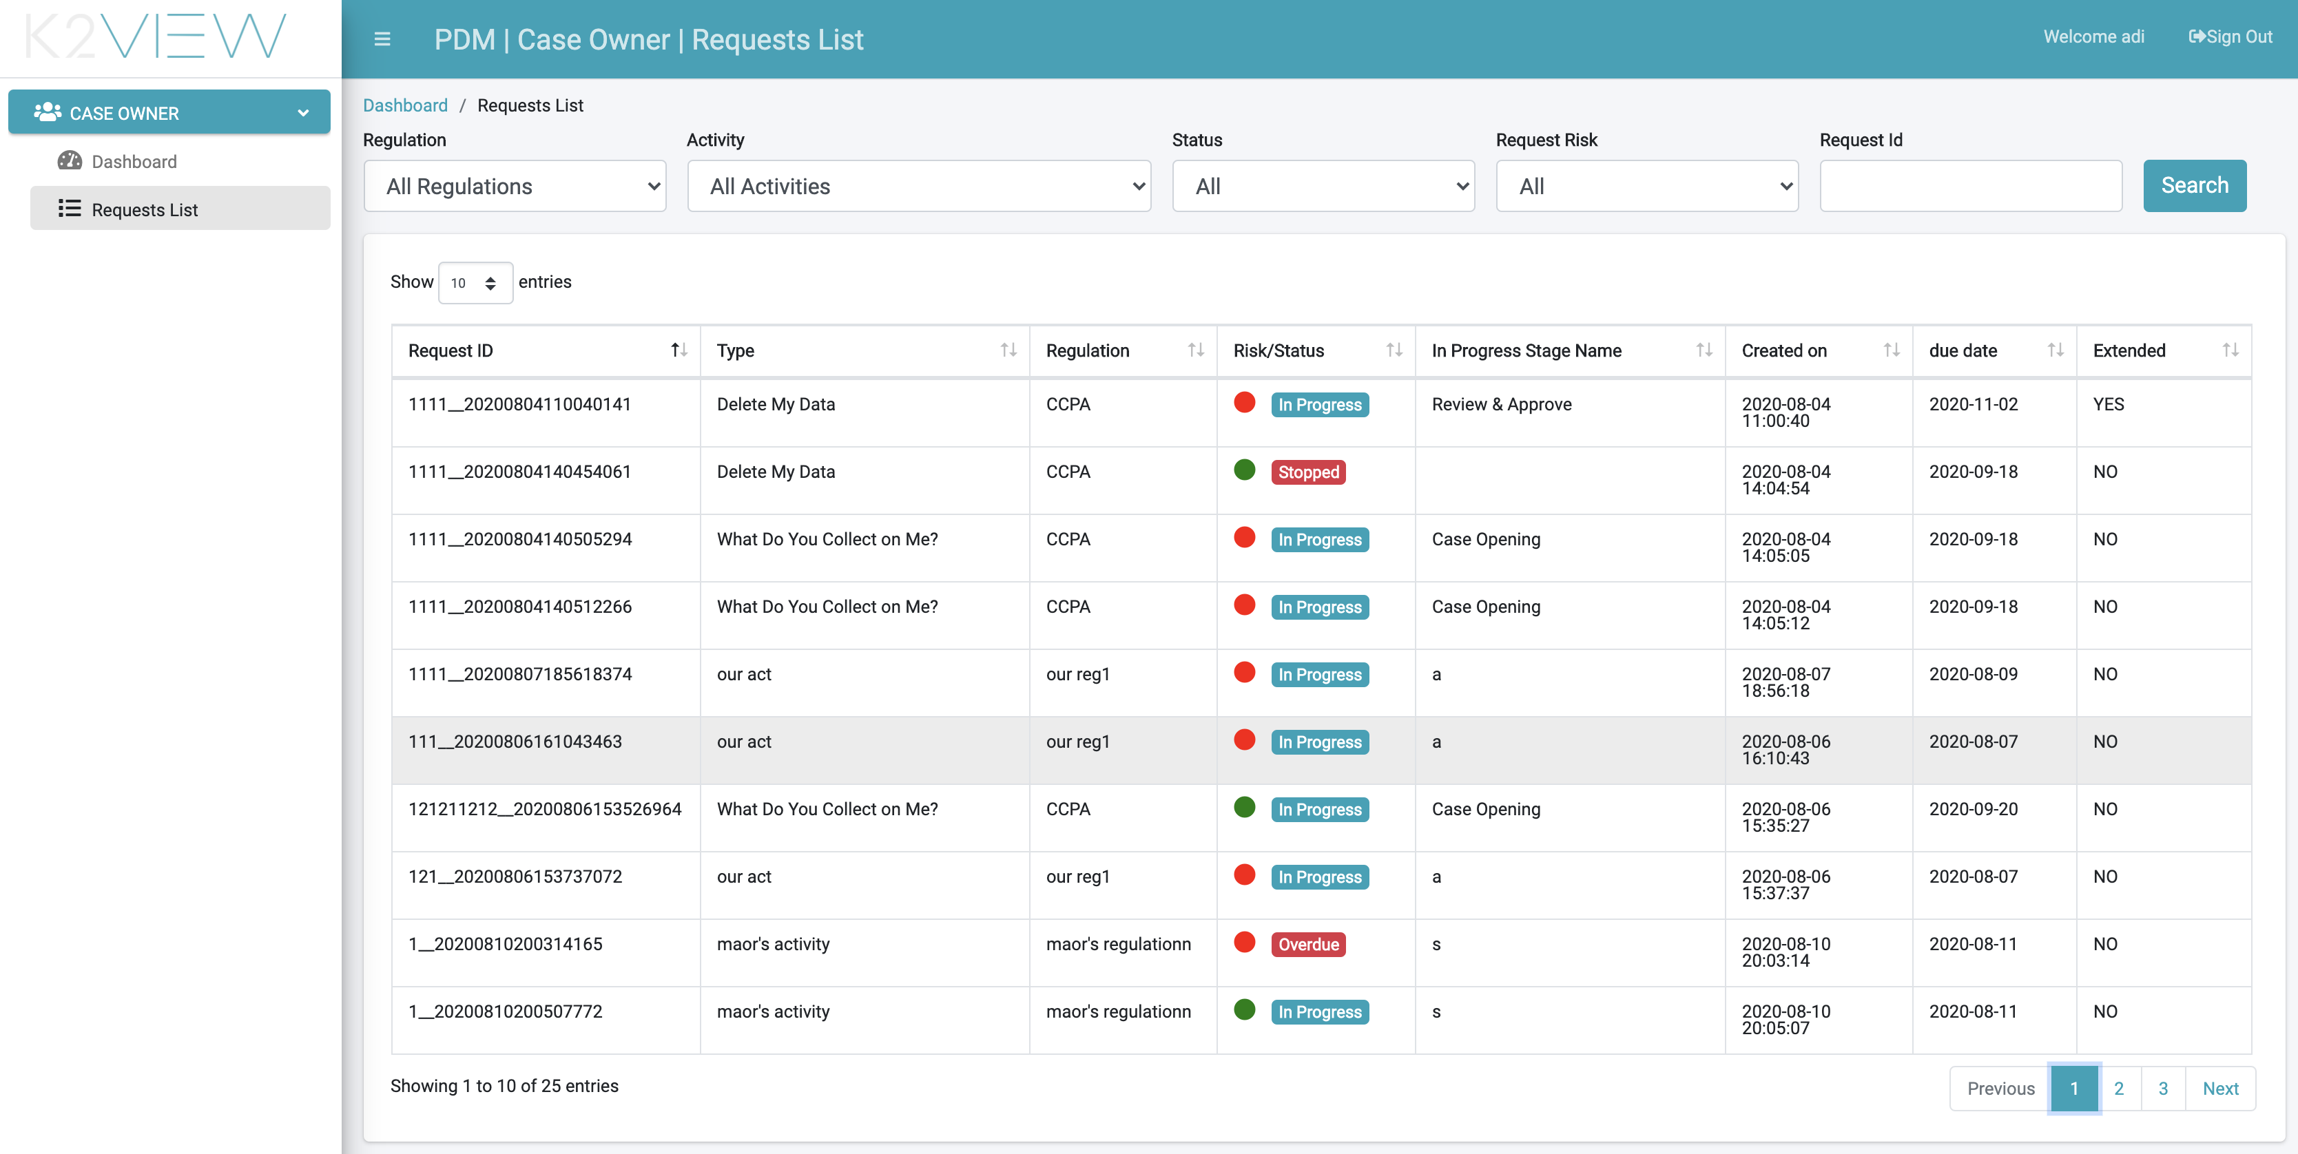

Figure 50. Case Owner Requests List

The Request list can be filtered based on:

* Regulation – Filter to present only Requests of a specific Regulation.
* Activity - Filter to present only Requests of a specific Activity.
* Status - Filter by Request status.
* Request Risk – This filter provides the user only requests under the risk of missing the overall request SLA.
* Request ID – search for a specific Request.

The Request List table presents the following information.

|  |  |
| --- | --- |
| Field | Description |
| Request ID | The unique identification of the request. |
| Type | The Activity that this Request executes. |
| Regulation | The Regulation for which the request was created. |
| Risk/Status | This fields includes both the Request status and an indication when the request is under any type of risk. The Request status is presented with the colored circle on the left side of the status; the Red color indicates the Request and its associated tasks are past due. Green indicates the Request is on track to its scheduled completion date. |
| Created on | The date and time the Request was submitted. |
| Due date | The expected completion date based on the Request creation date and the Activity SLA. |
| Extended | Indicates if the Request SLA was extended. The values are Yes/No. |

## Case Owner Request Details

From the Requests List screen, the case owner selects the row of a particular Request to open the corresponding Request Details Screen

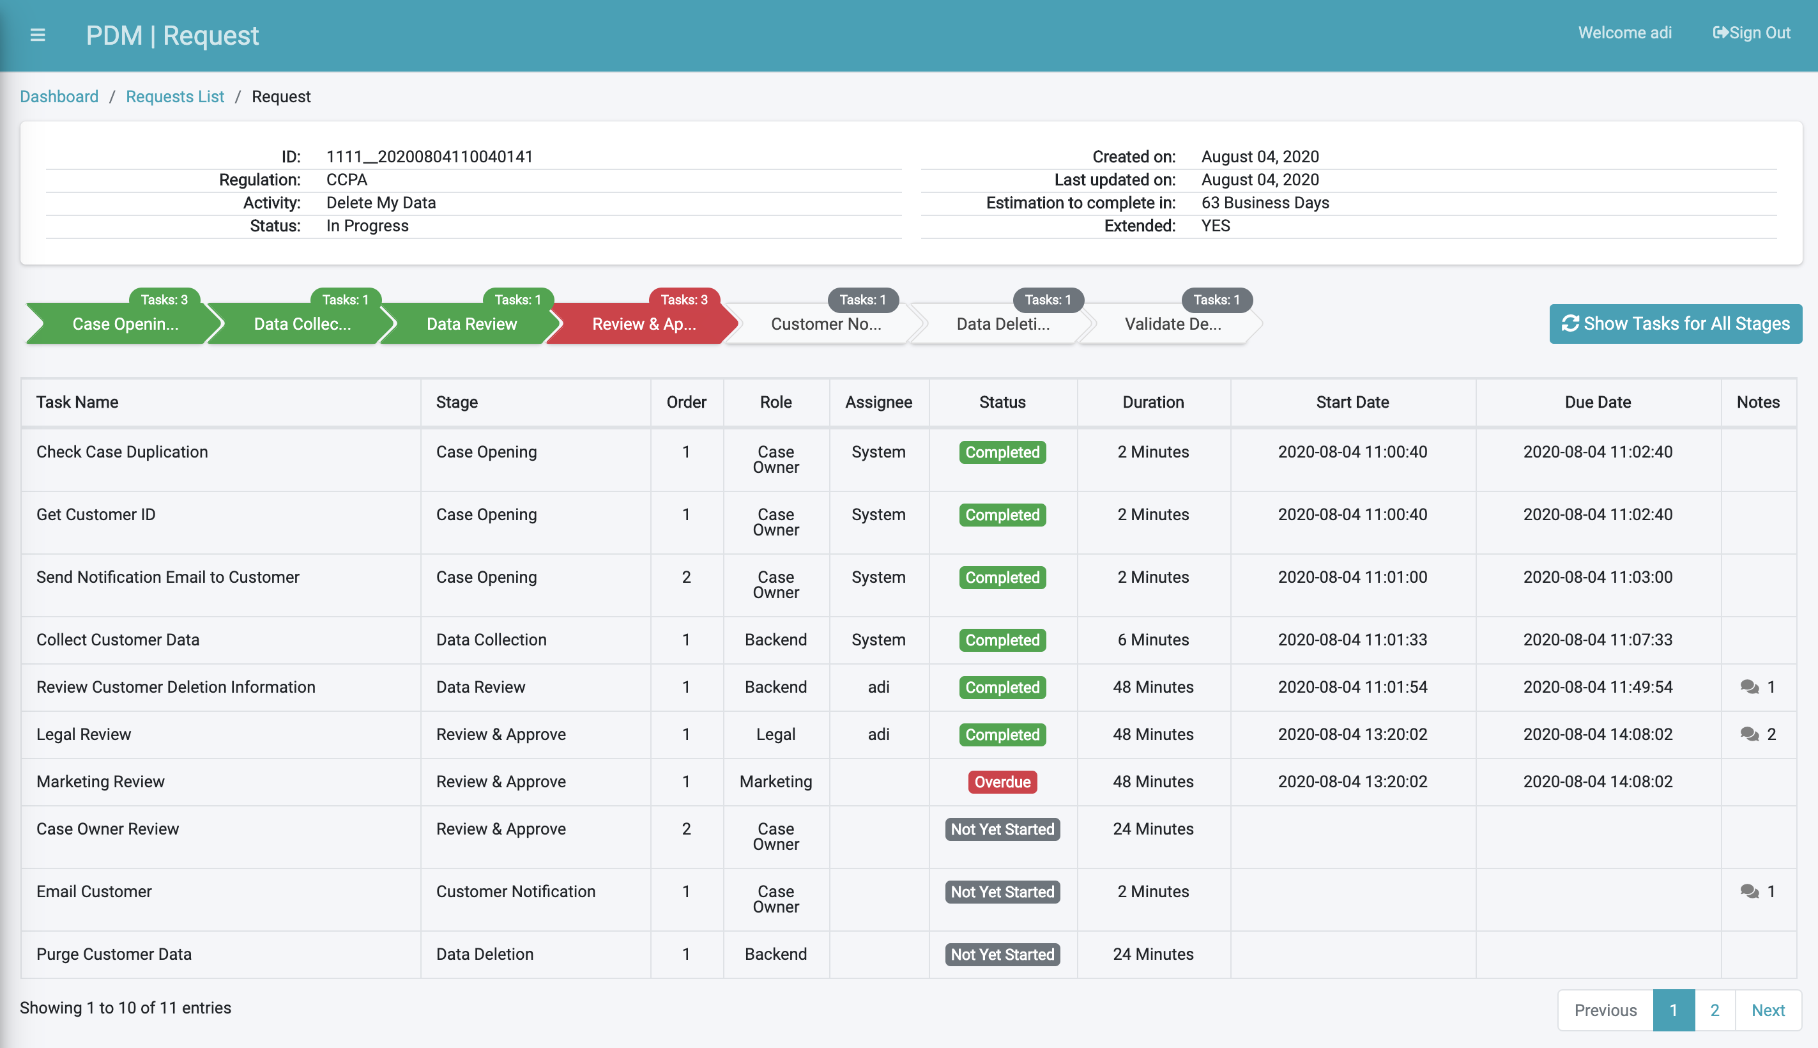

Figure 51. Case Owner Request Details

The Case Owner reviews all request details.

The upper part of the screen displays general information about the Request, heading information and Request stages, respectively.

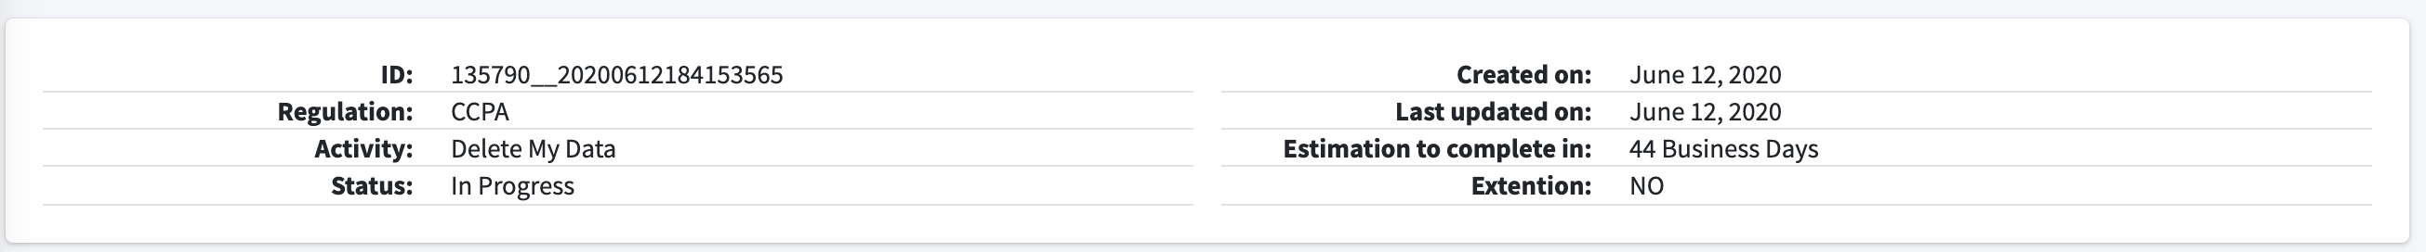

Figure 52. Case Owner General Information for Request Example



Figure 53. Case Owner View of Stages of Request

Completed Stages are shown in green. The current Stage is presented in blue when on track towards completion. When the Stage is not on track, it is shown in red signifying past due. Future Stages to be processed appear in grey.

The number of Tasks in the Stage is displayed on top of every stage. If a Stage includes an overdue Task, then the Tasks count is shown in red.

The Case Owner can navigate between the stages by clicking on the Stage section in the presented chart. Navigating to a particular stage presents only those tasks made a part of the Stage. The view of all Tasks can be restored by selecting the “Show Tasks for All Stages” button.

At the bottom of the screen, the list of Tasks is presented:

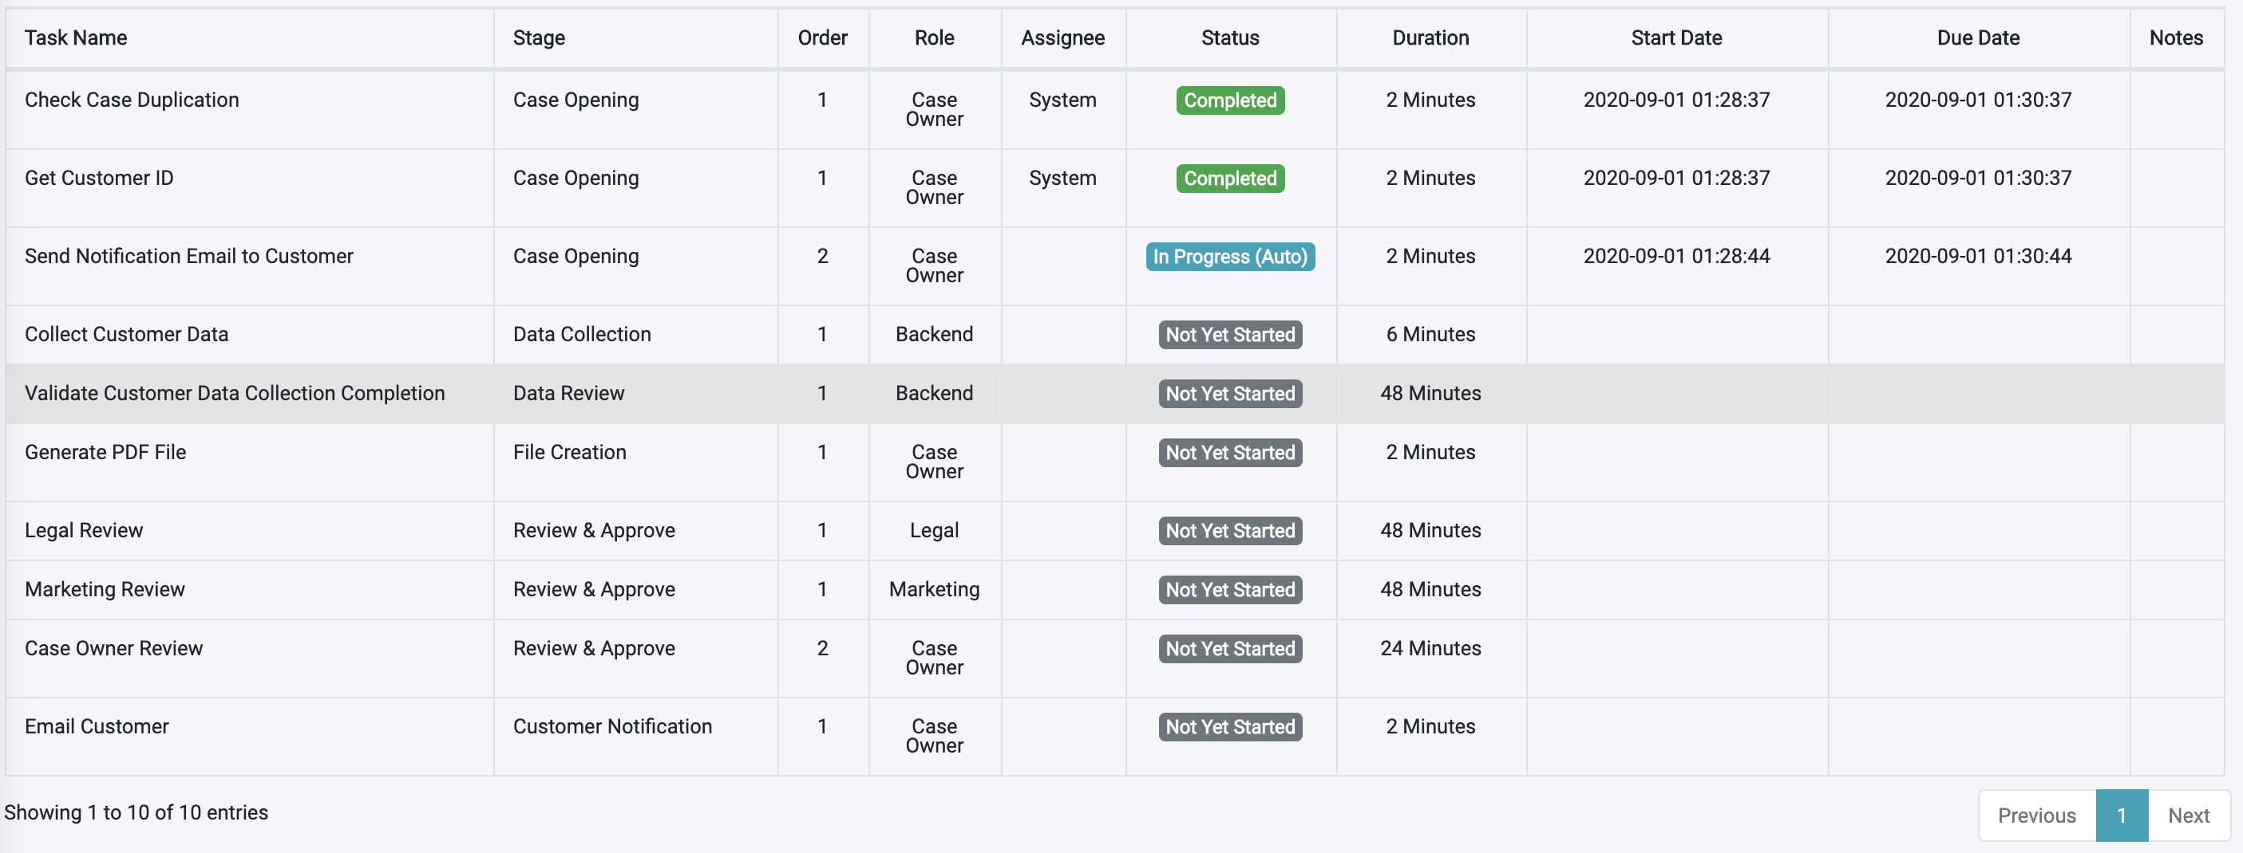

Figure 54. Task List as Viewed by Case Owner

|  |  |
| --- | --- |
| Field | Description |
| Task Name | The name description for the Task. |
| Stage | The Stage for which this Task belongs. |
| Order | The order of this Task within its Stage (details about the Task order are described in the Flow section). |
| Role | The Corporate Role defined as the owner of this Task to execute it. |
| Assignee | The user responsible to execute the Task. This field is populated when a user takes ownership of a Task by selecting the “Get” button from the Task details screen. |
| Task Status | The current status for the Task (i.e., processing, stopped, completed). |
| Duration | The duration of time this Task is expected to complete. The unit of time expressed is configured (hours, minutes). Hours is the most common configuration. |
| Start Date | The date and time the Task execution began. This field is populated for Tasks already in the execution phase. |
| Due Date | The date and time the Task was completed. Filled only for a Task already completed. |
| Notes | This field indicates if notes were submitted for this Task. |

The Case Owner can select a specific Task to view its details.

## Case Owner Task Details

When the Case Owner selects a particular Task from the Request Details screen, the DPM displays the Task Details screen:

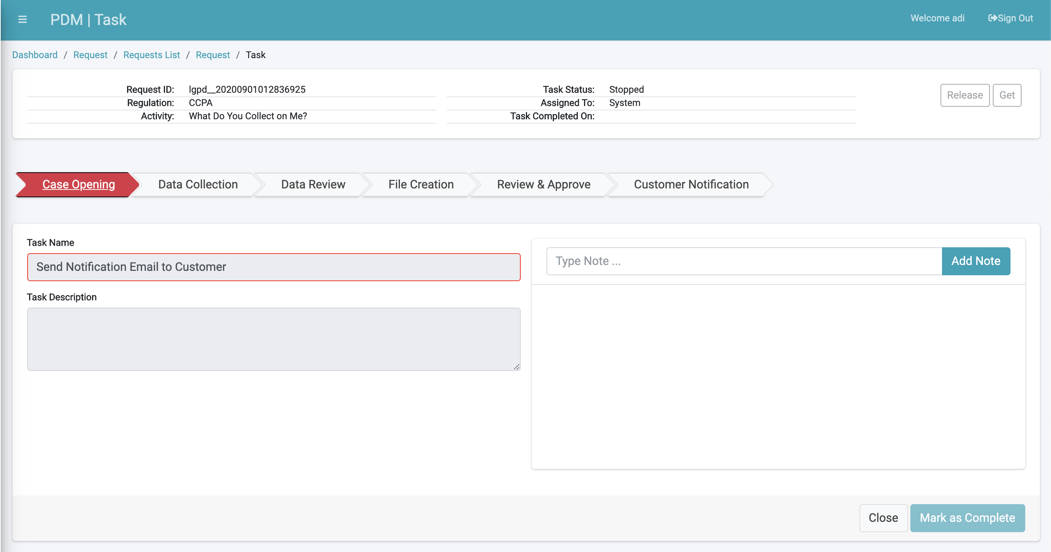

Figure 55. Case Owner Task Details

The content and Activities to be executed from this screen are similar to those of the Task Details screen at the Steward interface. Refer to the Steward User section for additional information.

# Supervisor User Interface

The Supervisor role oversees the overall DPM process.

A Supervisor can:

* View the Requests Dashboard
* View the Requests List
* Configure new Request allocation policy to a Case Owner.

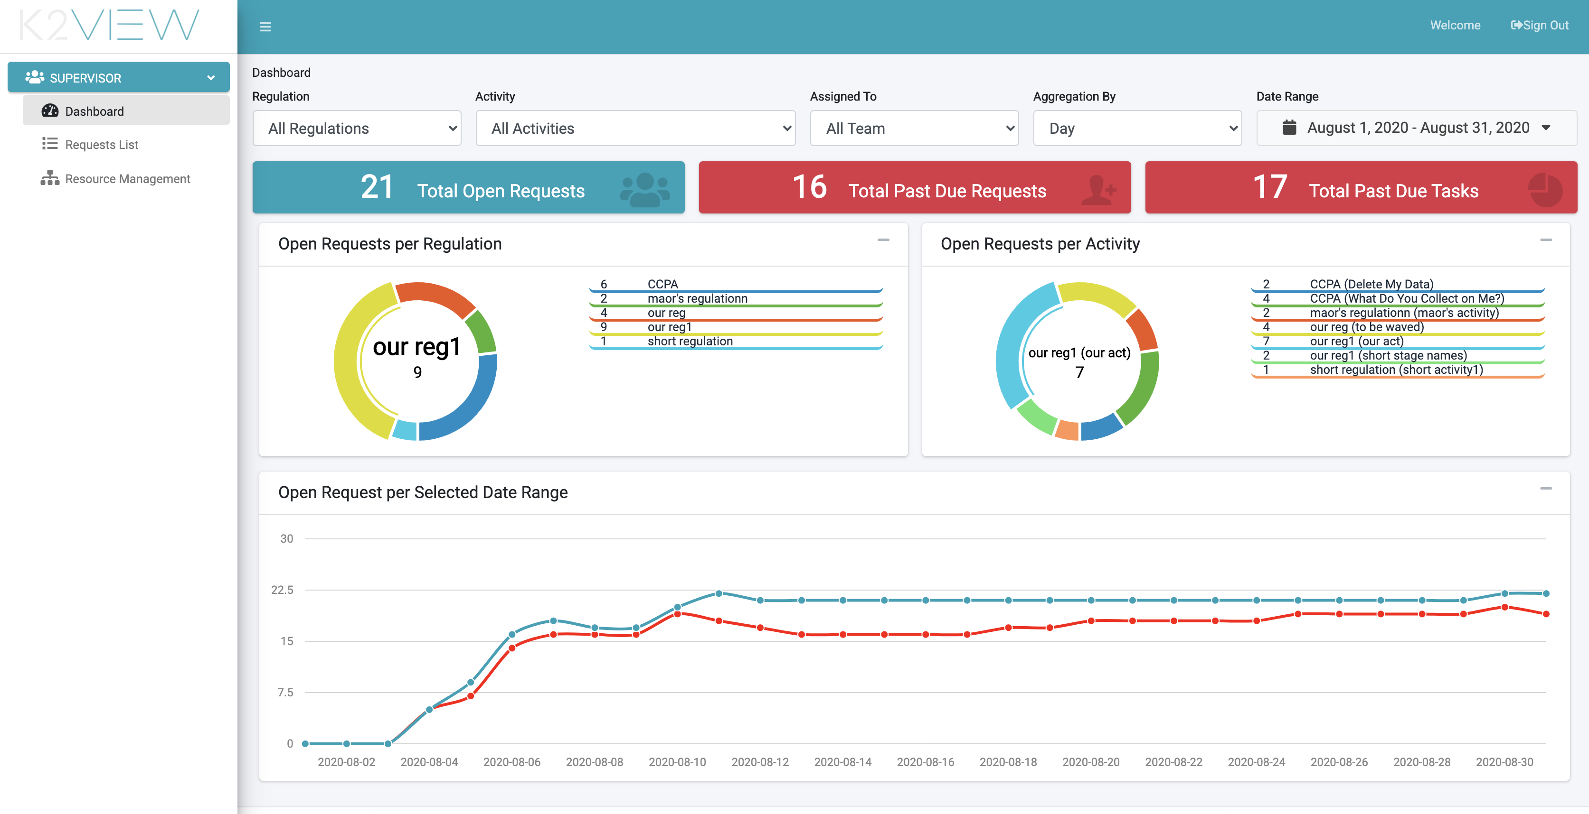

Figure 56. Supervisor User Interface

## Supervisor Requests Dashboard

The Supervisor Dashboard is equal to the Case Owner Dashboard. For additional information, refer to the Case Owner section.

## Supervisor Requests List

The Supervisor Request List and subsequent Request Details and Task Details screens are the same screen as presented to the Case Owner.

## Supervisor Case Owner Allocation Configuration

A supervisor is responsible for the configuration of how new DPM requests are allocated to the users that constitute the Case Owners team: Whenever a new Request is submitted, the system automatically selects one of the users defined as Case Owners, thus allocating the new Request to this user. The Resource Management screen is where the Supervisor can configure the method that the system uses to select one of the users.

The supervisor accesses the assignment method configuration screen by selecting the  menu option.

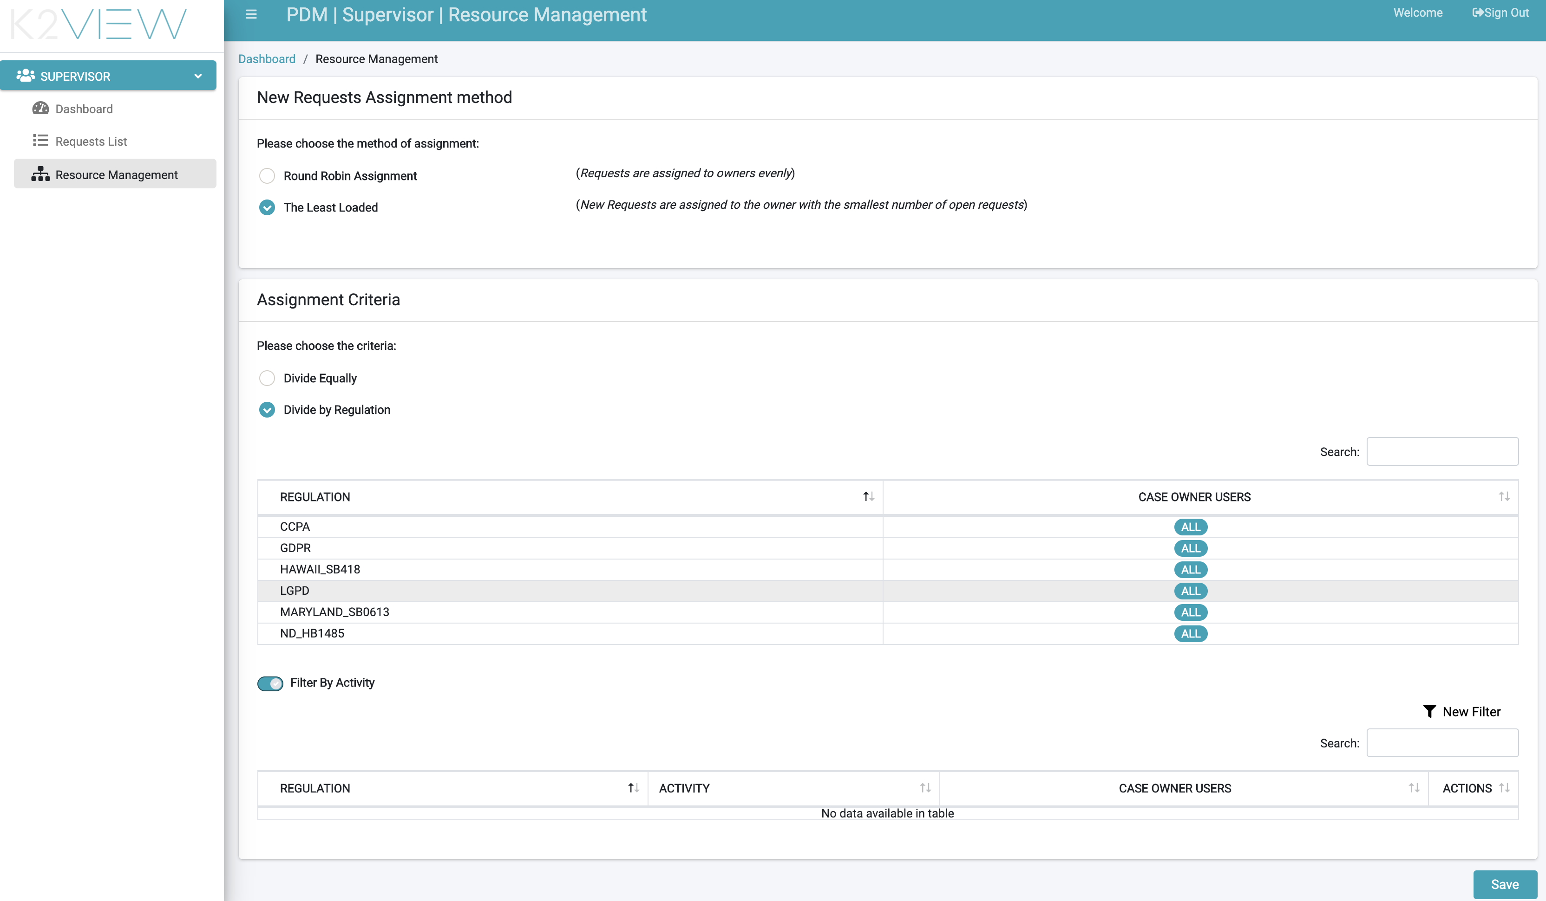

Figure 57. Supervisor Resource Management screen

There are two categories of configuration:

* Assignment method – defines how to allocate a new Request when more than one Case Owner could take this ownership.
* Assignment criteria – refinement of the assignment method, allowing the supervisor to indicate specific Case Owners as responsible for cases of a specific Regulation or Activities under a specific regulation.

### Assignment Method

The Assignment method is defined in the upper section of the Resource Management screen:

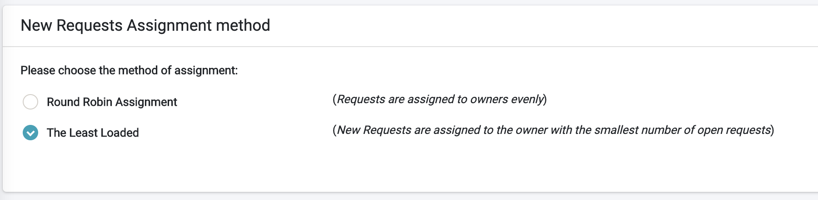

Figure 58. New Requests Assignment Method

The supervisor can select if new Requests will be allocated to Case Owners based on:

* Round Robin assignment – New Requests are allocated to the Case Owners in turns. With this assignment method, all the Case Owners are assigned an equal share of the Requests.
* The Least Loaded – New Requests are allocated to the Case Owner with the smallest number of open Requests.

### Assignment Criteria

The Assignment Criteria is defined in the lower section of the Resource Management screen:

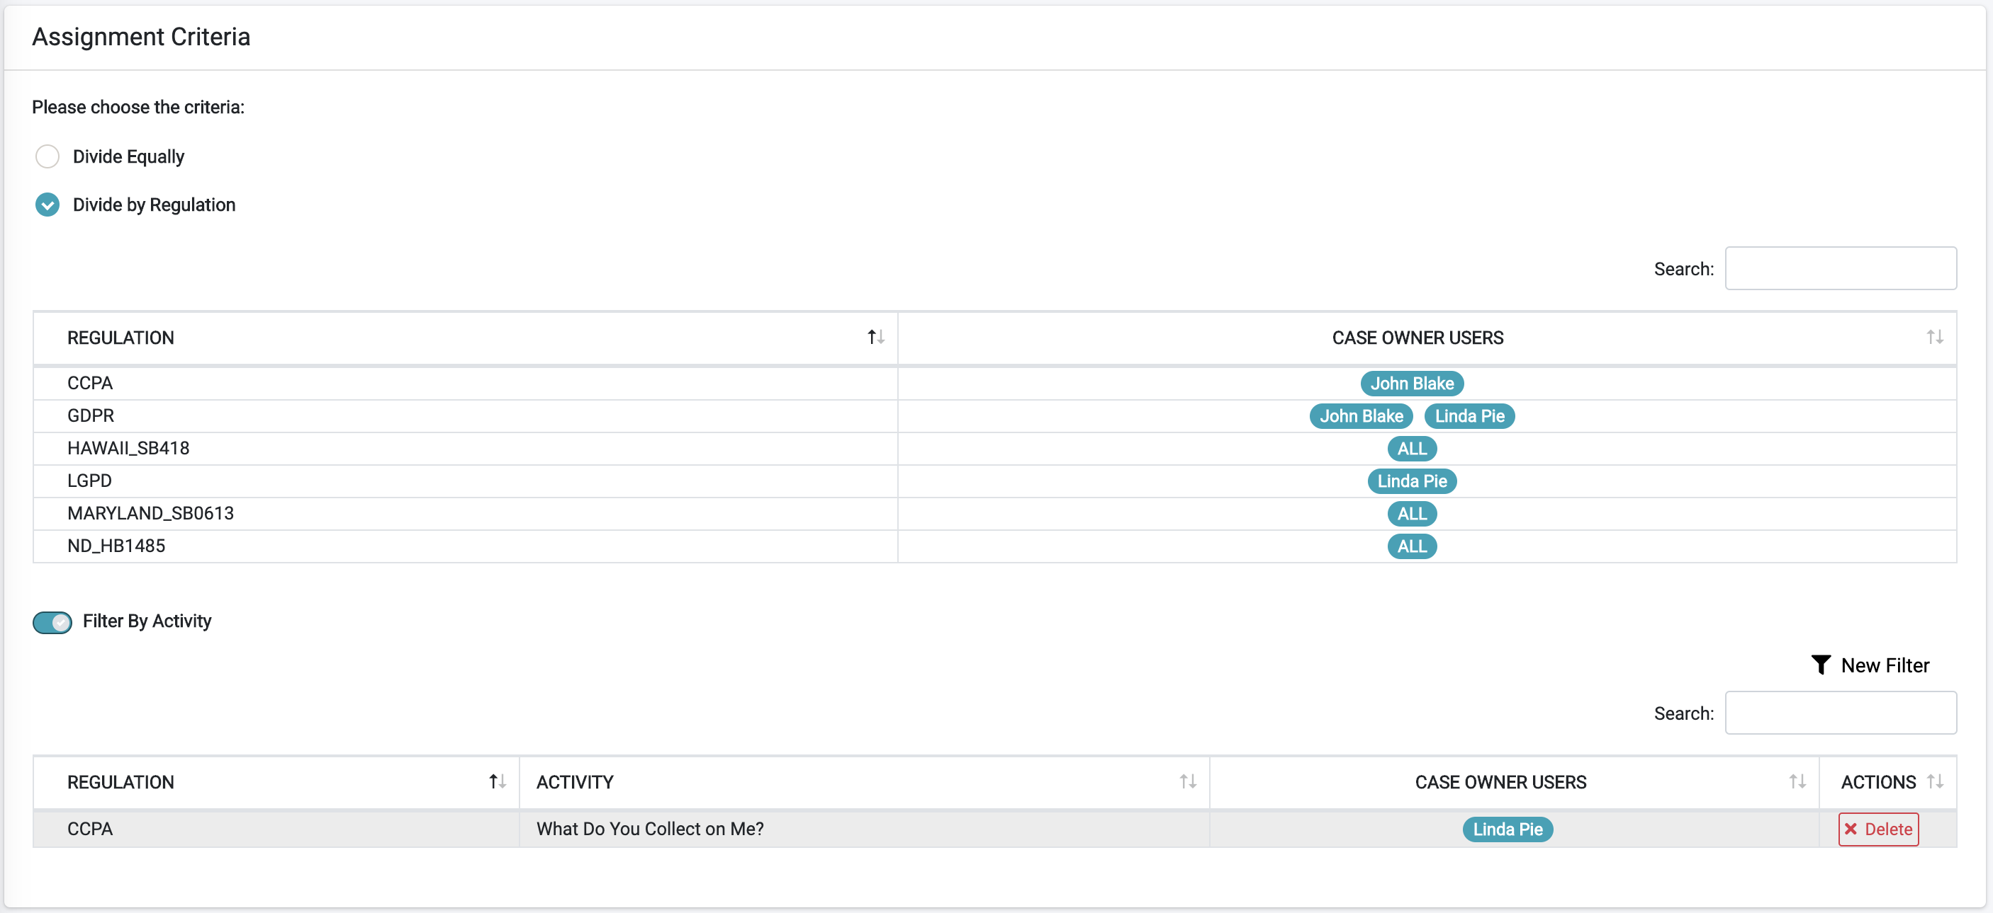

Figure 59. Assignment Criteria

The assignment criteria provide the ability to define who are the Case Owners responsible for a specific Regulation or for a specific Activity under this Regulation.

If the option selected is , then no special criteria should be used, and the system follows the assignment method selected in the upper section of the screen (see previous topic).

To activate the option to define Case Owners per Regulation, select the option , to display the list of active regulations in the DPM system, and allow the user to allocate a regulation to one or more Case Owners. In the example above, CCPA Requests are allocated only to the Case Owner called “John Blake”, the GDPR Requests are allocated to either “John Blake” or “Linda Pie”, and HAWAII_SB418 Requests are allocated to any Case Owner.

To define the users allocated to each Regulation, select the line of the Regulation to be configured. A pop-up screen allows selection of one or more Case Owner users.

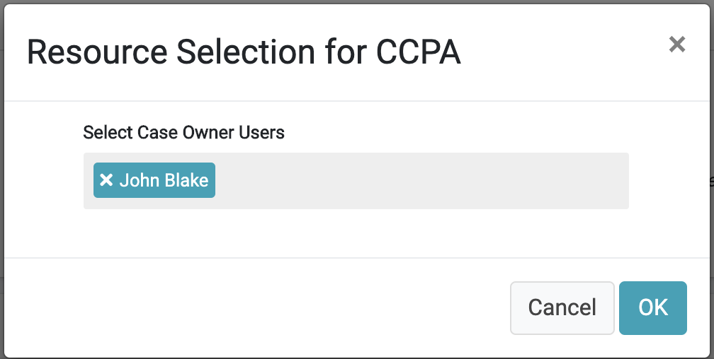

Figure 60. Resource Selection for CCPA

The next level of assignment criteria is the . When this option is switched on, the supervisor can define additional assignment criteria at the Activity level. In the example above, every Request of the Regulation CCPA and Activity “What Do You Collect on Me” will be allocated to the Case Owner user called “Linda Pie”.

To add new assignment criteria at the Activity level, use the  option at the right side of the screen. This opens a pop-up screen where the supervisor can select the Regulation, Activity and one or more Case Owners that should be responsible for the Requests of this type.

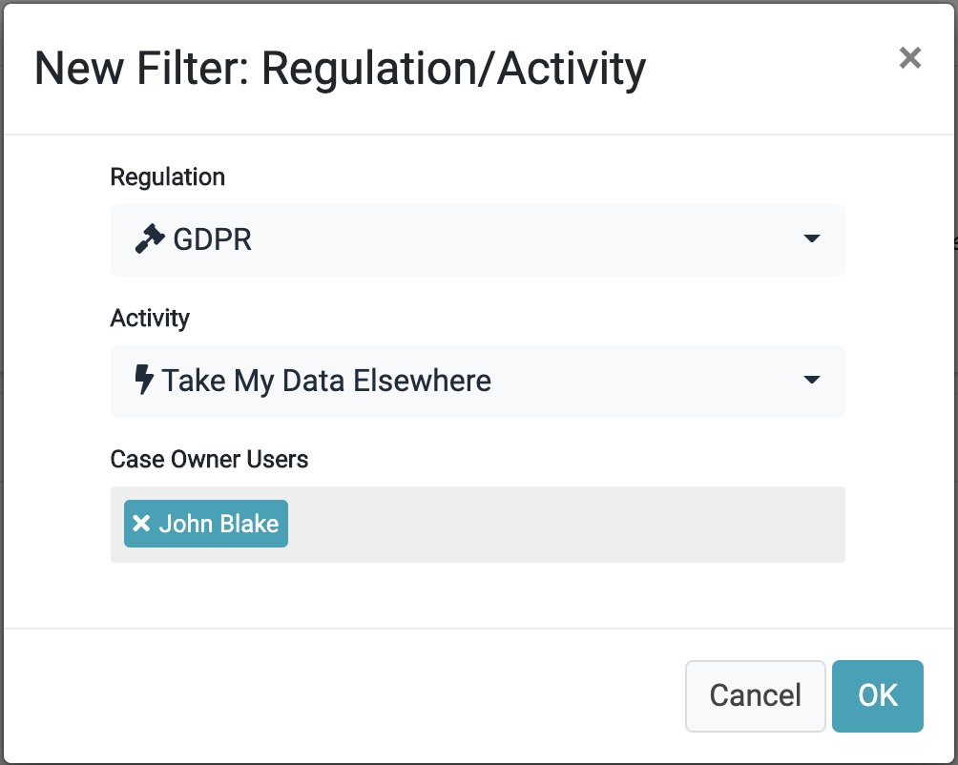

Figure 61. New Filter: Regulation/Activity

# Consent Management

The Consent Management function ensures that information is correctly, effectively collected with the proper authorization.

## Consent Management Overview

The K2View Data Privacy Management module (DPM) covers the end-to-end lifecycle of Consent Management, including consent configuration, customer consent preferences, central consent repository, integration with third parties, and more.

The following list describes the main features of Consent Management.

**Configurable Consent Topics**

DPM is fully configurable, and any consent topic can be defined by the DPM Administrator through a user-friendly, Web-based user interface.

**Obtain Customer’s consent and preferences**

Provide a list of consents relevant to the customer. This allows your customers to review, accept, or withdraw consents using a self-service, Web-based application. Customer preference changes are recorded for audit purposes.

**Maintain central consents repository**

DPM is the central repository for recording customer consent data across corporate systems. It obtains data from and provides data to any other application.

**Inform**

Provide a list of consents processed by a customer and their attributes. Provide an historical view of customer consent actions. The data can be exposed to authorized users or applications via APIs, files, publish/subscribe technologies (ex: Kafka), and more.

**Evidence**

Comply with audit requirements by keeping evidence of who consented, to what, when, and via what channel.

This chapter provides details about the way consents are configured and managed using K2View DPM.

## Consent Topics and Categories Configuration

K2View Consent Management is a flexible, configurable system, allowing each organization to determine which consent topics are managed by the system.

The administrator can define any number of consent topics and classify them under consent categories, allowing each organization to define the granularity of the consents it collects.

As legal requirements and services change over time, the administrator can add, edit, or remove consent topics at any time.

### Consent Topics List

To view the list of configured consents or to create new ones, access the Consent Management option at the DPM Administrator module.

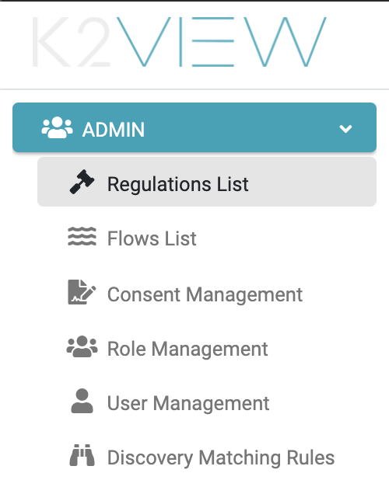

Figure 62. Consent Management Menu Item

The Consent Management screen displays the consent topics that were already configured by the Administrator, and allows adding a new consent or altering an existing consent configuration.

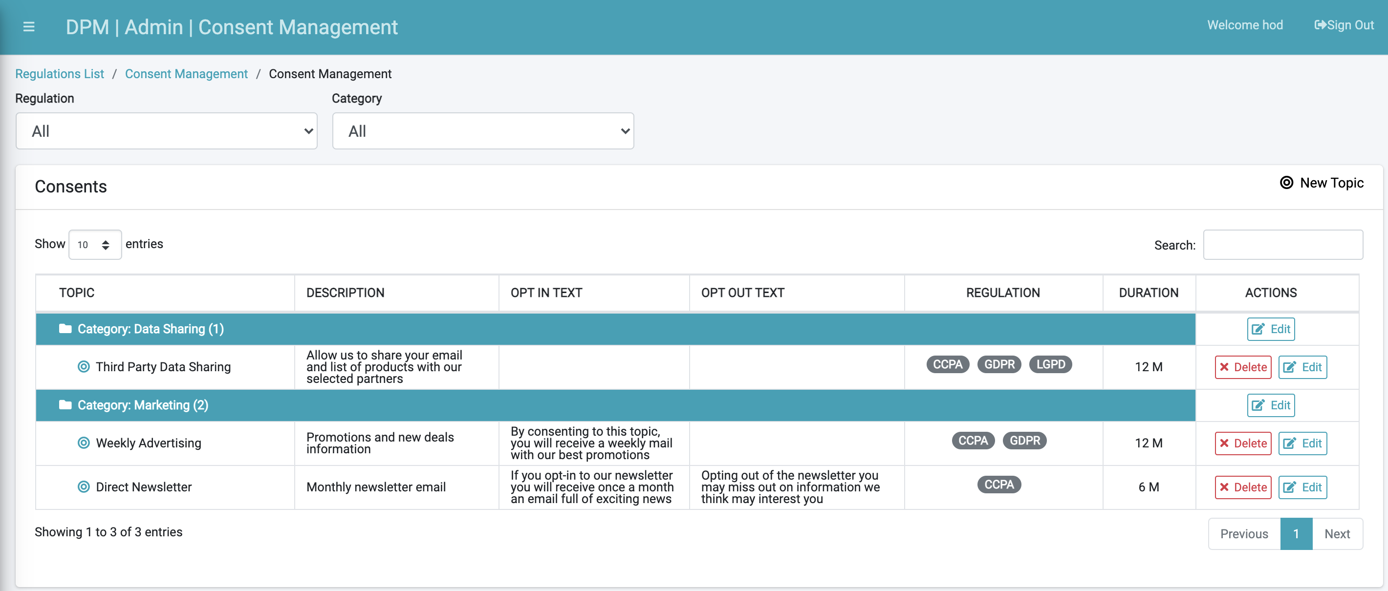

Figure 63. Consent Management Configuration Screen

Filter options display along the top-left of the screen, letting you clarify the list of consents presented by **Regulation** and/or **Category**.

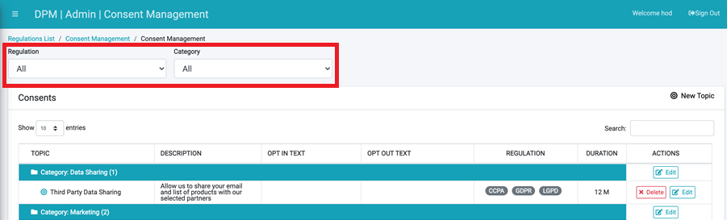

Figure 63. Consent Management Configuration Screen - Filters

To search a specific consent, use the **Search** option at the top-right of the Consents table.

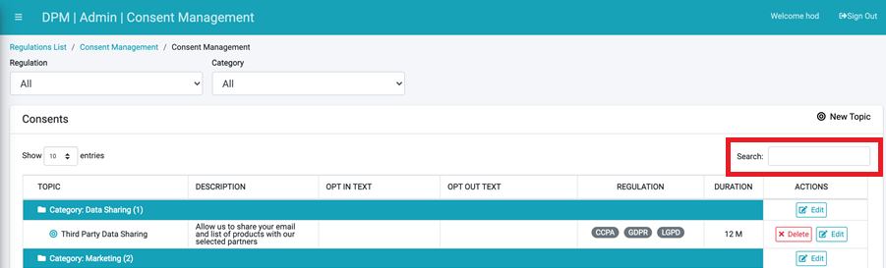

Figure 63. Consent Management Configuration Screen - Search

The following defines each column within the Consents table.

|  |  |
| --- | --- |
| Field | Description |
| TOPIC | The consent topic name. |
| DESCRIPTION | The consent topic description. |
| OPT IN TEXT | An additional description that explains the benefits of opting-in to each consent to the customer. |
| OPT OUT TEXT | An additional description that explains the impacts of opting-out from each consent to the customer. |
| REGULATION | The list of regulations linked to a consent. This allows control of the list of consents presented to each customer in accordance with the relevant regulation. |
| DURATION | The duration that the consent is considered valid at the customer level. For every customer, the consent takes effect the moment of opting-in, and then for the duration that is specified in this field. |
| ACTION | Click the **Edit** button to change the details for this consent topic, or click the **Delete** button to remove it. |

#### Consent Categories

Consents are grouped under user-defined Categories for better organization. Categories are defined by the Administrator when creating a new consent, as described in *8.2.2 Create New Consent Topic*. The Category name can be altered by clicking its respective **Edit** button under the **ACTIONS** column.

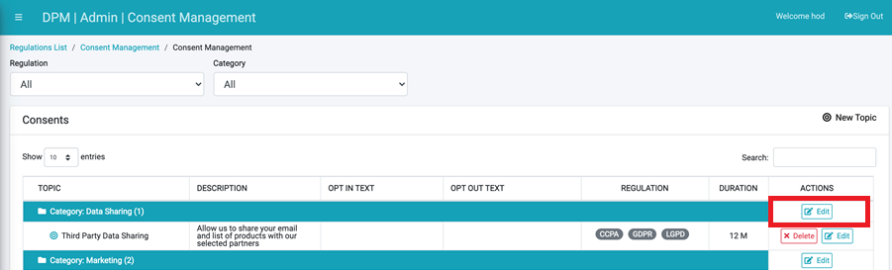

Figure 63. Consent Management Configuration Screen – Edit Category

### Create New Consent Topic

Click the  button at the top-right of the screen in order to configure a new Consent Topic.

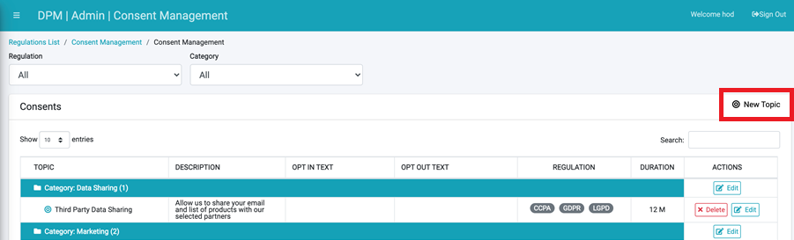

Figure 63. New Consent Topic

The following dialog box displays.

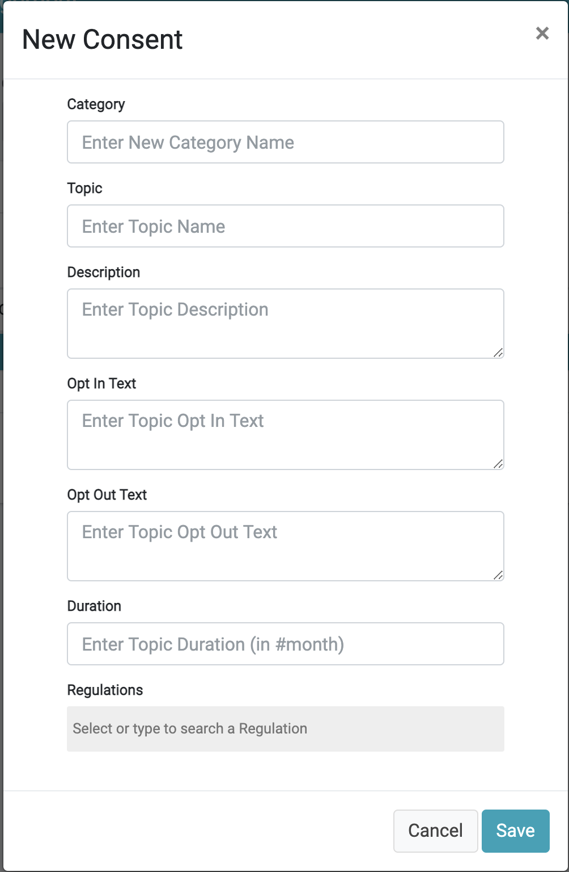

Figure 64. New Consent Topic - Configuration

|  |  |
| --- | --- |
| Field | Description |
| Category | Categories are used for grouping consent topics. This field lets the user classify the new consent under an existing Category or select **New Category** to manually enter a new one. |
| Topic | The consent topic name. |
| Description | The consent topic description. |
| Opt In Text | An additional description that explains the benefits of opting-in to each consent to the customer. |
| Opt Out Text | An additional description that explains the impacts of opting-out from each consent to the customer. |
| Duration | Define the duration that the consent is considered valid at the customer level. For every customer, the consent takes effect the moment of opting-in, and then for the duration that is specified in this field. |
| Regulations | Define the list of Regulations that this consent is linked to by selecting the relevant regulations from the dropdown list. The list of regulations that displays in this dropdown is defined in the Regulation List option on the Administrator menu. |

Click the **Save** button to save the new consent.

When a new consent is configured, it appears to a customer or representative in the Consent List. The customer or representative can then choose to opt-in to the new consent topic.

## Obtain Customer’s Consent and Preferences

### Customer Facing Interface

DPM offers multiple options to collect and manage customer consents:

* **DPM Web-based end-user interface**: K2View’s DPM includes a built-in, Web-based user interface that allows each customer to review the list of consents and update the preferences for each of the consent categories.
* **Integration with the customer self-service Web page and App**: The information that is managed within K2View’s DPM is also exposed via access-controlled REST APIs. These APIs provide the ability to integrate the consent data as part of your organization’s web portal, mobile app, CRM, or any other user interface.

DPM’s user interface presents to the end-user a clear and simple view of the consents which the user can concede to or withdraw from. Changing the preferences between opt-in and opt-out of each consent topic is done with one click. The user is then presented with a confirmation message that includes the text clarifying the advantages of opting-in or the impacts of opting-out.

Both the Web-based user interface as well as the REST APIs provide the ability to add information such as subscription agreement, terms and conditions and contact policy, without changes to the DPM product. This information can be retrieved directly by the DPM platform from the source systems or by integration with other applications.

### Customer Consent Management Screen

Each customer can set consent preferences by accessing the Consent Management menu option from the Customer menu.

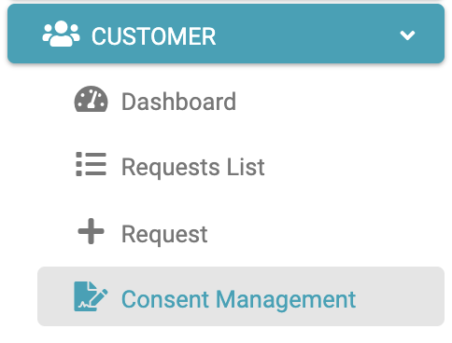

Figure 65. Consent Management at Customer Level

When accessing this menu option, the customer can review the list of consents, define whether to opt-in or opt-out to each one, or view historical information about opting-in or opting-out of previously performed activities.

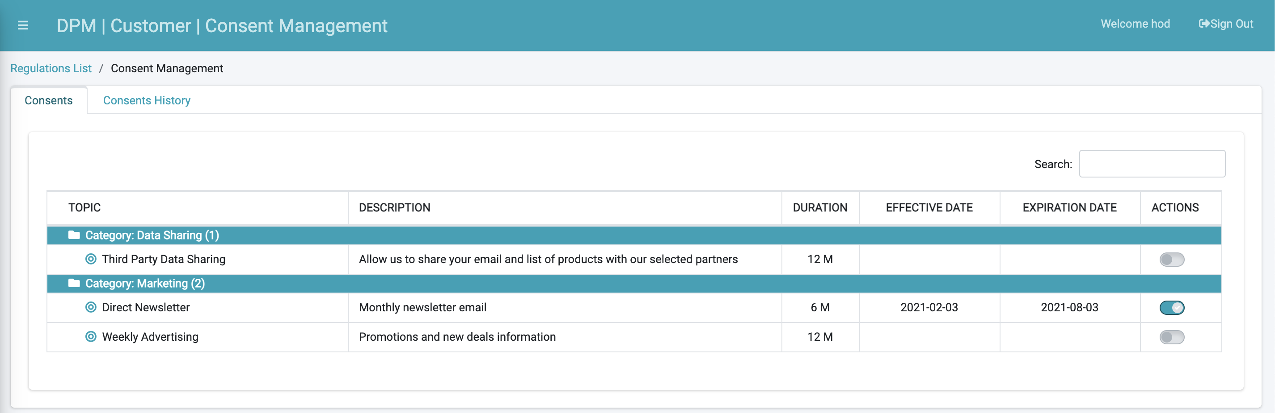

Figure 66. Customer Consent Management Screen

In this screen:

|  |  |
| --- | --- |
| Field | Description |
| TOPIC | The consent topic name. |
| DESCRIPTION | The consent topic description. |
| DURATION | The duration that the consent is considered valid. For every customer, the consent will be considered effective from the moment of opting-in, for the duration that is specified in this field. |
| EFFECTIVE DATE | The date the customer opted-in for this consent topic. |
| EXPIRATION DATE | The date the consent expires. This date is automatically calculated by adding the **EFFECTIVE DATE** to the number of months in the **DURATION** field. |
| ACTION | The **On**/**Off** slider allows the customer to opt-in or opt-out from the consent.  **Note**: The default value for this field is **Off** (opt-out.) |

When a user changes consent topic preferences (example: from opt-in to opt-out), a dislog box displays to confirm the selection. This dialog box includes the opt-in or opt-out text defined in the consent configuration.

#### Consent History

Any change that the customer performed in the consent preferences (example: opt-in or opt-out) is registered in the system for audit purposes. The change can be viewed in the **Consents History** tab.

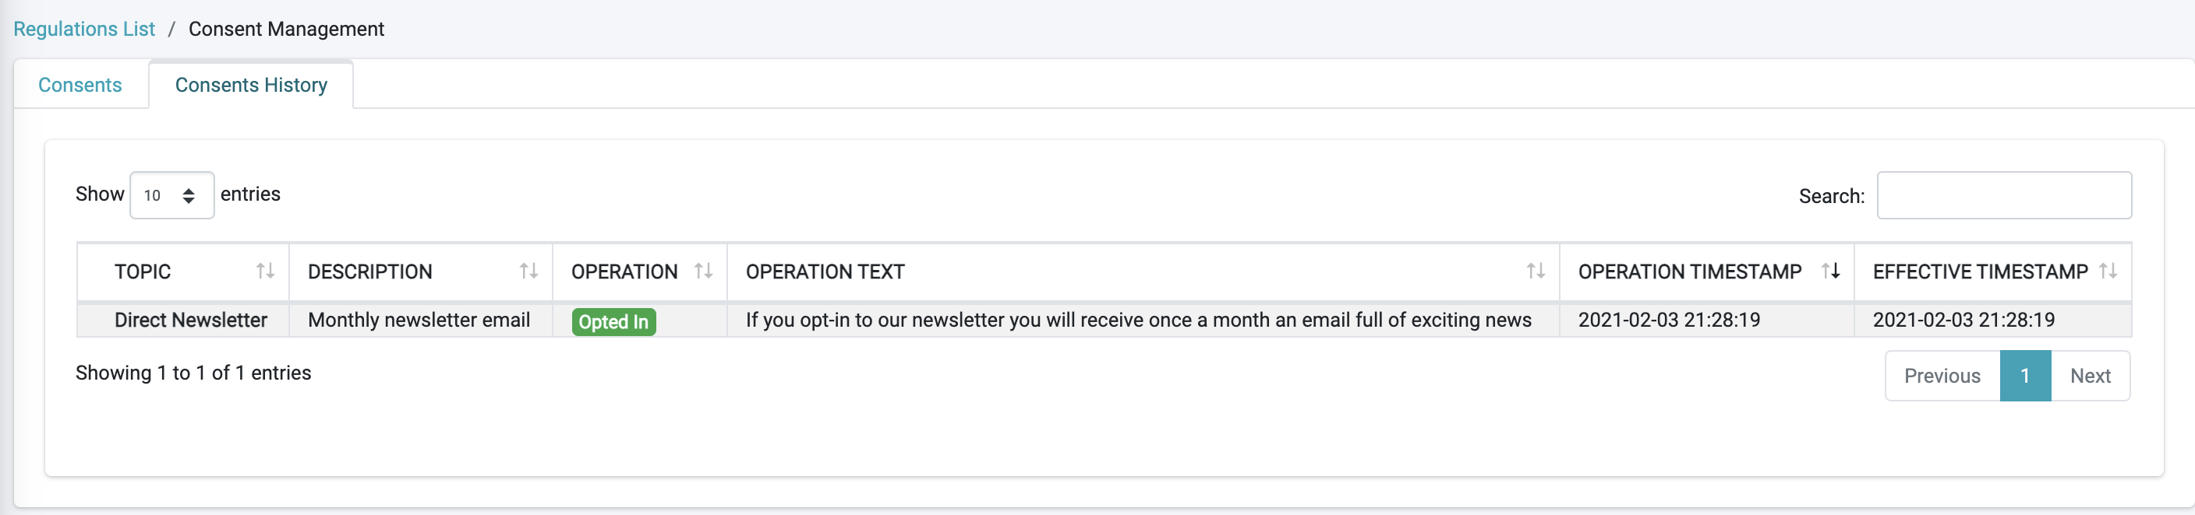

Figure 67. Consents History

### Customer Service Representative (CSR) User Interface

The DPM interfaces for representatives and agents are similar to the screens and APIs for the customer, described in *8.3.1 Customer Facing Interface*. DPM includes both a Web-based user interface and an API set to allow a Customer Service Representative (CSR) or an agent perform the same consent management activities as the customer. Activities include viewing the consent preferences of an end-user, as well as submitting a change to the consent preferences on behalf of the end-user.

The CSR can set consent preferences on behalf of a customer by accessing the Consent Management menu option from the **REPRESENTATIVE** menu.

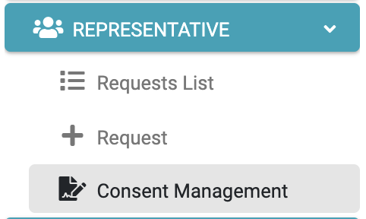

Figure 68. Consent Management from the REPRESENTATIVE Menu

For each customer, the CSR can review the list of consents, opt-in or opt-out of each one, or view historical information about opting-in or opting-out of activities previously performed.

The Consent Management functionality at the CSR level is equal to the functionality at the customer level with the only difference: The CSR should select the customer identification in order to retrieve the information.

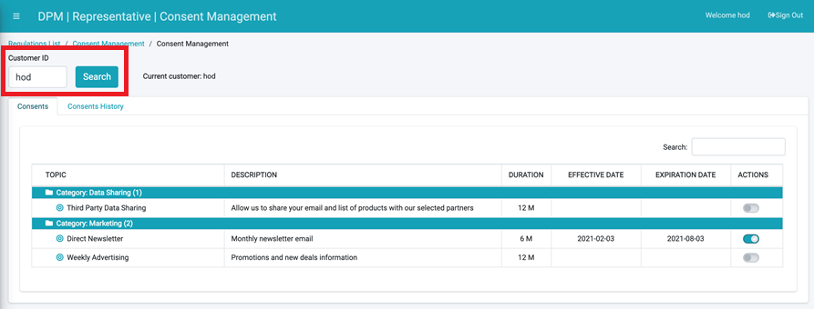

Figure 69. Representative Consent Management Screen

As depicted in the figure above, the CSR should enter the **Customer ID** in the upper-left corner of the screen, and then retrieve the information for the customer by clicking the **Search** button. For more details, refer to *8.3.2 Customer Consent Management Screen*.

## Consent Data Repository, Historical Data and Audit Information

The customer consent preferences are stored in the K2View DPM central Consent Management data repository. This data includes both current customer preferences and the user’s change history. The data is used in customer user interfaces, provides information to other applications, and enables historical tracking. The Consent Management data repository also provides detailed information for auditing, research, and reporting purposes.

The information stored for each consent preference and its respective change includes the following details.

* The user identification.
* The date and time the change was performed.
* The consent topic that was changed (example: consent to participating in a marketing campaign.)
* The user response to the consent topic (example: opt-in or opt-out.)

When a user accesses the Consent Management Web page, the current consent preference and history of changes are available for the user’s review. The information presented to the user is obtained by calling a built-in Consent Management API. This same API can be integrated with the company’s mobile app, and that the same data is presented in both the app and the Web portal.

## Consent Data Ingestion to/from Other Systems

The configurable integration and ingestion capabilities of K2View’s platform provide a strong and flexible mechanism for consent data ingestion to other systems, both inside and outside the corporate systems.

K2View’s DPM is built on the fabric customer data hub platform; therefore, data ingested from any other system is not limited to consent-related data. It can be enriched with any information related to the customer/user from any system within the organization. The platform also provides the ability to define any additional condition when deciding what population should be ingested to each system.

The K2View platform powering the DPM functionality includes the following built-in capabilities.

* A configurable connectivity layer that enables connectivity to the majority of systems without the need to code.
* Versatile integration methods that include files, streaming, publish/subscribe, message queues, APIs, and direct database injection.
* Change Data Capture (CDC) that identifies changes made to a configurable list of fields. It then publishes the change information to inform other applications about the changes as necessary.
* The ability to query consent data using JDBC with SQL queries.

Using these capabilities, full flexibility is provided to define how consent data are ingested into other systems (example: into data lakes.) The ingestion can be executed in multiple ways in accordance with the methods required by each system.

You can also configure replication of the consent preferences data to a separate repository for use by third parties.

The system provides full control of the data content provided to other systems. The information can be at the individual subscriber level, cover full populations, and extract subsets of customers or consent categories depending on configurable criteria. Both detailed data and summary information can be obtained this way.

Using the built-in implementation layer, each project can include additional logic or filter criteria without changing the product itself. The information can include whitelists, blacklists, or other rules that depend on a customer profile. The access, extraction, or ingestion of this information to other systems follows the same range of options as the overall consent preference data, including APIs, batches, streaming, CDC, and files. The extraction format is configurable and adaptable to the needs of each consuming/target application.

For example, information on subscribers that opted-out or opted-in can be delivered to the target system using streaming, invoking an API of the target system, exposing an API to be called by the interested system, providing extract files with the information, and directly updating the target database.

DPM provides versatile, configurable, two-way integration capabilities. Just as data can be provided to any other system, data can also be loaded into the DPM system from any external source. The data that is loaded into DPM is available in DPM Rest APIs in the same way as system-generated data is presented.

The integration in both directions is based on the data format expected by the source or target systems, because the adaptable data model and the configurable layout formatting features provide full flexibility.

Acquiring data back to the corporate data lake is fully supported. The integration method can be based on any of the previously explained options, and the data layout can be configured to any format the data lake expects to receive.

### Acquire and Publish in Real-Time

Using K2View DPM allows you to maintain the consents information obtained, updated and published in real-time. Consent preferences can be updated directly through the DPM user interface, by calling DPM REST APIs, and through methods such as acquiring data based on streaming. These options allow DPM to be updated in real-time on any update.

In the same manner that customer preference changes are updated in DPM, changes to other client applications are configurable in real-time, regardless of the method used by the subscriber to update the data.

### Consent Preferences Reminders

DPM can integrate with your corporate customer communication management system to trigger reminders to users to revisit their consent preferences. Reminder triggering can be timebound or in accordance with other conditions based on customer attributes, consent topic attributes, or other criteria, depending upon the project requirements. Two-way integration is provided, so DPM can acquire policy information defined in other systems as part of the communication triggering process.

DPM is based on K2View’s Fabric platform, so obtaining relevant customer attributes from any corporate systems is a simple configuration. This lets the communication include any required data for each customer, wherever it resides.

By integrating with the corporate communication management system, the reminders follow the existing controls and policies as required. In the absence of such a customer communication system, DPM enables direct reminder triggering in the implementation layer, without changes to the product.

Information about failed and successful SMS delivery attempts can be logged as part of DPM integration with the customer communication system.